La Societe
des 40 Hommes et 8 Chevaux
Grande Voiture du Missouri
2
023 – 2024
Directory

GRAND ROSTER
023-2024
2
“
Our Greatest Fun is Service”
1

John (Mike) Scruby
Grand Chef de Gare
2
023 – 2024
2
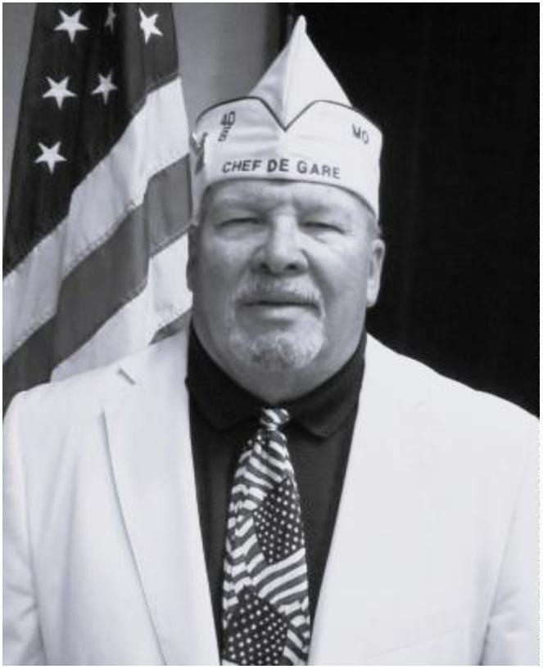

A.J. Noonan
Grand Correspondant
2
023 – 2024
3
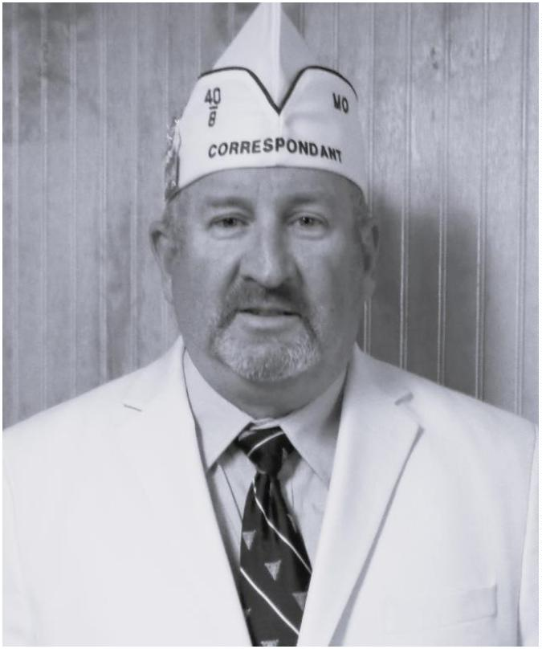

Preamble
For God and country we associate ourselves
together for the following purposes: To create a
charitable and non-profit veterans
organization; to uphold and defend the
Constitution of the United States of America; to
assist and promote the welfare and well-being of
those who have served or are now serving in the
Armed Forces of the United States and their
widows, widowers and orphans; to participate
in all memorial services for and to be present at
the funerals of departed comrades; to take part
in and to encourage others to participate in the
proper observance of all days honoring
veterans; to preserve the memories of our
Services in the Armed Forces of our Country; to
actively participate within our membership in
projects relating to (a) the welfare of the
children of America; (b) the health of our
Nation by fostering a nurses training program;
and (c) selected charitable endeavors.
4

Catechism of an Homme
“
I faithfully promise to obey the rules and
regulations of La Societe, to remember my
obligations, and to carry out the legal
orders of the Chef de Gare. I believe, for
the good of my country, that I should and
will always hold the organization of La
Societe in highest esteem, and will conduct
myself in such a manner as to reflect credit
upon it. It is my sincere desire, that the
United States of America, be one country,
with one language, and one flag, and, if
necessary, I will fight for that principle.”
5

GRANDE VOITURE du MISSOURI
023 - 2024 Directory
2
GRAND CHEF de GARE
Mike Scruby (1379)
Jill
7
909 N. Little Lane
Cell: 816-204-1746
jscruby50@gmail.com
Pleasant Valley, MO 64068
GRAND CHEF de TRAIN
Ron Leverenz (760)
Brittany
4
25 N Boonville Ave.
Res: 417-612-4505
ron1918@sbcglobal.net
Springfield, MO 65806
GRAND COMMISSAIRE INTENDANT
Rose Noonan (460)
A.J.
2
0165 Highway 28
Res: 573-647-9162
ajnoonan2003@yahoo.com
Dixon, MO 65459
CHEMINOT NATIONALE
A. J. Noonan (460)
Rose
2
0165 Highway 28
Res: 573-872-9068
ajnoonan2004@yahoo.com
Dixon, MO 65459
ALTERNATE CHEMINOT NATIONALE
Hallie Williams (448)
Yevette
Cell: 314-359-4748
Res: 314-381-7538
hw11@swbell.net
6
924 Willow Wood Drive
Northwoods, MO 63121
GRAND CORRESPONDANT
A. J. Noonan (460)
Rose
2
0165 Highway 28
Res: 573-872-9068
ajnoonan2004@yahoo.com
Dixon, MO 65459
SOUS GRAND CORRESPONDANT
Robert C. Emery (1379)
cell: 816-585-2098
Res: 816-313-5109
remery18@comcast.net
1
6001 East 31st Street South
Independence, MO 64055
6

SOUS GRAND CORRESPONDANT
Terry L. Lanning (448)
Linda
2
045 Granada Drive
Res: 314-839-2032
t_lanning@charter.net
Florissant, MO 63033
SOUS GRAND CHEF de TRAIN (Voitures-460-760-1321)
Ron Turner (760)
601 North Oakland Ave.
Springfield, MO 65802
Monika
Res: 417-860-5924
ronssg@aol.com
2
SOUS GRAND CHEF de TRAIN (Voitures-38-448-966-1541)
Hallie Williams (448)
924 Willow Wood Drive
Northwoods, MO 63121
Yevette
Cell: 314-359-4748
Res: 314-381-7538
hw11@swbell.net
6
SOUS GRAND CHEF de TRAIN (Voitures-3-130-1379-1402)
David N. Voyles (130)
PO Box 36
Amazonia, MO 64421
Ruth
Cell: 816-244-8411
dvoyles22@yahoo.com
SOUS GRAND CHEF de TRAIN (Voitures-292-333-1292-1403)
Dan Levasseur (1292)
1
1006 Route H
Res: 573-433-1923
Henley, MO 65040
dan.j.levasseur@gmail.com
GRAND AUMONIER
Theadore (Ted) McCart (1321)
Diane
1
320 Sunset Pointe
Res: 314-550-9791
tmccart09@gmail.com
Festus, MO 63028
GRAND AVOCAT
Richard A. Heigert (1321)
Beverly
3
202 Elm Grove Court
Cell: 314-740-6685
heigertr@aol.com
Arnold, MO 63010
7

SOUS GRAND AVOCAT
David N. Voyles (130)
PO Box 36
Ruth
Cell: 816-244-8411
dvoyles22@yahoo.com
Amazonia, MO 64421
GRAND CONDUCTEUR
Frank Angelo (460)
1
32 Sawmill Rd.
Res: 217-416-5695
St. Robert, MO 65584
franklin.v.angelo408@gmail.com
SOUS GRAND CONDUCTEURS
Benjamin Sargent (460)
Shelly
2
5625 Swan Road
Res: 573-528-6110
msgsgt2@yahoo.com
Richland, MO 65556
Forrest Johnson (1541)
7
Mark Twain Court
Res: 314-960-1027
O'Fallon, MO 63376
wolfdoctor@aol.com
Dan Levasseur (1292)
1
1006 Route H
Res: 573-433-1923
Henley, MO 65040
dan.j.levasseur@gmail.com
GRAND DRAPEAU EAST
Bob Evenson (1541)
3
50 Beaver Lake Drive
Res: 316-670-0433
St. Charles, MO 63303
bevenson60@gmail.com
GRAND DRAPEAU WEST
Ron Leverenz (760)
Brittany
4
25 N Boonville Ave.
Res: 417-612-4505
ron1918@sbcglobal.net
Springfield, MO 65806
8

GRAND GARDE de LA PORTE
Forrest Johnson (1541)
7
Mark Twain Court
Res: 314-960-1027
O'Fallon, MO 63376
wolfdoctor@aol.com
GRAND HISTORIEN
Frank Angelo (460)
1
32 Sawmill Rd.
Res: 217-416-5695
St. Robert, MO 65584
GRAND LAMPISTE
Vacant
franklin.v.angelo408@gmail.com
GRAND MEDICIN
Tommy Thomas (460)
3
08 S. Commercial Street
573-528-7139
Crocker, Mo 65452
tommy.t.thomas8.civ@mail.mil
GRAND ORGANIZER
Thomas (Chip) Berkley (292)
Lora
2
545 County Rd 269
Cell: 573-424-8877
tdberkley@msn.com
Columbia, MO 65202
SOUS GRAND ORGANIZER
David Bexten (1292)
Patty
1
343 County Road 632
Cell: 573-690-4705
davidhbexten@gmail.com
Freeburg, MO 65035
David N. Voyles (130)
PO Box 36
Amazonia, MO 64421
Ruth
Cell: 816-244-8411
dvoyles22@yahoo.com
9

GRAND PUBLICISTE
David Bexten (1292)
Patty
1
343 County Road 632
Cell: 573-690-4705
davidhbexten@gmail.com
Freeburg, MO 65035
GRAND CHEMINOT-AT-LARGE
Ralph Turner (460)
Tina
PO Box 112
Richland, MO 65556
Res: 573-528-7424
ralph.n.turner@hotmail.com
Kevin T. Johnson (460)
1
6810A Huntington Lane
Res: 573-452-1157
St. Roberts, MO 65584
kthomasj01@icloud.com
Arthur L. Wilson (448)
3
125 Country Bluff Dr.
Cell: 314-680-8860
awilson725@att.net
St. Charles, MO 63301
Clarence C. Buckley (760)
Martha
1
325 N. Johnson
Res: 417-866-8343
chubb65@sbcglobal.net
Springfield, MO 65802
Robert W. Phillips (1541)
Tina
3
14 Kent Drive
Cell: 314-609-2492
tibo5635@charter.net
Wentzville, MO 63385
PROGRAM DIRECTEUR’S AND SOUS’S
GRAND DIRECTEUR AMERICANISM
Robert C. Emery (1379)
cell: 816-585-2098
Res: 816-313-5109
remery18@comcast.net
1
6001 East 31st Street South
Independence, MO 64055
1
0

SOUS GRAND DIRECTEUR AMERICANISM
Calvin Bumgarner (1379) Karen
212 Cody
Res: 913-631-1487
Cell: 913-522-1103
cbumgar522@aol.com
5
Shawnee, KS 66203
GRAND DIRECTEUR BOX CAR
John Kramer (1321)
Mary
2
20 N Allen Street
Res: 573-358-4191
ucjkramer@aol.com
Bonne Terre, MO 63628
GRAND DIRECTEUR CARVILLE STAR
Shiran Jackson (460)
Cindy
1
9671 Lannigan Road
Res: 270-874-9257
pynkie89@yahoo.com
Waynesville, MO 65583
GRAND DIRECTEUR CHILD WELFARE
Bowman McArthur III (460)
2
0103 Highway 28
Res. 910-733-3188
Dixon, MO 65583
bowman_mcarthur22@yahoo.com
GRAND DIRECTEUR NURSES TRAINING
Kevin T. Johnson (460)
1
6810A Huntington Lane
Res: 573-452-1157
St. Roberts, MO 65584
kthomasj01@icloud.com
GRAND DIRECTEUR POW/MIA
Janice Hartley (1541)
2
102 Martin Dr.
Res: 314-799-4568
O’Fallon, MO 63366
jgharrtleykdr@outlook.com
SOUS GRAND DIRECTEUR POW/MIA
Harry T. Barnes Jr. (1321
Theresa
9
40 S. 2nd Street
Cell: 314-420-5225
htbarnesjr@sbcglobal.net
Festus, MO 63028
1
1

GRAND DIRECTEUR RITUAL
Duane H. DeClue (1321)
Sandy
1
08 Virginia Ave.
Res: 636-931-2796
duanedeclue@earthlink.net
Crystal City, MO 63019
GRAND DIRECTEUR SPECIAL AWARDS
Benjamin Sargent (460)
Shelly
2
5625 Swan Road
Res: 573-528-6110
msgsgt2@yahoo.com
Richland, MO 65556
GRAND VAVS DIRECTEUR
Thomas (Chip) Berkley (292)
Lora
2
545 County Rd 269
Cell: 573-424-8877
tdberkley@msn.com
Columbia, MO 65202
SOUS GRAND VAVS DIRECTEURS
Donald Newman II (1541)
7
20 Mayer Drive
Res: 636-949-0440
St. Charles, MO 63301
newman-d@sbcglobal.net
Gary Puck
(1379)
Ann
1
104 Pier Street
Cell: 816-469-0271
annroberts977@gmail.com
Liberty, MO 64068
Lora Berkley (292)
Thomas (Chip)
2
545 County Rd 269
Cell: 573-424-8877
tdberkley@msn.com
Columbia, MO 65202
Samuel Mercer Jr. (1321)
5
755 Highway F
Res: 573-915-0776
Farmington, MO 63640
sammercer1970@gmail.com
Dennis Ecker (1321)
Pam
1
670 Juanita Drive
Res: 314-753-8189
moc42@ix.netcom.com
Barnhart, MO 63012
1
2

GRAND DIRECTEUR VOITURE ACTIVITIES
Calvin Bumgarner (1379) Karen
Res: 913-631-1487
Cell: 913-522-1103
cbumgar522@aol.com
5
212 Cody
Shawnee, KS 66203
GRAND DIRECTEUR YOUTH SPORTS
Ann Puck (1379)
Gary
1
104 Pier Street
Cell: 816-469-0271
annroberts977@gmail.com
Liberty, MO 64068
COMMITTEES
DISTINGUISHED GUEST COMMITTEE
Robert W. Phillips (1541)
Tina
3
14 Kent Drive
Cell: 314-609-2492
tibo5635@charter.net
Wentzville, MO 63385
Terry L. Lanning (448)
Linda
2
045 Granada Drive
Res: 314-839-2032
t_lanning@charter.net
Florissant, MO 63033
Richard A. Heigert (1321)
Beverly
3
202 Elm Grove Court
Cell: 314-740-6685
heigertr@aol.com
Arnold, MO 63010
DISTINGUISHED VOYAGEUR AWARD COMMITTEE
Calvin Bumgarner (1379) Chairman Karen Res: 913-631-1487
212 Cody
5
Cell: 913-522-1103
Shawnee, KS 66203
cbumgar522@aol.com
Terry L. Lanning (448)
Linda
2
045 Granada Drive
Res: 314 839-2032
t_lanning@charter.net
Florissant, MO 63033
Robert W. Phillips (1541)
Tina
3
14 Kent Drive
Cell: 314-609-2492
tibo5635@charter.net
Wentzville, MO 63385
1
3

Janice Hartley (1541)
2102 Martin Dr.
Res: 314-799-4568
O’Fallon, MO 63366
janice.hartley@hotmail.com
David Bexten (1292)
Patty
1
343 County Road 632
Cell: 573-690-4705
davidhbexten@gmail.com
Freeburg, MO 65035
Ralph Turner (460)
PO Box 112
Richland, MO 65556
Tina
Res: 573-528-7424
ralph.n.turner@hotmail.com
EXECUTIVE COMMITTEE ADVISORY & PROTOCOL
Richard A. Heigert (1321)
202 Elm Grove Court
Arnold, MO 63010
Beverly
Cell: 314-740-6685
heigertr@aol.com
3
TIME & PLACE COMMITTEE
Kevin T. Johnson (460) Chairman
1
6810A Huntington Lane
Cell: 573-452-1157
St. Roberts, MO 65584
kthomasj01@icloud.com
Janice Hartley (1541)
2
102 Martin Dr,
Res: 314-799-4568
O’Fallon, MO 63366
janice.hartley@hotmail.com
David Bexten (1292)
Patty
1
343 County Road 632
Cell: 573-690-4705
davidhbexten@gmail.com
Freeburg, MO 65035
MAVO
LEGISLATIVE REPRESENTATIVE
Thomas (Chip) Berkley (292)
Lora
2
545 County Rd 269
Cell: 573-424-8877
tdberkley@msn.com
Columbia, MO 65202
1
4

DELEGATE at LARGE
Dan Levasseur (1292)
1
1006 Route H
Res: 573-433-1923
Henley, MO 65040
dan.j.levasseur@gmail.com
DELEGATES:
Mike Scruby (1379)
Jill
7
909 N. Little Lane
Cell: 816-204-1746
jscruby50@gmail.com
Pleasant Valley, MO 64068
Ron Leverenz (760)
Brittany
4
25 Boonville Ave.
Res: 417-612-4505
ron1918@sbcglobal.
Springfield, MO 65802
A. J. Noonan (460)
Rose
2
0165 Highway 28
Res: 573-872-9068
ajnoonan2004@yahoo.com
Dixon, MO 65459
AIDE DE CAMP (292)
Frank Angelo
1
32 Sawmill Rd.
Res: 217-416-5695
St. Robert, MO 65584
franklin.v.angelo408@gmail.com
GRAND CHEFS de GARE PASSE
986 Edward "Al" Vidricksen (3)
1
1
1
2
016 S.W. 4th Street
Lee's Summit, MO 64081-2225
Res: 816-524-6191
997 Richard A. Heigert (1321)
Beverly
3
202 Elm Grove Court
Cell: 314-740-6685
heigertr@aol.com
Arnold, MO 63010
998 Ronald P. Doyon (3)
Nancy
1
313 N.E. Timbercreek Way
Res: 816-246-8220
ronalddoyon@att.net
Lee's Summit, MO 64086
1
5

2
2
000 Terry L. Lanning (448)
045 Granada Drive
Linda
Res: 314-839-2032
t_lanning@charter.net
2
Florissant, MO 63033
004 Arthur L. Wilson (448)
3
125 Country Bluff Dr.
Cell: 314-680-8860
awilson725@att.net
St. Charles, MO 63301
2
2
2
2
2
2
2
005 Kevin T. Johnson (460)
1
6810A Huntington Lane
Cell: 573-452-1157
kthomasj01@icloud.com
St. Roberts, MO 65584
006 Clarence C. Buckley (760)
Martha
Res: 417-866-8343
chubb65@sbcglobal.net
1
325 N. Johnson
Springfield, MO 65802
007 Donald W. Fligge (3)
Yvonne
9
000 N Congress Ave Apt 343
Kansas City, MO 64153
Res: 816-621-3819
009 Robert W. Phillips (1541)
Tina
3
14 Kent Drive
Cell: 314-609-2492
tibo5635@charter.net
Wentzville, MO 63385
011 Larry R. Ebersold (1292)
4
5 Denton Road
Eldon, MO 65026
Cell: 573-480-3652
012 David S. Christian (38)
Jill
5
Parkville Lane
Res: 636-931-3568
DSChristian2082@aol.com
Festus, MO 63028
013 Edward R. Jones (3)
Joyce
8
401 Elm Ave.
Res: 816-663-1700
ed.jones13@yahoo.com
Raytown, MO 64138
1
6

GRAND CHEFS de GARE PASSE (continued)
2
2
2
2
014 Ralph Turner (460)
PO Box 112
Tina
Res: 573-528-7424
ralph.n.turner@hotmail.com
Richland, MO 65556
015 Leon L. Hill (1541)
Linda
Res: 636-387-0671
1
011 Pegasus Circle
St. Peters, MO 63376
016 David Bexten (1292)
Patty
1
343 County Road 632
Cell: 573-690-4705
davidhbexten@gmail.com
Freeburg, MO 65035
016 Honorary
Sam M. Guenther (1403)
675 S. Jefferson Ave. Unit 131B
Jan
2
Springfield, MO 65807
Res: 573-372-6562
2
2
2
2
017 Thomas (Chip) Berkley (292)
Lora
2
545 County Rd 269
Cell: 573-424-8877
tdberkley@msn.com
Columbia, MO 65202
018 David N. Voyles (130)
PO Box 36
Ruth
Cell: 816-244-8411
dvoyles22@yahoo.com
Amazonia, MO 64421
019 Calvin Bumgarner (1379)
Karen
Res: 913-631-1487
Cell: 913-522-1103
cbumgar522@aol.com
5
212 Cody
Shawnee, KS 66203
020 Janice Hartley (1541)
2
102 Martin Dr,.
Res: 314-799-4568
O’Fallon, MO 63366
janice.hartley@hotmail.com
1
7

GRAND CHEFS de GARE PASSE (continued)
2
2
2
021 Frank Angelo (460)
32 Sawmill Rd.
1
Res: 217-416-5695
franklin.v.angelo408@gmail.com
St. Robert, MO 65584
022 A. J. Noonan (460)
Rose
2
0165 Highway 28
Res: 573-872-9068
ajnoonan2004@yahoo.com
Dixon, MO 65459
023 Hallie Williams (448)
Yevette
6
924 Willow Wood Drive
Cell: 314-359-4748
hw11@swbell.net
Northwoods, MO 63121
1
8

VOITURE LOCALE OFFICERS
VOITURE # 3
Meets on the last Thursday of quarter at 6:00pm
at Post 189, 820 Vista Dr., Lee’s Summit.
CHEF de GARE
Mike Timm
1
329 NE Timbercreek Way
Lees’s Summit, MO 64082
Res. 816-835-9845
CORRESPONDANT
John R. Neger
1
720 NW O’Brian Road Apt 110
Res: 816-358-0508
Lee’s Summit, MO 64081
jneger1934@yahoo.com
GRAND CHEMINOT
Pat Burton
2
4622 Trail Ridge Pass
Res: 816-618-3861
Cleveland, MO 64734
pkburton1@yahoo.com
VOITURE # 38
Meets the 3rd Monday at 1:00pm, American Legion Post 37
CHEF de GARE
Mike Patrich
741 Hunting Valley Dr.
Betty
Res: 573-820-9043
3
St. Louis, MO 63129
CORRESPONDANT
Gerald J. Fitzgerald
Julie
#
7 Zinzer Court
Res: 314-843-7312
gfitz05@att.net
St. Louis, MO 63123
GRAND CHEMINOT
Noel F. Barlows
Linda
4
741 Seibert Street
Res: 314-308-9337
bean@gameon.net
St. Louis, MO 63123
1
9

VOITURE LOCALE OFFICERS
VOITURE # 130
Meets on the 4th Wednesday at Post 287, 501 E. Price Street,
Savannah, MO 64485 at 6:00pm
CHEF de GARE
Michael J. Fisher
0901 E. 236th
1
Res: 816-738-5061
mifisher@aol.com
Peculiar, MO 64078
CORRESPONDANT
Kenneth Ballard
8
316 Country Road 57
Res: 515-238-0568
Rosendale, MO 64483
theballards67@gmail.com
GRAND CHEMINOT
Daniel Petitt
1
013 S Cedar
Res:816-244-0773
Savannah, Missouri 64485
dpetitt130@gmail.com
VOITURE # 292
Meets on the 1st Wednesday at various towns & Posts.
CHEF de GARE
David Bentley
408 Bentley Court
2
Res: 573-881-8261
Columbia, MO 65202
uscavmajor@gmail.com
CORRESPONDANT
Leslie E. Davis
Marie
6
10 Meadowbrook Circle
Res: 573-998-5231
Moberly, MO 65270
GRAND CHEMINOT
Lora Berkley
Chip
2
545 County Rd 269
Res: 573-777-2691
berkleyrebel@msn.com
Columbia, MO 65202
2
0

VOITURE LOCALE OFFICERS
VOITURE # 333
Meets on the 3rd Thursday, 7:45 AM. Sedalia Knights of Columbus
CHEF de GARE
Walter (Cliff) C. McBride Jr.
207 S. Park
Cheryl
Res: 660-826-1910
mcbride@charter.net
3
Sedalia, MO 65301
CORRESPONDANT
Ernie Parker
Susan
2
7659 Schenk Road
Res: 660-460-0991
susnerne@hughes.net
Green Ridge, MO 65332
GRAND CHEMINOT
Don Barbour
Carolyn
1
611 S. Carr
Res: 660-826-2102
dbarbour5@charter.net
Sedalia, MO 65301
VOITURE # 448
Meets on the 4th Tuesday on various months at 7:00 PM at Legion Post 208,
Old Sulphur Springs Road, Manchester, MO 63021
CHEF de GARE
James Christman
384 Westbrooke Meadows Lane
Ballwin, MO 63021
Muriel
1
Cell: 314-779-8421
jimchristman1484@gmail.com
CORREPONDANT
Terry L. Lanning
Linda
2
045 Granada Drive
Res: 314 839-2032
t_lanning@charter.net
Florissant, MO 63033
GRAND CHEMINOT
Hallie Williams
Yevette
Cell: 314-359-4748
Res: 314-381-7538
hw11@swbell.net
6
924 Willow Wood Drive
Northwoods, MO 63121
2
1

VOIITURE LOCALE OFFICERS
VOITURE # 460
Meets 3rd Tuesday 6:00PM at Post 331, 484 St. Robert Outer Road, St. Robert
CHEF de GARE
Rose Noonan
AJ
2
0165 Highway 28
Res: 573-647-9162
ajnoonan2003@yahoo.com
Dixon, MO 65459
CORRESPONDANT
Benjamin Sargent
Shelly
2
5625 Swan Road
Res: 573-528-6110
msgsgt2@yahoo.com
Richland, MO 65556
GRAND CHEMINOT
Tommy Thomas
3
08 S. Commercial Street
573-528-7139
Crocker, Mo 65452
tommy.t.thomas8.civ@mail.mil
VOITURE # 760
Meets on the 3rd Tuesday, at Post 69 at 7:00pm.
CHEF de GARE
Ron Turner
Monika
2
601 North Oakland Ave.
Res: 417-860-5924
ronssg@aol.com
Springfield, MO 65802
CORRESPONDANT
Roger Wallenburg
Julie
1
361 E. Woodgate
Res: 417-425-5546
rwallenburg@yahoo.com
Springfield, MO 65804
GRAND CHEMINOT
Ron Leverenz
Brittany
4
25 Boonville Ave.
Res: 417-612-4505
ron1918@sbcglobal.net
Springfield, MO 65802
2
2

VOITURE LOCALE OFFICERS
VOITURE # 966
Meets at various times.
CHEF de GARE
Robert W. Fohey
18 Spur Drive
Marcia
8
Palmyra, MO 63461
Res: 573-769-2062
CORRESPONDANT
Larry R. Pickett
Cathy
1
1390 Huron Drive
Res: 573-221-4870
larrypickett1950@gmail.com
Hannibal, MO 63401
GRAND CHEMINOT
Larry R. Pickett
Cathy
1
1390 Huron Drive
Res: 573-221-4870
larrypickett1950@gmail.com
Hannibal, MO 63401
VOITURE # 1292
Meets on the 2nd Thursday 7:00PM usually at Post 5, 1423 Tanner Bridge
Road, Jefferson City, MO 65101
CHEF de GARE
Dan Levasseur
1
1006 Route H
Res: 573-433-1923
Henley, MO 65040
dan.j.levasseur@gmail.com
CORRESPONDANT
Charlotte Dudenhoeffer
1
224 West High Street
Res: 573-230-8387
Jefferson City, MO 65101
rhette75@mchsi.com
GRAND CHEMINOT
Gary Kempker
1
2923 Eagle Ridge Road
Res: 573-690-3439
Holts Summit, MO 65042
gkempker@centurylink.net
2
3

VOITURE LOCALE OFFICERS
VOITURE # 1321
Meets at 2nd Sunday on March, June, & September at various Posts at 1:00 PM.
Where the District meets.
CHEF de GARE
John Kramer
20 N Allen Street
Bonne Terre, MO 63628
Mary
Res: 573-358-4191
ucjkramer@aol.com
2
CORRESPONDANT
Theadore McCart
Diane
1
320 Sunset Pointe
Res: 314-550-9791
tmccart09@gmail.com
Festus, MO 63028
GRAND CHEMINOT
Duane H. DeClue
Sandy
1
08 Virginia Ave.
Res: 636-931-2796
duanedeclue@earthlink.net
Crystal City, MO 63019
VOITURE # 1379
Meets on the 4th Wednesday at 7:00 PM at various locations.
Web site http://www.voiture1379.com
CHEF de GARE
Mike Scruby
909 N. Little Lane
Jill
7
Cell: 816-204-1746
jscruby50@gmail.com
Pleasant Valley, MO 64068
CORRESPONDANT
Robert C. Emery
Cell: 816-585-2098
Res: 816-313-5109
remery18@comcast.net
1
6001 East 31st Street South
Independence, MO 64055
GRAND CHEMINOT
Calvin Bumgarner
Karen
Res: 913-631-1487
Cell: 913-522-1103
cbumgar522@aol.com
5
212 Cody
Shawnee, KS 66203
2
4

VOITURE LOCALE OFFICERS
VOITURE # 1402
Meets at various times.
CHEF de GARE
Timothy Morehouse
06 Myrtle
3
Tarkio, MO 64491
Res: 660-736-5509
CORRESPONDANT
Marvin Harper
Mary
2
02 Mc Candles
Res: 660-652-3291
marehar@grm.net
Barnard, MO 64423
GRAND CHEMINOT
Marlin F. Slagle
Sharon
1
801 Hub Club Drive
Bethany, MO 64424
Res: 660-582-2914
VOITURE # 1403
Meets on the 3rd Tuesday at Post 624, 852 American Legion Rd, Sunrise
Beach, MO 65079.
CHEF de GARE
Sam M. Guenther
2675 S. Jefferson Ave. Unit 131B
Jan
Springfield, MO 65807
Res: 573-372-6562
CORRESPONDANT
Robert B. "Barry" Campbell, Jr.
Cell: 573-216-3605
2
400 Woodland Drive
Sedalia, MO 65301
campjr48@gmail.com
GRAND CHEMINOT
Cindy
Robert B. "Barry" Campbell, Jr.
Cell: 573-216-3605
2
400 Woodlan Drive
Sedalia, MO 65301
campjr48@gmail.com
2
5

VOITURE LOCALE OFFICERS
VOITURE # 1541
Meets on the 4th Wednesday at 7:30 PM at Post 312, St. Charles.
CHEF de GARE
Forrest Johnson
Mark Twain Court
7
Res: 314-960-1027
O'Fallon, MO 63376
wolfdoctor@aol.com
CORRESPONDANT
Allen Schultz
1
427 Summergate Parkway
Res: 636-447-7347
St. Charles, MO 63303
ajblues9243@sbcglobal.net
GRAND CHEMINOT
Janice Hartley (1541)
2
102 Martin Dr.
Res: 314-799-4568
O’Fallon, MO 63366
janice.hartley@hotmail.com
CHEFS de CHEMIN de FER PASSE
John O. Newberry
1
1
953
965
*
*
1292
38
O. J. Laubenthal
GRAND CHEFS de GARE PASSE
1
1
1
1
1
1
1
1
1
1
1
921
922
923
924
925
926
927
928
929
930
931
*
*
*
*
*
*
*
*
*
*
*
John H. Parker
38
38
3
38
3
Harry D. McBride
Dr. Paul V. Wooley
Francis M. Curlee
Clark R. Mandigo
Robert D. Turner
Hugh D. Mason
W. Vincent Brennan
Clem M. White
Charles L. Brown
Tom A. J. Anseim
38
293
448
130
760
448
2
6

GRAND CHEFS de GARE PASSE (cont.)
James R. Anserson
Joseph F. Healy
Jake H. Karchmer
Arthur A. Jordan
George Fiske
Curt E. Kuehn
Dr. H. Chris Oltman
A. B. Weyer
Percy M. Gash
Clyde H. Ormsbee
Charles E. Teel
John J. Barada
Bartlett Boder
1
1
1
1
1
1
1
1
1
1
1
1
1
1
1
1
1
1
1
1
1
1
1
1
1
1
1
1
1
1
1
1
1
1
1
932
933
934
935
936
937
938
939
940
941
942
943
944
945
946
947
948
949
950
951
952
953
954
955
956
957
958
959
960
961
962
963
964
965
966
*
*
*
*
*
*
*
*
*
*
*
*
*
*
*
*
*
*
*
*
*
*
*
*
*
*
*
*
*
*
*
*
*
*
*
3
130
760
38
3
130
293
3
38
760
3
38
130
637
292
3
448
38
333
. 848
. 156
448
130
1292
3
Fred A. Carlton
John O. Newberry
Vaughan T. Williams
John Bell
F. Lee Price
Frank P. Reynolds
E. Farmer Oakes
J. Ralph Hutchison
C. Ray Drummond
Lester B. Miller
Mel Whiteside
Neil F. Cline
W. Lee Morgan
38
P. A. Fredericksen
Dr. H. V. Herider
O. E. Blankenbaker
Ralph S. Holland
O. J. Laubenthal
Cecil Montgomery
Robert E. Natsch, Jr
Raymond O. Money
Charles E. Peebles
1379
333
448
3
38
293
1292
3
1379
2
7

GRAND CHEFS de GARE PASSE (cont.)
Russell H. Miller
Clarence W. Bowers
John J. Peacock
Harold T. Most
Roy L. Carver
Robert W. Turina
Arthur G. Yoder
William P. Osthoff
Paul D. Hamilton
C. L. Stadtler
1
1
1
1
1
1
1
1
1
1
1
1
1
1
1
1
1
1
1
1
1
1
1
1
1
1
1
1
1
1
1
1
1
1
2
967
968
969
970
971
972
973
974
975
976
977
978
979
980
981
982
983
984
985
986
987
988
989
990
991
992
993
994
995
996
997
998
998
999
000
*
*
*
*
*
*
*
*
*
*
*
*
*
*
*
*
*
*
*
333
38
3
38
292
448
3
130
38
760
301
3
W. D. Jones
W. H. (Harold) Evans
Henry J. Renz, Jr.
Roger L. Goray, Sr.
Ira A. Hassenpflug
Charles W. Mickey
George W. Powell
Raymond J. Brodzinski
Merton I. Adreon
Al Vidricksen
Wayne S. Gregory
Joe P. Yeargain
James C. Henson
George G. Gilmour
Robert T. Wilde
Donald E. Adams
Paul M. Beck
Richard A. Swope
Jack M. Smith
Jerry J. Castulik
Richard A. Heigert
Jerry D. Key
38
448
130
1292
292
38
448
3
760
1321
1379
38
448
1402
1292
1379
38
448
1321
1541
3
*
*
*
*
*
*
*
*
*
*
*
*
Ronald P. Doyon
William H. Moore
Terry L. Lanning
38
448
2
8

GRAND CHEFS de GARE PASSE (cont.)
Virgil C. Morice
2
2
2
2
2
2
2
2
2
2
2
2
2
2
2
2
2
2
2
2
2
2
2
001
002
003
004
005
006
007
008
009
010
011
012
013
014
015
016
017
018
019
020
021
022
023
*
*
*
1321
1541
1403
448
460
760
3
448
1541
1379
1292
38
Robert G. Eisenbath
Norman I. Reichel
Arthur L. Wilson
Kevin T. Johnson
Clarence C. Buckley
Donald W. Fligge
Leslie G. Willis, Jr.
Robert W. Phillips
Gary L. Reno
Larry R. Ebersold
David S. Christian
Edward R. Jones
Ralph Turner
Leon Hill
David Bexten ………………………….….....1292
Thomas Berkley……………………………….292
David N. Voyles…………………………........130
Calvin Bumgarner ………………………… 1379
Janice Hartley ……………………………… 1541
Frank Angelo
AJ Noonan……………………………………..460
Hallie Williams………………………………...448
*
*
3
460
1541
460
HONORARY GRAND CHEFS de GARE PASSE
1
1
1
2
2
983
984
992
013
016
*
*
*
*
Dr. Benjamin S. Jolly
Elmer E. Kuhs
William L. Weiss
William A. Russell ………………………........130
Sam Guenther ………………………………..1403
292
38
38
*
DECEASED
2
9

GRANDE du MISSOURI VOITURES' HISTORY
VOITURE - 3 - Charter date of November 4, 1920 for Jackson County.
HEART OF AMERICA VOITURE TROIS.
VOITURE - 38 - Charter date of January 31, 1921 for St. Louis City. SPIRIT
OF ST. LOUIS VOITURE 38.
VOITURE - 130 - Charter date of September 21, 1921 for Buchanan County.
JESSE JAMES VOITURE 130.
VOITURE - 292 - Charter date of June 23, 1922 for Boone County. HEART
OF MISSOURI VOITURE 292.
VOITURE - 333 - Charter date of March 12, 1944 for the 7th District in Saline,
Howard, Lafayette, Pettis, Benton & Hickory Counties.
STATE FAIR 333.
VOITURE - 448 - Charter Date of November 6, 1922 for St. Louis County.
GATEWAY VOITURE 448.
VOITURE - 460 - Charter date of April 22, 1985 for Pulaski County.
CENTRAL OZARK VOITURE 460.
VOITURE - 760 - Charter date of October 24, 1924 for Greene County.
KICKAPOO VOITURE 760.
VOITURE - 966 - Charter date of December 1, 1947 for Marion County.
MARK TWAIN VOITURE 966.
VOITURE - 1292 - Charter date of June 23, 1947 for Cole County. CAPITAL
VOITURE 1292.
VOITURE - 1321 - Charter date of March 18, 1948 for St. Francois County.
MINERAL AREA VOITURE 1321.
3
0

GRANDE du MISSOURI VOITURES' HISTORY (cont.)
VOITURE - 1379 - Charter date of October 18, 1949 for Caldwell County.
NEUF COMPT VOITURE 1379.
VOITURE - 1402 - Charter date of August 3, 1950 for Atchison, Nodaway, &
Holt Counties. ATCHISON, NODAWAY, HOLT
COUNTIES VOITURE 1402.
VOITURE - 1403 - Charter date of January 11, 1990 for Camden County.
LAKE OF THE OZARK VOITURE 1403.
VOITURE - 1541 - Charter date of March 20, 1974 for St. Charles County.
TWO RIVERS VOITURE 1541.
CHARTERS TURNED INTO THE GRANDE VOITURE
VOITURE 156 - Chartered December 14, 1987, Semo County.
VOITURE 293 - Chartered June 23, 1922, for Jasper County.
VOITURE 301 - Chartered June 30, 1922, Missouri Valley.
VOITURE 447 - Chartered July 2, 1992, Stone & Taney Counties
VOITURE 520 – Chartered March 22, 1923, Audrain, Calloway, Monroe, &
Montgomery Counties
VOITURE 637 - Chartered October 15, 1923, Grundy County.
VOITURE 848 - Chartered June 8, 1938, 6th District.
VOITURE 1395 - Chartered April 30, 1950 for Webster, Laclede, Pulaski, and
Phelps Counties. HEART OF THE OZARKS VOITURE
1
395.
3
1

GRAND CHEF de GARE PASSE WIDOWS
Juanita "Neet" Key
701 Westminster Dr.
2
St. Charles, MO 63301
Res: 636-946-2782
Cell: 636-464-4122
Donna Morice
6
029 Old State Road
Imperial MO 63052
Tudie Reichel
Shirley Willis
Res: 618-416-0285
Cell: 314-791-1119
2
709 Pipers Court
Belleville, IL 62221
willis.shirley@sbcglobal.net
3
2

La FEMMES CABANE LOCALE
CABANE 333
LA PRESIDENTE
Susan Parker
2
7659 Schenk Road
Res: 660-619-3557
Green Ridge, MO 65332
susnerne@hughes.net
LA CORRESPONDANT
Carolyn Miller
2
7175 Schenk Road
cmiller58@exede.net
Res: 660-527-3792
Green Ridge, MO 65332
TREASURER
Carolyn Miller
2
7175 Schenk Road
Green Ridge, MO 65332
Res: 660-527-3792
3
3

VOITURE NATIONALE
CORRESPONDANT NATIONALE
Ron Rolfes
Off: 317-634-1804
2
50 East 38th Street
Fax: 317-632-9365
Indianapolis, IN 46205
voiturenationale@msn.com
DEPARTMENT OF MISSOURI, THE AMERICAN LEGION
DEPARTMENT HEADQUARTERS
P.O. Box 179
Off: 800-846-9023
Off: 573-893-2353
Jefferson City, MO 65102
Fax: 573-893-2980
Info@missourilegion.org
DEPARTMENT COMMANDER
Mark Clark
Linda
1
308 NW Basswood Ct
Res: 816-503-8520
mandlclark@comcast.net
Grain Valley, MO 64029
DEPARTMENT ADJUTANT
Lowry Finley-Jackson
P.O. Box 179
Albert
Off. 573-893-2353
Fax: 573-893-2980
Jefferson City, MO 65102
DEPARTMENT AUXILIARY PRESIDENT
Sheridan Mires
3
4649 US Highway 136
Res: 660-744-4457
Burlington Jct, MO 64428
sheridansmires@gmail.com
DEPARTMENTAL Le DEMI CHAPEAU 8/40
Marybeth Roehr
1
39 Eldorado Dr.
Res: 314-213-4447
St. Peters, MO 63376
mkroehr@hotmail.com
3
4

FUTURE DATES TO REMEMBER
FALL GRANDE CHEMINOT & GRAND CHEF'S HOMECOMING
October 13 - 15, 2023
Oasis Hotel and Convention Center, Springfield, Missouri
VETERANS DAY
November 11, 2023
SPRING GRANDE CHEMINOT & WRECK
April 5-7, 2024
Oasis Hotel and Convention Center, Springfield, Missouri
CENTRAL STATES PROMENADE 2024
Dates to be determined and location
Texas
TRUMAN DAY
May 7 & 8, 2024
Independence, Missouri
MEMORIAL DAY
May 27, 2024
FLAG DAY
June 14, 2024
GRANDE CHEMINOT & PROMENADE
June 28 - 30, 2024
Oasis Hotel and Convention Center, Springfield, Missouri
DEPARTMENT AMERICAN LEGION CONVENTION
July 11 to 14, 2024
Hilton St. Louis Airport, St Louis Missouri
3
5

FUTURE DATES TO REMEMBER (cont.)
05th PROMENADE NATIONALE
1
September 10 - 14, 2024
Sandusky, Ohio
FALL GRANDE CHEMINOT & GRAND CHEF'S HOMECOMING
October 4 - 5, 2024
Oasis Hotel and Convention Center, Springfield, Missouri
3
6

3
7
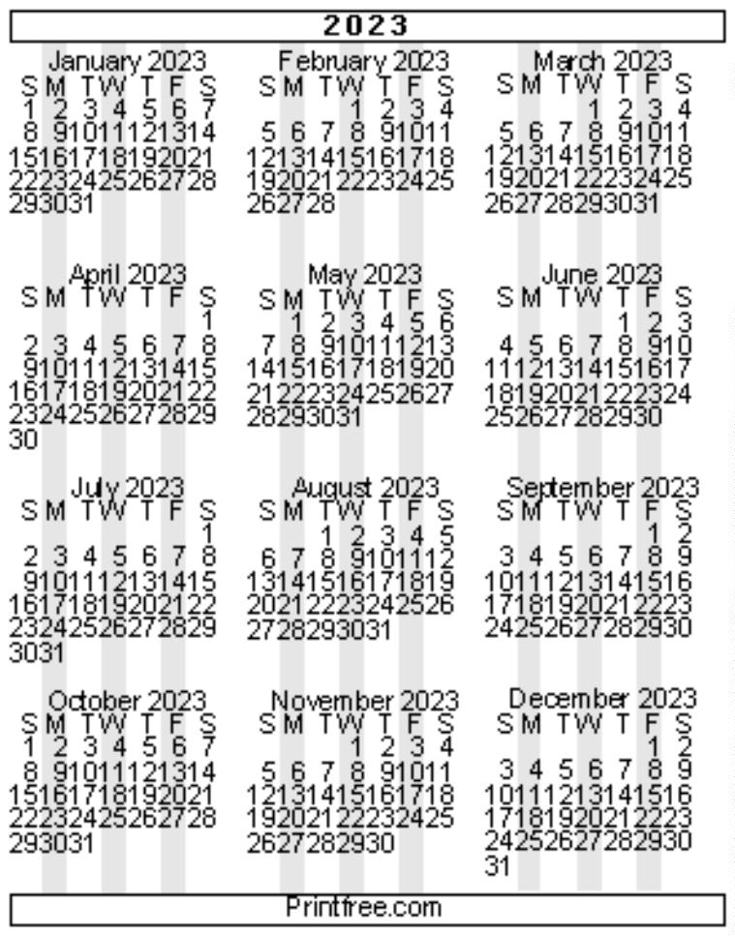

3
8
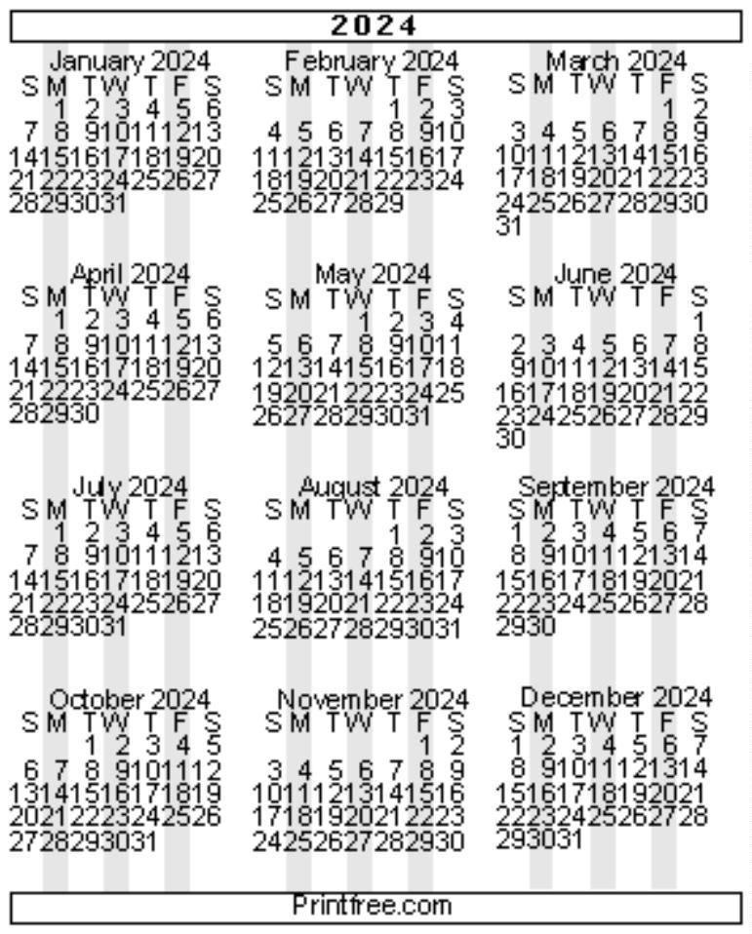

NOTES
3
9

NOTES
4
0

