AMERICANISM
Consolidated Report—2019
Report for (check one) Voiture Locale # du or Total Membership

Date Prepared / / Grande Voiture du Total Membership Directeur’s Name Telephone ( ) ‐
Address City/St/Zip

GRANDE ONLY: Outstanding Locale "Flags For First Graders" is Outstanding Locale is Attach Locale Reports
Locale Mail to: Grand Voiture Directeur Grand Directeur Mail to: (REPORT DUE JULY 15, 2019)
Dan Evers, 1850 Walker Rd NE, Salem, OR 97305

ACTUAL | ACTUAL | ACTUAL | CATEGORY
AMERICANISM AWARDS
School, High School, College, Jr. ROTC, Sr. ROTC,Community Organizations, Citizens
(Private), Fire Prevention, Law Enforcement, Others
AMERICANISM SPEECHES AND FLAG ACTIVITIES
Flag presentations, Flag raising ceremonies, Flag retirement ceremonies
YOUTH ACTIVITIES
Band support, Baseball, Boys and Girls State, Oratorical Contests, Scouting (Boy, Girl, Cub), Valley Forge Freedom Foundation, Child ID Programs,
Driver Training, FFA, 4H, PTA, etc.
COMMUNITY ACTIVITIES
Blood donor, Community Services, Get out the Vote, National Security, Political Action, Senior Citizens, Hunter Safety Programs, Poppy Sales, Special Olympics Meetings/Promenades/Wrecks, Activities in other Fraternal Organizations
HOLIDAYS AND MEMORIALS
Calvin Kain Memorial Service, Grave Decoration, Memorial Day, Memorial Ser- vices: funerals, memorial dedications, Parade participation, patriotic events, installations, Veterans Day
VETERANS
Veterans Home Activities, Transportation to Hospitals/Doctors, Veterans Employment
 |  |  | FLAGS FOR FIRST GRADERS PROGRAM
 |  |  | Number of Schools where Flags were distributed: |  |  |  | Total Number of Flags:
hrs. |  |  | A. $ | Total Hours x $5.00  Total Miles x $.50 ($1.00 for locomotive) Total Cash Spent
 | mi. |  | B. $
 |  | $ | C. $

TOTAL CASH AND SERVICES (A + B + C)
$

PER CAPITA (Total Cash divided by membership)
$

Americanism Award Guidelines

The Americanism Award is a very prestigious award given to an individual who meets the following guidelines. The person who is selected is expected to attend Promenade Nationale and be a keynote speaker at the official functions.
- Involved in an “Americanism” type program on a National or very broad regional scale
- Involved in improving the general conditions of and for Veterans should be considered, but not necessary (there are many community programs that are larger scale and touch all walks of life)
- Need not be a veteran to be eligible, but should be an American citizen either born or Naturalized
- Non-Pay status strictly volunteer work
- No political reflections, influence or ramifications
- Able to attend Promenade Nationale
- Members of La Societe should not be considered for the Americanism Award based on personal actions or office performance involving the 40&8
- If the person is a member of the 40&8 the fact should be downplayed or mentioned only in a passing manner

Recommendations for award should be submitted to Nationale Americanism Directeur no later than June 1. Nationale Directeur Americanism submits the recommended recipient’s file to the Correspondant National by June 10. Recommendations should be accompanied by:

Letters of Recommendation
  - Grande Directeur Americanism
  - Voiture Locale
  - Person making recommendation
- Biography of candidate
- Subjects Program with complete description of the way and degree the person is involved. This should include:
  - Photographs
  - Newspaper articles
  - Letters of recommendations from locale organizations and individuals
  - Demographics of numbers of people involved and monies spent, etc
- Press ready photo for publication in the 40&8er if selected

Note! The package should be assembled in the above stated order in a binder of your choice. It is recommended that you use this document as a check list to insure you do not omit any items

Dan Evers, Nationale Directeur Americanism 1850 Walker Rd NE
Salem, OR 97305
(503) 981-1470 Home
legionpost46@q.com

CARVILLE STAR
Annual Report

Grande Voiture du Date

Voiture Locale Membership Total:

1. Total number of pins sold @ $3.00 each | $
2. Total dollar amount for Star subscriptions purchased | $
3. Total number of Buy‐A‐County purchased x $50.00 | $
4. Total number of Buy‐A‐Clinic purchased x $50.00 | $
5. Total dollars donated to the Carville Star Museum | $
6. Total dollar amount donated to the Carville Star General Fund | $
(Please note what program fund, i.e., monument, special project, etc.)  7. Total amount donated to Carville Star Equipment Fund | $

(Equipment Fund is used to update computers and copiers)
- Money spent in the performance of you Carville Star duties $
- Total number of hours spent on the program x $5.00 $
- Total number of miles traveled (POV) x $.50 $

TOTAL DOLLAR AMOUNT (add items 1‐10) $

Submitted by: Name Address City/State/ZIP Phone E‐mail Signature

CHILD WELFARE
Report Form Instructions— 2019

WHO REPORTS: Negative reports are required. Each Voiture Locale in La Societe des 40 Hommes et 8 Chevaux must submit a report, even if just to indicate number of members and the $ .25 per member from each Voyageur’s dues which is earmarked for the C. W. Ardery Trust Fund.

FORM TO BE USED: Voiture Locale and Grande Voiture Directeurs will use the same form; Voiture Locale Directeurs should check the block in front of Voiture Locale and show your Voiture #, Grande Voiture and membership, and then forward com‐ pleted report to YOUR GRAND DIRECTEUR, CHILD WELFARE by the deadline established by your Grande Voiture. Please try to be as accurate as possible (estimate value, if necessary, within reason).

The Grand Directeur of Child Welfare will collect all reports, consolidate on this same form, check the block in front of the Grande Voiture du (place name of Grande Voiture here), and indicate Grande Voiture membership as of July 31st, and then forward to the National Directeur by August 1th.

Item “A”: For any money that was spent on Child Welfare. Please do not list cash spent that was reimbursed to your Voiture from the Charles W. Ardery Trust Fund. You may, however, tabulate and take credit for time and mileage involved in such cas‐ es.

Item “B”: “Other than cash” For any assistance and services rendered where other than cash was spent for such items as used clothing, toys, etc., please place a reasonable dollar value on such items and be sure to take credit for any mileage and time spent for this category.

Supplemental Reports: Please give any additional facts and figures on separate sheet and attach to this report form for activi‐ ties not listed on other side of this report form. Examples could be: Youth to Washington, D. C., an overseas school project where funds were given, providing Pledge of Allegiance banners for school classrooms, Easter Egg Hunts, etc. Record totals of all supplemental activities in Items 8 & 11, Other.

Special Note: Please also remember, as a member of the American Legion, Masonic Lodge, Knights of Columbus, Lions, Elks, Fire Department, School Boards, etc. Voyageurs may and are encouraged to take credit for all activities within these various organizations where you have dealt with Children & Youth Programs, and include monies, mileage, and time spent on your re‐ ports.
It is the submitting individual’s responsibility to add all items and complete the form.

Awards
At Promenade Nationale each year, the National Child Welfare Committee meets to judge entries for awards. It is recommend‐ ed (but not required) that those Voiture Locales and/or Grande Voiture Directeurs who wish to enter their report for competi‐ tion, prepare a binder or note book (similar to the typical Voiture or Grande History Book) containing photos of events, newspaper clippings or articles, copies of cancelled checks, copies of Voiture or Grande Newsletters, etc. to substantiate the work accomplished throughout the year, and submit along with this form (Locales to Grand Directeurs and Grand Directeurs to National Directeur).

John T. Digilio, Jr. Award
Awarded to the Grande Voiture with membership of 1 to 299 that performed the greatest service to La Societe in the Child Wel‐ fare program. A plaque is given to 1st place with honorable mention to 2nd place.

N. Carl Neilson Award
Awarded to the Grande Voiture with membership of 300 - + that performed the greatest service to La Societe in the Child Welfare Progam. A plaque is given to 1st place with honorable mention to 2nd place.

Charles W. Ardery, Jr. Award
Honorary Chef de Chemin de Fer Award to the Best Locale that performed the greatest service to La Societe in the Child Wel‐ fare Program. A plaque is given to 1st place with honorable mention to 2nd place.

Date Prepared

CHILD WELFARE

Consolidated Report 2019

Report for (check one) Voiture Locale # du
Grande Voiture du Directeur’s Name
Total Membership Total Membership Telephone

Address

Mail Voiture Locale Report to: Mail Grande Voiture Report to: Grande Voiture Only
Grand Directeur Child Welfare National Directeur , Child Welfare Program # of Locales Reporting
Joseph R Donovan
4660 N River Rd Spc 12 Outstanding Locale #
Oceanside CA 92057-5879 (Please attach report & supporting Jdonovan4660@hotmail.com documentation)
FAX 760-721-0339
DEADLINE: DEADLINE: July 15, 2019

- Activities for which Cash was donated # of Children Cash Spent
  - Direct money assistance to children and families.
  - Food, Clothing, Rent, and/or Fuel.

  - Health care (medical, dental, surgical, hospital, etc.

  - Parties, toys, gifts, etc.

  - Participation in Boys State, Girls State, other Programs involving children.

  - Donations – Salvation Army, health care & other charities with services for children.

  - Flags for first Graders.

8. Sports organizations (AAU, Little League,
etc).
- Activities in state training schools.

- Other.

SUB-T OTAL A

- Assistance and Services Rendered in Other than Cash # of Children Cash Spent
  - For Medical, Surgical, Dental, or Hospital Services etc.
  - For Food, Clothing, Rent or Fuel.

  - For School Lunches or other Feeding Services.

  - For Parties and Entertainment.

  - For Toys, Gifts, etc. (Christmas and other Holidays).

6. For Services for Children in Facilities including Hospitals, State Training Schools, Nursing Homes, Probation Placement, etc.
- For Transportation (Children to and from Clinics, Immunization Centers, Hospitals, etc.)

- Other.

SUB-T OTAL B

- Other Items TOTALS
# Children $ Spent

Mileage in support of Programs = @ $ .50/mile Rolling Stock Mileage in support of Program= @ $ 1.00/mile Man-Hours in Support of Programs = @ $ 5.00/hr # Child Welfare Pins Sold = @ $ 3.00/each Direct Donations to CW Program = # of Current Voyageurs = @ $ .25/Voy
SUB-TOTAL A _ SUB-TOTAL B _ SUB-TOTAL C

T OTAL

Total $ of LaFemmes Child Welfare NOTE: Deadline for Grande Voiture Reports to National Directeur Child Program Activities (Cabane Locale or Grande Cabane) Welfare is July 15, 2019 >>>>ONLY Grande Voiture Reports are
to be sent to National Dir
CW Rpt 2018 Rev 12/17

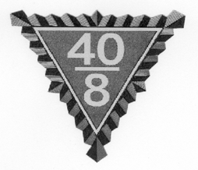
HISTORIEN
Grande Voiture & Voiture Locale
History Book & Scrapbook Contest Rules
1, Voitures Locale are to submit their History Book or Scrapbook to their Grande Historien for judging by the Grande. Only the First Place Winners for Locale, one History Book and one Scrapbook from each Grande will be accepted for competition by Nationale. They should be delivered to Nationale prior to the Historiens’ Meeting for Judging. The Locale History Book & Scrapbook must be accompanied by the Certification Form filled out by their Grande. If there is no Certification Form accompanying the Locale’s book, they will be disqualified.

- The Grande History Book and Scrapbook do not need a Certification Form, as the next level for them is Nationale.
- All Locale Books and Grande Books require a Title Page that looks like the following:

**********************************************TITLE PAGE FOR LOCALE******************************************* Voiture Locale History Format
History Book (or Scrapbook) of
Voiture Locale No.
County, Grande du/de

From (Month) of 20 to (Month) of 20

By:
(Person compiling History Book or Scrapbook)

Title:

*************************************************TITLE PAGE FOR GRANDE******************************************** Grande History Format
History Book (or Scrapbook) Of
Grande Voiture du/de

From (Month) of 20 to (Month) of 20

Grande Chef de Gare

Grande Historien

- History Books require a Table of Contents, Scrapbooks do not.
- History Books and Scrapbooks require Alphabetical Indexing. Scrapbooks only require a list of activities and on which pages they can be found (to make them easier to find for judging). The alphabetical indexing is located at the end of he History Book or Scrapbook.
- History Books require a Forward that must include a brief statement on the formation of the 40 et 8 as well as a tie- in statement about the formations of the Voiture Locale.
- Reporting period is for the year’s activities and should coincide with their Grande. (Starting and ending with their Grande Promenade.)
- Physical size should be a maximum of 12 by 14 1/2 ins. and have a substantial hard cover. (Books are available from American Legion Headquarters, P.O. Box 1055, Indianapolis, IN 46206
- Identifying captions must be used with all clippings, photographs, and items listing occasion, source, dates, func- tions and names identifying the subject matter.

HISTORIEN
Grande Voiture & Voiture Locale
History Book & Scrapbook Contest Rules
10, Voiture Activity theme is suggested, as the scrapbook history should relate the various activities conducted during the year. Accuracy is most important.
- Arrangement may be either chronological or by the various programs of La Societé. Systematic and logical arrange ment should be sought. The reader must be able to follow the meaning of the illustrations (pictures, etc.) with very little difficulty or confusion.
- Judges will be members of the Forty and Eight Historiens’ Asscoiation selected at Nationale. They will select three
(3) Voiture Locale Histories, three (3) Voiture Scrapbooks and three (3) Grande Voiture Histories as winners.
- Rating Criteria: Cover-5 points; Clearness-5 points; Arrangement-10 points; Table of Contents-10 points; POW/MIA- 10 points; Americanism-10 points; Child Welfare-10 points; Nurses Training-10 points; Carville Star-10points; Youth Sports-10 points; Number of Activities-10 points.
- Name and address of Voiture Locale Historien to be on the inside cover, lower left hand corner. This book will be returned to the name and address of the person whose name appears inside the cover of the book or may be picked up by your Voiture or Grande at Nationale after judging.

Locale
1st Place Locale History Book-First Place Plaque 2nd Place Locale History Book-Runner-up Plaque 3rd Place Locale History Book–Plaque
Ist Place Locale Scrapbook-First Place Plaque 2nd Place Locale Scrapbook-Runner-up Plaque 3rd Place Locale Scrapbook-Plaque

AWARDS

Grande
1st Place Grande History Book-First Place Plaque 2nd Place Grande History Book-Runner-up Plaque 3rd Place Grande History Book-Plaque

40 & 8 News Media Awards 40&8 Staff Writer Awards

Final selection is made by the Nationale Forty and Eight Historiens Association, whose decision is final.

NOTE: Cross out either History Book or Scrapbook, whichever applies.

Certification Form

Voiture Locale History Book or Scrapbook Contest

Voiture Locale # . Grande Voiture du/de

Submitted by: Historien Number of Volumes

Grande Voiture Certification

Grande Voiture du/de certifies that this entry participated in and was awarded First Place in theVoiture Locale History Book or Scrapbook Contest held at the Grande.

Grande Voiture Certification Officer Phone

Street Address———————————————-City/State/ZIP

Date of Grade Certification Date Received HQ

Membership and participation in the Forty and Eight Historiens Association is encouraged, but is not required as a pre- requisite for contest participation.

2019 DUES NOTICE FORM

2017
2019

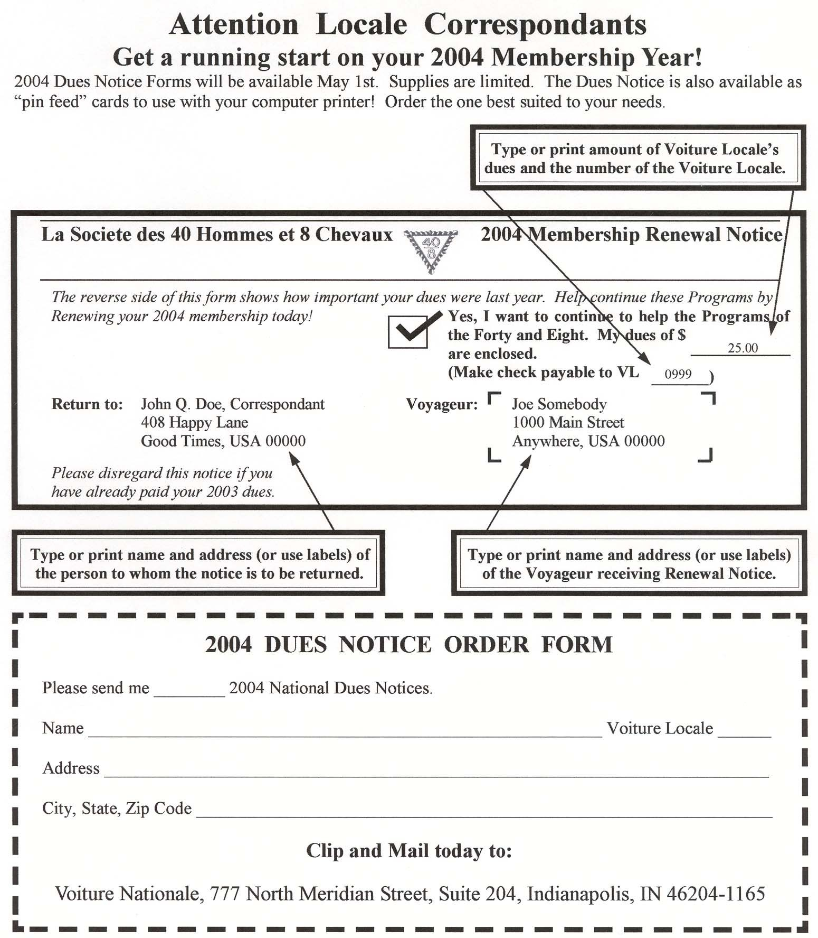

2019

2019

2019 dues

2019

2019

Voiture Nationale, 250 E 38th Street, Indianapolis, IN 46205

ss

Nurses Training Consolidation Report Grande/Locale
Nurses Training Consolidation Report

Locale V-
Grande du
of Grande

Date Prepared

N.T. Directeur:
Reporting Period August 1 2018 to July 31, 2019 >Excel File<

Total Membership 0

City:

Telephone: Address:

E-Mail:
E-Mail/Mail to Nurses Training Directeur Ernest Lane jr - elanejr3688@gmail.com Address: 4286 So. Reindeer Court - Gilbert ,AZ 85297

N.T. Voiture Expenses Reporting Calculations

Annual
Expenses | (Input)
Car Miles Travel |  | 0 | ($.50/mile) |  |  |  | $0.00
Man-Hours |  | 0 | ($5/Hr.) |  |  |  | $0.00
Loco Miles |  | 0 | ($1/Mile) |  |  |  | $0.00
Administrative Expenses |  |  |  |  | (Input)
Ex Phone calls, Pins & Stamps |  |  |  |  | $0.00
Total Expenses Reporting |  |  |  |  |  |  | $0.00

 | Current Nurse Training Scholarship results | (input) | (input)
Total | Dollar expended in Nursing scholarship this year |  | $0.00
Total | Number of scholarships this year | 0
 | Current Program Yearly results
Total | No. of Student in your Nurse Training program | 0
 | (add one Nurse for each $300 Donated to Boland Trust Fund) | 0
Total | This year RN's Graduates in your program | 0
Total | Dollars Donated to the Boland Trust Fund |  | $0.00
Total | Dollars expended in Nurse Training this year |  |  | $0.00
Per Capita Investments
List all activities at the Grande, Locale and Communities events Accompli Index

#DIV/0!

Attested By

Grande/Locale Correspondant Grande/Locale Nurse Training Directeur
Locale Deadline: July 15 Grande Deadline: Aug1 App. Doc. 9/19/2019

POW/MIA
2019 Consolidated Report

Date Prepared / /
Report for (check one) Voiture Locale # du

Total Membership

Grande Voiture du Total Membership

Directeur’s Name
Telephone ( ) ‐

Address City/St/Zip

PLEASE COLLECT THE FOLLOWING DATA:

1. Total Man Hours………… .................@ $5.00 per hour… $
(Include all hours of travel, computer time, phone time, etc.)

2. Total Mileage…………….. .................@$.50 per mile… $
Include all travel to promenades, post oﬃce, lectures, etc.)

  - Actual Expenditures… $
(Postage, printing, fuel, room & meals, long distance charges, donations, etc.)

  - ACCRUED TOTALS… $
(Although expenses are not reimbursable, they are tax deductible. Keep all receipts for your records.)

  - Activities
(List all activities a1ended at the Grande, Locale and Nationale levels, fund raising events, etc.)

LOCALE DEADLINE: July 1st GRANDE DEADLINE: July 15st
1317 Mulberry Ct
Greenfield, IN 46140
anthonycross8511@yahoo.com
Tony D. Cross
Mail Consolidated Grande Reports to:

PUBLIC RELATIONS
Annual Report

Date of Report: Reporting Period: October 1, 2018 to September 1, 2019
Report type: Check ( ) for Locale Report: Voiture Locale # , Grande du
Report type: Check ( ) for Grande Report: Grande Voiture du
Submitting PR Directeur: Phone: ( )

Address: City: _ State:
E-mail:
ZIP:

Locale Directeur: Mail report to your Grand Public Relations Directeur no later than July 1st.
IMPORTANT NOTICE
Reports to National Directeur must be postmarked not later than September 1, 2019
(Or as assigned by Grand Directeur)
Grande Directeur: Mail reports to: Robert Cearlock, Directeur Public Relations
P.O. Box 1782
Mt. Vernon, IL 47022
1-618-244-5761 E-mail: cearlock@aol.com

Part 1- Grande Voitures  Does your Grande have a Grand PR Directeur? | Yes | No
Is your Grande listed in the National Public Relations submittal report?
Does your Grande have an active* website? {Must be updated within every 30 days to be active}
Does your Grande have a Newsletter or Newspaper?
Has a Grande representative appeared on TV or Radio representing the 40/8 this year?
Part 2- Locale Voitures  Does your Locale have a PR Directeur? | Yes | No
Is your Locale listed in the National Public Relations submittal report?
Does your Locale have an active* website? {Must be updated within every 30 days to be active}
Does your Locale have a Newsletter or Newspaper?
Has a Locale representative appeared on TV or Radio representing the 40/8 this year?
E-MAIL ADDRESS FOR POINT OF CONTACT FOR YOUR LOCALE/GRANDE:
 | Please print

RITUAL
Consolidated Report—2019—Locale

Voiture Number, County, Grande Date

This Form is to be filled out by Voiture Locales only!

Voyageurs in Voiture Locale……………………………….. Total Number

Promenade opened and closed by the Ritual? ……………….. Yes No Calvin Kain Memorial Service conducted by Voiture Locale? .. Yes No
Does Voiture Locale have a Wrecking Crew… Yes No No. of Voyageurs

Number of active wrecks by your Voiture Number of PG’s wrecked

Number of formal wrecks performed by Voiture Number of PG’s wrecked

Number of funerals attended by Voiture Locale Number of Voyageurs present

Number of memorial services attended by Locale Number of Voyageurs present

Does Locale have a color guard? ……..Yes No Number of Voyageurs

Does your Voiture have an Honor Guard…. Yes No Number of Voyageurs

Did Voiture Locale participate in National Color Guard competition? Yes No

Ritual “3M” Report (Man hours‐Miles‐Money)

Number of Ritual related hours devoted to 40 & 8 work………… Total

Number of Ritual related miles devoted to 40 & 8 work ………… Total

Amount of Ritual money spent or claimed……………………….. Total
(Out of pocket/Commissaire Intendant expenses only. Do not include hours or miles dollar values)

(List any other comments on the reverse of this form)

If your Voiture Locale wishes to be considered for the Joel A. Bunch Award, awarded by Voiture Nationale
to the Voiture Locale displaying the highest degree of Ritual performance excellence, it must be submitted on a separate piece of paper. (List your qualifications and comments on the Grande Continuation Report Form)

Prepared by:
Forward Report to Grand Directeur of Ritual and Grand Correspondant
no later than July 10, 2019
Voiture Locale Directeur or Correspondant

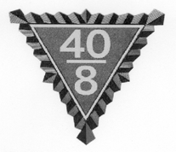
15
RITUAL
Joel A. Bunch Award Nominee (Locale Continuation Sheet)

Voiture Locale to be considered for the Joel A. Bunch Award, awarded by Voiture Nationale to the Voiture Locale displaying the highest degree of Ritual performance excellence. (Voiture Locale Report attached.)
Voiture Locale Name and Number County Qualifications, comments and recommendations for the Joel A. Bunch Award (for legibility, please type).
(Use additional sheets of plain paper, if necessary.).

Prepared by: Title:
Recommended by:  Grand Chef de Gare | Grand Directeurs must forward this report to: Walter Ciokajlo Jr., National Ritual Directeur 135 Newporrt Ct  Elyria, OH 44035  DEADLINE: July 23, 2019

RITUAL
Consolidated Report—2019—Grande

Grande Voiture du Date

Total Number of Voiture Locales in Grande Total Number of Voyageurs in Grande

Total Number of Voiture Locales Submitting Reports

How Many Voiture Locales

Opened and Closed Promenades by the Ritual…

Conducted Calvin Kain Memorial Service…

Have Wrecking Crews……………………………….. Number of Voyageurs Participating

Performed Active Wrecks……………………………. Number of PGs Wrecked

Performed Formal Wrecks………………………….... Number of PGs Wrecked

Number of Veterans Funerals Attended…………….... Number of Voyageurs Present

Number of Veterans Memorial Services Attended …... Number of Voyageurs Present

Have Color Guards…………………………………… Number of Voyageurs Participating

Have Honor Guards… Number of Voyageurs Participating

Ritual “3M” Report (Man Hours — Miles — Money)

Total Number of Ritual Related Hours Devoted to 40 & 8 Work…

Total Number of Ritual Related Miles Devoted to 40 & 8 Work…

Total Amount of Ritual Moneys Spent or Claimed…
(Out‐of‐pocket/Commissaire Intendant expenses only. Do not include hours or miles dollar values)

A. Voiture Locale to be considered for the Sam Friedman Award, awarded to the Voiture Locale conducting the greatest number of Wrecks during the reporting year just ending. (Voiture Locale Report attached.)

Voiture Locale Name and Number County

Number of Active Wrecks Performed…
Number of Formal Wrecks Performed…
Number of PGs Wrecked Number of PGs Wrecked

Nationale Color Guard Competition
Please print

Grand Voiture du

Locale Voiture #

Captain of Color Guard Sign your name Date

Please be advised that your unit should be at the designated area for competition at less (1/2) half hour before the competition begins.

Also I need this form turned into me no later than July 23, 2019

Proposed Password change
please print

New
Password

French Password

Meaning

Submitted by

Grand Voiture

Locale Voiture

Date

Do not write below this line

Approved at Nationale Yes No

Nationale Ritual Directeur

These Special Awards pages are instructions for submitting nomination packets for competition. The third page is also to be used for end of year reports from both Locale and Grande. Special Awards is one of the “newer” programs. Each Voiture Locale should appoint a Spe- cial Awards Program Chairman. That Chairman should contact his/her Grande Directeur for current and pertinent information.
If no one is appointed to do the job, it falls back on the Chef de Gare and/or Correspondant to get it done or, in so many cases, it doesn’t get done. If it doesn’t get done, it isn’t fair to your Voiture and the voyageurs associated with it. It also isn’t fair to potential candidates for these awards. They deserve better.
There is a lot of satisfaction in giving out these awards. The pride in the eyes of the recipient will make you a believer when you pre- sent them an award. The presentation can be made at your regular Promenade, a special meeting or a dinner meeting is even nicer. Contact the media to get some publicity for the recipient. He or she will enjoy this and believe it or not, it will acquaint the public with La Societe also. You can promote your other programs at this same time. Your Voiture will appreciate this publicity the next time they are raising funds for their pro- grams. If people have heard of you, it is a lot easier to sell tickets and other fund raising items.
SPECIAL AWARDS
Where to Start? - 2019
VOYAGEUR OF THE YEAR CITY OR TOWN OF THE YEAR
HERO OF THE YEAR
LAW OFFICER OF THE YEAR
The Nomination Form is designed so it can be used for any of the four awards. A separate nomination form must be submitted for each award; for instance, one form for Hero; one form for Voyageur; etc. The top part of the Nomination Form is to be completed by the Locale. The bottom is used for reporting to Nationale Special Awards. All nominations to Nationale must go through the Grande Voiture and be accompanied by a Par- ticipation Reporting Form (found on page 19 in this booklet) signed by the Grand Correspondant.
The submission process starts with the Voiture Locale submitting their nominations to their Grande Voiture by June 1st or a date set by the Grande. The Voiture Locale’s nominations must be accompanied by the Participation Reporting Form completed with all requested information (top part pf page 19). The Grande Voiture then selects a winner to send to the National Sous Directeur Special Awards judge for that category. The selected winner is usually honored by the Grande Voiture at one of its Grande functions, such as a Grande Promenade or Grande Cheminot meet- ing. These winning Grande Voiture nomination packets must be received by the designated National judges no later than July 1st. The bottom part of page 19 must be completed with all requested information and signed by the Grand Correspondant.
Year 2019

- Your Grand Hero of the Year nomination is to be sent to Sous Directeur National Special Awards Ron Pfalzgraf, 625 Oak Lane, Horicon, WI 53032 and Dale Oatman, 405 E 10th Ave, Antigo, WI 54409.
- Your Grand Law Officer of the Year nomination is to be sent to Sous Directeur National Special Awards, Glenn Seymour, P O Box #4, Feeding Hills, MA 01030
- Your Grand Voyageur of the year nomination is to be sent to Sous Directeur National Special Awards D. R. Richards,
2811 Timbercreek Trail, Valdosta, GA 31605
- Your Grand City/Town of the Year nomination is to be sent to Sous Directeur National Special Awards James Carpenter, 15750 Arroyo Dr. #1, Moorpark, CA 93021
General Guidelines for Special Awards
- Each Voiture Locale may enter only one (1) candidate for each of the four awards. Likewise, Grande Voitures may enter one candidate for each of the four awards. All nominations to Nationale must come through the Grande Voiture and must be accompanied by a Participation Reporting Form from the Grande Voiture. A nomination without a Participation Reporting Form is considered incomplete and will not be judged.
- All entries must be made on the form approved by Voiture Nationale. All nominations must be typewritten or legibly printed.
- All documentation is to be attached to, or included with, the Official Nomination Form (page 18). Documentation includes, but is not limited to, a biography newspaper clippings, radio/TV transcripts, magazine articles, letters of commendation, etc. It is suggested, but not required, that two color photos (one 8 x 10 and one 3 x 5) accompany the nomination. In any event, photos will be required within a few days of the individual’s selection as a Nationale winner. These are for the article in
the Forty and Eighter magazine.
- All candidates must live or be involved in the jurisdiction of the Grande Voiture.
- All Grande Voiture nomination “packets” must be received by the appropriate National Sous Directeur of Special Awards judge by July 1st. “Packets” received late cannot be judged as there is no time to spare to get everything done for the Forty and Eighter Magazine deadline and Promenade Nationale.

SPECIAL AWARDS
Official Nomination Form—2019

For:
Hero of the Year
Law Officer of the Year City/Voyageur of the Year

Make a separate Official Nomination Form for each Award you are submitting and “X” one of the above. Date
Candidate’s Name:
Complete Mailing Address:

Telephone
If Candidate is for Law Officer give Position: and Employer: Brief description of why this nominee deserves this Award: (Attach a second sheet if necessary) Please attach (or include) all documentation to this form.

Can candidate attend Grande and Nationale Promenades if selected and requested? Yes No Submitted by: Title:
Voiture Locale # Grande Voiture de
Voiture Locale is to complete all of the above and by June 1 send to Grand Directeur Special Awards or Grand Correspondant if Grande does not have a Special Awards Directeur. Application must include Locale’s Participation Report (Page 19).

+ + + + + + + + + + + + + + + + + + + + + + + + + + + + + + + + + + + + + + + + + + + + + +
Grande Voiture is to complete all below and send to the designated Sous Directeur National Special Awards judge. Nomination packets must be received by July 1st. La te packets will not be conside red. Current names and addresses may be found in the Octo- ber issue of the Forty & Eighter Magazine.

This certifies that the above has been selected as the of the Year for the Grande Voiture du .
Grand Directeur Special Awards
Grand Correspondant

THE GENERAL’S CLUB
The funding for the Nationale Special Awards Programs is the General’s Club. Contact any of the members of the Special Awards Committee, current General’s Club members (r ecognized by the fi ve star pin they wear) or Nationale Headquarters, for how to join. The General’s Club is a worthwhile club to which you will be pr oud to belong and wear the five star pin. An added bonus is the Genera l’s Brunch which is held on Friday morning at Promenade Nationale. Watch for information in the Forty and Eighter!

SPECIAL AWARDS
Participation Reporting Form-2019

LOCALE REPORT
LOCALE REPORT
Date of report:_____________ Voiture _________ Membership __________ Grande_________
Submitted Candidate for Hero of the Year to Grande ___Yes No
Submitted Candidate for Law Officer of the Year to Grande ___Yes No
Submitted Candidate for Voyageur of the Year to Grande ___Yes No
Submitted City of Town of the Year to Grande ___Yes No
Homme Hours______ x $5.00 equals $_______ Miles Traveled $0.50 equals $______
Actual Cash Expended $___________ Total $ ($ Hours + $Miles + Actual Cash)
Person responsible for submitting report _.

Signature of Locale Correspondant _.

Voiture Locale: X “ box”, complete all above and send to Grand Directeur Special Awards or Grand Correspondant by June 1st each year. If sending in a Candidate attach to Nomination Report.
+ + + + + + + + + + + ++ + + + + + + + + + + + + + + + + + + + + + + + + + + + + + + + + + + + + + + + + +
Grande Voiture: X “box” below and complete all below. A copy of the below report must accompany all nominations for Special Awards. as shown on the Official Nomination Form.

GRANDE REPORT
Date of Report___________(Deadline is July 1st) Grande Submitting Report ______________
Submitted Candidate for Hero of the Year to Nationale ___Yes No
Candidate’s Name, Address, and Phone__________________
Submitted Candidate for Law Officer of the Year to Nationale___Yes No
Candidate’s Name, Address and Phone_________________________________________________________________
______________________________________________________________________________ Submitted Candidate for Voyageur of the Year to Nationale___Yes ___No
Candidate”s Name, and Address and Phone_______________________________________________________________________

__________________________________________________________________________________________________________ Submitted Candidate for City or Town of Year to Nationale___Yes ___No
City or Town Name______________________________________________________________
Membership of Grande_______________
Number of Locales in Grande (A)
Number of Locales Reporting __________(B) Percentage of Participation(B divided by A)___
Number of Locales submitting a Candidate______
Homme Hours_____X $5.00 = $_______ Miles _____X $0.50 = $_______
Actual Cash Expended $_______ Total $ (Hours +$Miles + Actual Cash)
Name, address and Phone and title of Grande Officer Submitting Report_________________________________________________

__________________________________________________________________________________________________________

Date of report: Submitted Candidates to Grande:
* Hero of the Year
Voiture

Yes No
Membership
Grande

- Law Officer of the Year Yes No
- Voyageur of the Year Yes No
- City or Town of the Year Yes No
Homme Hours x $5.00 equals $ Miles Traveled x $0.50 equals $
Actual Cash Expended $ ($ hours + $ miles + $ actual cash) = Total $
Person responsible for submitting report . Signature of Locale Correspondant .
Voiture Locale: X “ box”, complete all above and send to Grand Directeur Special Awards or Grand Correspondant by June 1st
each year. If sending in a Candidate attach to Nomination Report.

+ + + + + + + + + + + ++ + + + + + + + + + + + + + + + + + + + + + + + + + + + + + + + + + + + + + + + + +
Grande Voiture: X “box” below and complete all below. A copy of the below report must accompany all nominations for Special Awards, as shown on the Official Nomination Form.

GRANDE REPORT

Date of Report (Deadline is July 1st) Grande Submitting Report
Submitted Candidate for Hero of the Year to Nationale Yes No
Candidate’s Name, Address, and Phone Submitted Candidate for Law Officer of the Year to Nationale Yes No
Candidate’s Name, Address and phone
Submitted Candidate for Voyageur of the Year to Nationale Yes No
Candidate”s Name, and Address and Phone Submitted Candidate for City/Town of the Year to Nationale Yes No
City or Town Name Membership of Grande
Number of Locales in Grande (A)
Number of Locales Reporting (B) Percentage of Participation(B divided by A) Number of Locales submitting a Candidate
Homme Hours X $5.00 = $ Miles X $0.50 = $
Actual Cash Expended $ Total $ ($Hours +$Miles + $Actual Cash)= Total $
Name, address and phone # and title of Grande Officer Submitting Report

Signature of Grand Correspondant

IMPORTANT: Each nomination packet must include this form completely filled out and signed. If this form is omitted or incom- plete, the nomination packet will automatically be disqualified from Nationale Competition.

SPECIAL AWARDS
Nominations Guidelines—2019

Guidelines for Hero of the Year
The Hero of the Year award was adopted by La Societe during 1991. The purpose of the award is to recognize and pay tribute to a person who m, without hesitation or regard for their own safety, did demonstrate an unselfish desire to aid others. B y recognizing and respecting those who perform a heroic deed, we familiarize our community, state and nation with the programs of the 40 et 8.
In every Voiture’s co mmunity or state there are individuals w orthy of becoming a candidate for the Hero of the Year Award.
Don’t wait for another Voyageur to sponsor a candidate, for it may be too late and never happen.
  - A Grande Voiture may submit a candidate only once for a specific heroic deed.
  - The candidate need not be a veteran to be eligible. The candidate, however, must be living and over the age of 18.
  - The candidate’s “packet” must be received on or before July 1st by Sous Directeur National Special Awards judge
Ron Pfalzgraf, 625 Oak Lane, Horicon, WI 53032 and Dale Oatman, 405 E 10th Ave, Antigo, WI 54409.

Guidelines for Voyageur of the Year
The Voyageur of the Year was adopted by La Societe during 2001. The purpose of this award is to recognize and honor Voya- geurs who have performed outstanding service to La Societe. Each Voiture Locale shoul d honor a Voy ageur each year at one of their main Promenades. Our Voyageurs doing service for La Societe deserve to be recognized. This service can be for something done for a particular program (Nurses Training, Child Welfare, Americanism or any of our named programs or for La Societe in general (attending functions, setting examples and/or creating an atmosphere of camaraderie that will create a desire for one to be or become a Voyageur Militaire). There are many Voyageurs among us worthy of t his honor and should be recognized at all lev els-Locale, Grande and N a- tionale.
- A Grande Voiture may submit the same candidate only once in three years.
- A previous winner of the Nationale award cannot renominated.
- A candidate may live anywhere. His membership must be within the Grande Voiture submitting the candidate.
- It is not a requirement to hold or have held an office in La Societe, but must be living Voyageur in good standing.
- The candidate’s “packet” must be received on or before July 1st by Sous Directeur National Special Awards judge
D. R. Richards 2811 Timbercreek Trail, Valdosta, GA 31605

Guidelines for Law Officer of the Year
The Law officer of the Year a ward has been in existence for so me time and has been well received by the Me mbership. The purpose of this award is to recognize and pay tribute to a Law Enforcement Officer who has done an outstanding job of performing his or her duties at the level of his employment, both past and present.
Candidates for this award may be obtained by seeking recommendations from the agency chief executive (Superintendent, Sheriff, Chief, etc.) or directly by the Voiture Locale. The rules for selection are as follows:
- A Grande Voiture may submit the same candidate only once.
- At the time of entry, the candidate shall be a living, full-time Law Enforcement Officer (Local, County, State, Federal, Military, etc.). The candidate must reside within a nd/or perform his duties within y our Grande Voiture, b ut not neces sarily within the jurisdiction of the submitting Voiture Locale.
- The candidate need not be a veteran to be eligible for this award.
- It is not a prerequisite, although a favorable attribute, for any candidate to have accomplished an extraordinary feat to be eligible. It is the intent of the Program to recognize the Law Enforcement Officer who has performed their duties in an outstanding manner for a number of years, as well as their off-duty contributions to the community,
state and nation.
- The candidate’s “packet” must be received on or before July 1st by Sous Directeur National Special Awards judge,
Glenn Seymour, P O Box #4, Feeding Hills, MA 01030

Guidelines for City or Town of the Year
The City or Town of the Year was adopted by La Societe during 2001. The purpose of this award is to recognize and honor a City or Town which has and/or is doing something significant for veterans in that City or Town. There are many cities and towns that meet this requirement. These cities and towns should be recognized and given publicity at all levels-Locale, Grande and Nationale. This recognition, hopefully, will encourage other cities and towns to do more for Veterans. The rules for selection are as follows: 1. A Grande Voiture may submit the same candidate only once in three years.
- A previous winner of the Nationale Award cannot be renominated.
- The City or Town should be within the jurisdiction of the Grande Voiture.
- The candidate’s “packet” must be received on or before July 1st by Sous Directeur National Special Awards judge James Carpenter, 15750 Arroyo Dr. #1, Moorpark, CA 93021

VOITURE ACTIVITIES
Consolidated Report 2019

INSTRUCTIONS FOR COMPLETING YOUR 2019 VOITURE ACTIVITES REPORT
Forms are available at the Nationale Website: www.fortyandeight.org

LOCALE INSTRUCTIONS
List all events held throughout the year. Most of the activities are Listed on the Locale Report. List the number of Voyageurs attending each activity. Fill in the boxes under the different activities and add the columns for their totals. Dames should be listed under number of Voyageur. Use as many continuation sheets as necessary, remembering to carry all your totals to the front page. If the activity included rolling stock be sure to enter "yes", number of miles and dollars spent. Do not forget to include quests. Submit your completed report to your Grande Directeur by whatever deadline he established.

GRANDE INSTRUCTIONS

Once you have received all of your Locale Reports, do the formula, left of center (# of Voyagers participating divided by # of events, divided by total member’s equals and come up with a Grande Percentage participation. The column's right of center, (guest, $ spent, mileage, without rolling stock and with rolling stock) are for reporting at Nationale Promenade. Please be sure to send in the highest scoring Local report and also the highest scoring Locale with rolling stock reports with your Grande report.

There are three Nationale Awards for Voiture Activities, including:
  - Best Grande Program

Best Local
  - Best Locale with Rolling Stock

VOITURE ACTIVITIES 2019
Locale Report
VOITURE LOCALE GRANDE DU
TOTAL MEMBERSHIP REPORT FILED BY

Attend any Meetings, Proms, Wrecks, Picnics?

# OF VOYAGEURS GUEST $ SPENT MILES HRS ROLLING STOCK?

YES NO

Attend any activities concerning the Flag? (Presentations, Raising, Retirement or distribute to First Graders?

# OF VOYAGEUR GUEST $ SPENT MILES HRS ROLLING STOCK?

YES NO

Participate in any Memorial Services? (Funerals, Dedications, Color Guard, Rifle Squad, Grave Decorations)?

# OF VOYAGEURS GUEST $ SPENT MILES HRS ROLLING STOCK?

YES NO

Activities in any/or attended any school functions; be it Elementary, High School, College, ROTC Programs, Community Organizations (Elks, Eagles, Lions, Moose, Legion, Fire Prevention, Law Enforcement)

# OF VOYAGEURS GUEST $ SPENT MILES HRS ROLLING STOCK?

YES NO

Participate in parades (Color Guard, Marching Units, Riding)?

# OF VOYAGEURS GUEST $ SPENT MILES HRS ROLLING STOCK?

YES NO
6.

Any sport activities concerning the Youth? (Baseball, softball, Bowling, Basketball, T-Ball, Soccer) How many Youths participated?

# OF VOYAGEURS GUEST $ SPENT MILES HRS ROLLING STOCK?

YES NO

Other

# OF VOYAGEURS GUEST $ SPENT MILES HRS ROLLING STOCK?
YES NO
TOTALS # OF VOYAGEURS GUEST $ SPENT MILES HRS ROLLING STOCK?
YES NO

VOITURE ACTIVITIES 2019 Grande Report

GRAND DU
LOCALE
MEMBERSHIP

REPORT FILED BY
TITLE
ADDRESS
# OF
VOYA GER S TOTA L
P A R TIC IP A TIN N UM B ER M EM B ER G OF EVEN TS S
÷
÷
=
%

ALL THEABOVETOTALS TO BE ENTERED BELOW

GRAND TOTALS
STOCK
ROLLING
WITHOUT

GUEST
%
P A R TIC IP A TION

VOITUR E

COMBINED LOCAL REPORTS WITH & WITHOUT ROLLING STOCK

% OF AL COMBINED LOCAL REPORTS
WITH ROLLING STOCK

MILEAGE

$ SPENT

HRS

# OF EVEN TS

# OF VOYA GER S
Please submit your completed reports to the National Directeur-Voiture Activities with one copy to the Sous Directeur-Voiture Activities by July 25, 2019. Electronic submissions are fine. Also, submit your highest percentage of participation for a Locale without rolling stock and Locale with rolling stock. Submit by Mail or e-mail to:
Joseph Dolwig 1502 U.S. Hwy 52
New Richmond, OH 45157-9408 Submit by Email Print Form 513-553-6302 jdolwig132@gmail.com

V.A.V.S. & S.V.H.
Consolidated Report—2019

Report for (check one) Voiture Locale # du Total Membership Date Prepared / / Grande du Total Menbership Directeur’s Name Telephpone
Name of (Specify) VAVS or SVH Representative Name of (Specify) VAVS or SVH Deputy Representative Names of Other 40/8 Volunteers (includes La Femmes)

Name of person preparing this report (If not Grande Directeur)
Miles Traveled Money Spent
Number of VAVS or SVH Committee meetings attended Hours Miles Traveled Number of Veteran’s Advisory Committee Meetings attended Hours Miles Traveled Number of Junior Volunteers secured for your facility
SERVICES RENDERED
Hours
Escort Service………………………………………………………………………………………..
Pharmacy…………………………………………………………………………………………….
Feeding Patients……………………………………………………………………………………..
Filing…………………………………………………………………………………………………
Clerical Work………………………………………………………………………………………..
Serving Coﬀee……………………………………………………………………………………….
Using Bookmobile……………………………………………………………………………………
Information Desk…………………………………………………………………………………….
Salute to Veterans……………………………………………………………………………………
Decorating for Holidays……………………………………………………………………………..
Country Store………………………………………………………………………………………..
Other Services Rendered Special Occasions

Other:

TOTAL HOURS…………………………………………….
Mail Voiture Locale Report to: | Mail Grande Voiture Report to: | Grande Voiture Only
Grande Directeur, VAVS  Deadline: | Ronald W. Rolfes, Jr. National Directeur-VAVS 5450 Tropic Dr.  New Port Richey, FL 34653 E-Mail: rolfesr@hotmail.com Deadline: August 15th | Number of Locales Reporting:

V.A.V.S. & S.V.H.
Certification Form for Grande Voitures

Date:
Correspondant Nationale Voiture Nationale
250 E 38th Street
Indianapolis, IN 46205‐2644 Dear Sir,
The Grande Voiture du takes GREAT PLEASURE in submitting the:

NAME OF:

ADDRESS:

CITY, STATE, ZIP CODE:
EMAIL ADDRESS:

For Appointment as:
Representative Deputy Recertification

In VA Hospital/Clinic:

ADDRESS:

CITY, STATE, ZIP CODE:

Approved By:
Grand Chef de Gare / Grand Correspondant

NATIONAL YOUTH SPORTS
Report for Voiture Locale

For the period covering August 1, 2018 through July 31, 2019

Date of Report Locale # Grande du with Membership of

Cash Expended for Youth Sports Participation

Youth Sports Booster Cards, Pins, Merchandise Purchased $ Direct Donations to the Nationale/Grande Youth Sports Program Donations to Teams or Individuals
Other Cash Expenditures

TOTAL CASH SPENT AS LISTED ABOVE $

Assistance and Service Other than Cash

Miles driven for the Youth Sports Program . . . . . @ $ .50 mile $ Hours donated for the Youth Sports Program . . . @ $ 5.00 hour Other Assistance or Services Provided
TOTAL OF ASSISTANCE OTHER THAN CASH $

GRAND TOTAL OF ALL CONTRIBUTIONS FOR YOUTH SPORTS $

GRAND TOTAL OF ATHLETES ASSISTED
Name, Address and Telephone Number of the Name, Address, Telephone Number of Individual
Voyageur that performed the most work in support who prepared this Report: of the Youth Sports Program:

Name
Address
City, State, Zip Code
Telephone Number
E-Mail:
Name Address City, State, Zip Code Telephone Number E-mail: Locale #

Forward Report to Grand Directeur of Youth Sports and Grand Correspondant
no later than date established by your Grande Voiture

27
NATIONAL YOUTH SPORTS
Consolidated Report for Grande Voiture

For the year of August 1, 2018 through July 31, 2019

Date of Report Grande Voiture du with a Membership of

Cash Expended for Youth Sports Participation

Youth Sports Booster Cards, Pins, Merchandise Purchased $ Direct Donations to the Nationale/Grande Youth Sports Program Donations to Teams or Individuals
Other Cash Expenditures
Pocket change for Kids

TOTAL CASH SPENT/DONATED AS LISTED ABOVE $

Assistance and Service Other than Cash

Miles driven for the Youth Sports Program . . . . . @ $ .50 mile $ Hours donated for the Youth Sports Program . . . @ $ 5.00 hour Other Assistance or Services Provided
TOTAL OF ASSISTANCE OTHER THAN CASH $

GRAND TOTAL OF ALL CONTRIBUTIONS FOR YOUTH SPORTS $

GRAND TOTAL OF ATHLETES ASSISTED

* * * * * * * * * * * * * * * * * * * * * * * * * * * * * * * * * * * * * * * * * * * * * * * * *

Note: Please attach a copy of the best Voiture Locale Report to this report when you forward it to the National Directeur at the address below.

Individual who prepared this report:
Grand Directeurs must forward report to National Youth Sports Directeur Robert Kadow 6214 NW McKinley Dr, Vancouver, WA 98665 no later than August 15, 2019

Name

E-mail:

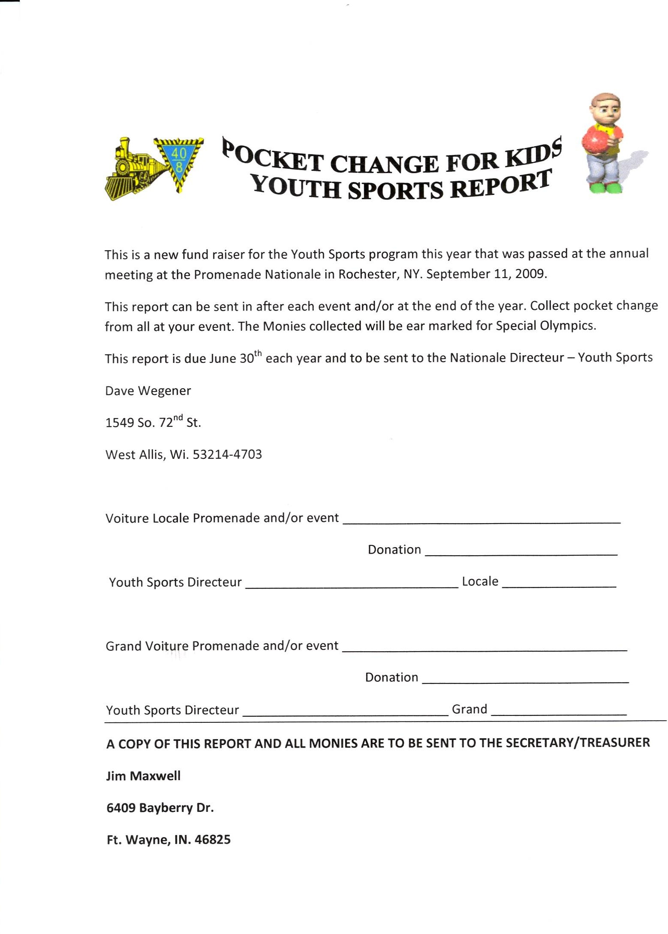

Robert Kadow
6214 NW McKinley Dr Vancouver, WA 98665

William "Bill" Simpson 204 Horseshoe Drive Goose Creek, SC 29445
wsimpson204@comcast.net

