

La Societe

des 40 Hommes et 8 Chevaux
Grande Voiture du Missouri



2026 – 2027

Directory

GRAND ROSTER

2026-2027



“Our Greatest Fun is Service”

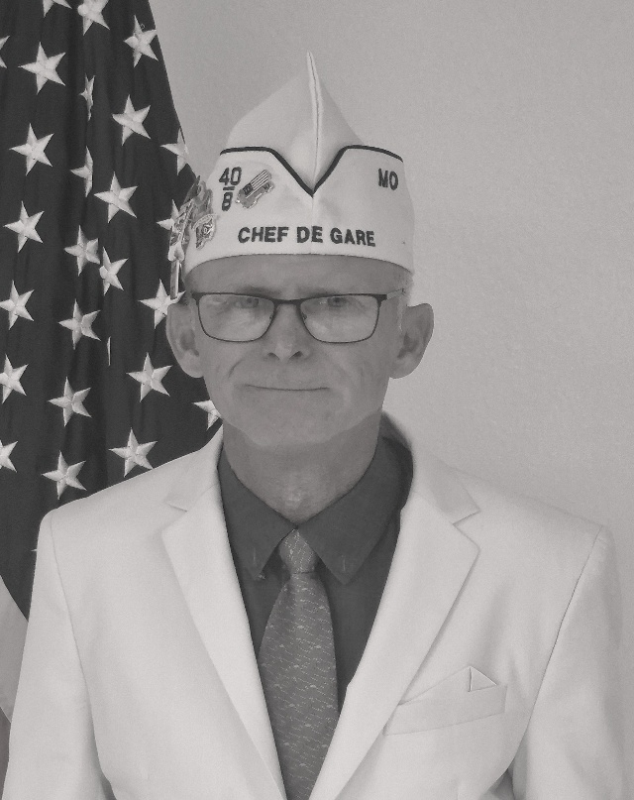
Ben Sargent
Grand Chef de Gare
2026 – 2027

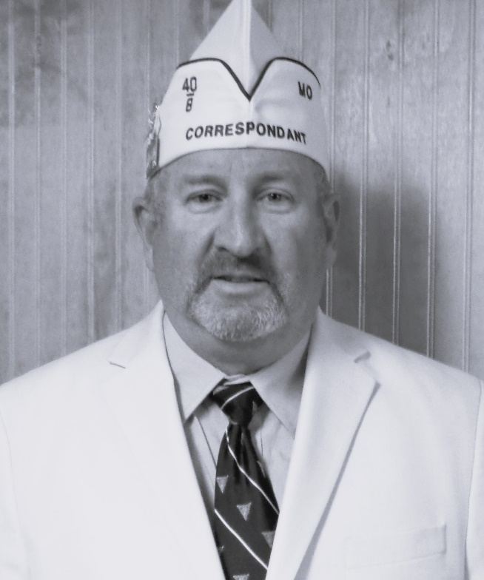
A.J. Noonan
Grand Correspondant
2026 – 2027
Preamble

For God and country we associate ourselves together for the following purposes: To create a charitable and non-profit veterans organization; to uphold and defend the Constitution of the United States of America; to assist and promote the welfare and well-being of those who have served or are now serving in the Armed Forces of the United States and their widows, widowers and orphans; to participate in all memorial services for and to be present at the funerals of departed comrades; to take part in and to encourage others to participate in the proper observance of all days honoring veterans; to preserve the memories of our Services in the Armed Forces of our Country; to actively participate within our membership in projects relating to (a) the welfare of the children of America; (b) the health of our Nation by fostering a nurses training program; and (c) selected charitable endeavors.

Catechism of an Homme

“I faithfully promise to obey the rules and regulations of La Societe, to remember my obligations, and to carry out the legal orders of the Chef de Gare. I believe, for the good of my country, that I should and will always hold the organization of La Societe in highest esteem, and will conduct myself in such a manner as to reflect credit upon it. It is my sincere desire, that the United States of America, be one country, with one language, and one flag, and, if necessary, I will fight for that principle.”

GRANDE VOITURE du MISSOURI
2026 - 2027 Directory

GRAND CHEF de GARE
Benjamin Sargent (460) Shelly
25625 Swan Road Res: 573-528-6110
Richland, MO 65556 msgsgt2@yahoo.com

GRAND CHEF de TRAIN
Forrest Johnson (1541)
535 Briar Meadow Ct. Res: 314-960-1027, Wentzville MO 63385 wolfdoctor@aol.com

GRAND COMMISSAIRE INTENDANT
Dan Levasseur (1292) Buffy
11006 Route H Res: 573-433-1923
Henley, MO 65040

CHEMINOT NATIONALE
Ron Leverenz (760) Brittany
425 N Boonville Ave. Res: 417-612-4505
Springfield, MO 65806 ron1918@sbcglobal.net

ALTERNATE CHEMINOT NATIONALE
Rose Noonan (460) A,J.
20165 Highway 28 Res: 573-647-9162
Dixon, MO 65459 ajnoonan2003@yahoo.com

GRAND CORRESPONDANT
A. J. Noonan (460) Rose
20165 Highway 28 Res: 573-872-9068
Dixon, MO 65459 ajnoonan2004@yahoo.com

SOUS GRAND CORRESPONDANT
Robert C. Emery (1379) cell: 816-585-2098
16001 East 31st Street South Res: 816-313-5109
Independence, MO 64055 remery18@comcast.net

SOUS GRAND CORRESPONDANT
Terry L. Lanning (448) Linda
2045 Granada Drive Res: 314-839-2032
Florissant, MO 63033 t_lanning@charter.net

SOUS GRAND CHEF de TRAIN (Voitures-460-760-1321)
John Kramerr (1321) Mary
220 N Allen Street Res: 573-358-4191
Bonne Terre, MO 63628 ucjkramer@aol.com

SOUS GRAND CHEF de TRAIN (Voitures-38-448-966-1541)
Gene Vaucher
336 Ruckridge Road Res: 314-724-4811 Wentzville, MO 63366 genegail26@sbcglobal.net

SOUS GRAND CHEF de TRAIN (Voitures-3-130-1379-1402)
Calvin Bumgarner (1379) Karen Res: 913-631-1487
5212 Cody Cell: 913-522-1103
Shawnee, KS 66203 cbumgar522@aol.com

SOUS GRAND CHEF de TRAIN (Voitures-292-333-1292-1403)
Thomas (Chip) Berkley (292) Lora
2545 County Rd 269 Cell: 573-424-8877
Columbia, MO 65202 tdberkley@msn.com

GRAND AUMONIER
Theadore (Ted) McCart (1321) Diane
1320 Sunset Pointe Res: 314-550-9791
Festus, MO 63028 tmccart09@gmail.com

GRAND AVOCAT
Kevin T. Johnson (460)
16810A Huntington Lane Res: 573-452-1157
St. Robert, MO 65584 kthomasj01@icloud.com

SOUS GRAND AVOCAT
Ralph Turner (460) Tina
PO Box 112 Res: 573-528-7424
Richland, MO 65556 ralph.n.turner@hotmail.com

GRAND CONDUCTEUR
Janice Hartley (1541)
415 Dames Park Dr. Res: 314-799-4568
O’Fallon, MO 63366 jghartleykdr@outlook.com

SOUS GRAND CONDUCTEURS
Stephen Rossberg (460)
19776 Sugar Lane Res: 773-405-7962
Waynesville, MO 65583 stephen.rossberg@yahoo.com

Chris Neal (292)
415 County Road 142 Res: 573-303-8860 Clark, MO 63366 cmneal042@gmail.com

Harry T. Barnes Jr. (1321) Theresa
940 S. 2nd Street Res: 314-420-5225 , Festus, MO 63028 htbarnes@sbcglobal.net

GRAND DRAPEAU EAST
Janice Hartley (1541)
415 Dames Park Dr. Res: 314-799-4568
O’Fallon, MO 63366 jghartleykdr@outlook.com

GRAND DRAPEAU WEST
Ron Leverenz (760) Brittany
425 N Boonville Ave. Res: 417-612-4505
Springfield, MO 65806 ron1918@sbcglobal.net

GRAND GARDE de LA PORTE
Harry T. Barnes Jr. (1321) Theresa
940 S. 2nd Street Res: 314-420-5225 , Festus, MO 63028 htbarnes@sbcglobal.net

GRAND HISTORIEN
A. J. Noonan (460) Rose
20165 Highway 28 Res: 573-872-9068
Dixon, MO 65459 ajnoonan2004@yahoo.com

GRAND LAMPISTE
Vacant

GRAND MEDICIN
Tommy Thomas (460)
308 S. Commercial Street 573-528-7139
Crocker, Mo 65452 tommy.t.thomas8.civ@mail.mil

GRAND ORGANIZER
Thomas (Chip) Berkley (292) Lora
2545 County Rd 269 Cell: 573-424-8877
Columbia, MO 65202 tdberkley@msn.com

SOUS GRAND ORGANIZER
David Bexten (1292) Patty
1343 County Road 632 Cell: 573-690-4705
Freeburg, MO 65035 davidhbexten@gmail.com

David N. Voyles (130) Ruth
PO Box 36 Cell: 816-244-8411
Amazonia, MO 64421 dvoyles22@yahoo.com

GRAND PUBLICISTE
David Bexten (1292) Patty
1343 County Road 632 Cell: 573-690-4705
Freeburg, MO 65035 davidhbexten@gmail.com

GRAND CHEMINOT-AT-LARGE
Ralph Turner (460) Tina
PO Box 112 Res: 573-528-7424
Richland, MO 65556 ralph.n.turner@hotmail.com
Kevin T. Johnson (460)
16810A Huntington Lane Res: 573-452-1157
St. Roberts, MO 65584 kthomasj01@icloud.com

Terry L. Lanning (448) Linda
2045 Granada Drive Res: 314-839-2032
Florissant, MO 63033 t_lanning@charter.net

Calvin Bumgarner (1379) Karen Res: 913-631-1487
5212 Cody Cell: 913-522-1103
Shawnee, KS 66203 cbumgar522@aol.com

Thomas (Chip) Berkley (292) Lora
2545 County Rd 269 Cell: 573-424-8877
Columbia, MO 65202 tdberkley@msn.com

PROGRAM DIRECTEUR’S AND SOUS’S

GRAND DIRECTEUR AMERICANISM
Robert C. Emery (1379) cell: 816-585-2098
16001 East 31st Street South Res: 816-313-5109
Independence, MO 64055 remery18@comcast.net

SOUS GRAND DIRECTEUR AMERICANISM
Calvin Bumgarner (1379) Karen Res: 913-631-1487
5212 Cody Cell: 913-522-1103
Shawnee, KS 66203 cbumgar522@aol.com

GRAND DIRECTEUR BOX CAR
Theadore (Ted) McCart (1321) Diane
1320 Sunset Pointe Res: 314-550-9791
Festus, MO 63028 tmccart09@gmail.com

GRAND DIRECTEUR CARVILLE STAR
Roger Wallenburg (760) Katherine
1980 W High Point St. Res: 417-425-5546
Springfield, MO 65810 rwallenburg@yahoo.com

GRAND DIRECTEUR CHILD WELFARE
Hallie Williams (448) Yevette
6924 Willow Wood Drive Cell: 314-359-4748
Northwoods, MO 63121 hw11@swbell.net

GRAND DIRECTEUR NURSES TRAINING
Kevin T. Johnson (460)
16810A Huntington Lane Res: 573-452-1157
St. Roberts, MO 65584 kthomasj01@icloud.com

GRAND DIRECTEUR POW/MIA
Frank Angelo (460)
132 Sawmill Rd. Res: 217-416-5695
St. Robert, MO 65584 franklin.v.angelo408@gmail.com

SOUS GRAND DIRECTEUR POW/MIA
Johnny Richardson (460)
19960 Simmons Road Cell: 573-528-9929
Waynesville, MO 65583 jcrichardson2023@outlook.com
GRAND DIRECTEUR RITUAL
Frank Angelo (460)
132 Sawmill Rd. Res: 217-416-5695
St. Robert, MO 65584 franklin.v.angelo408@gmail.com

GRAND DIRECTEUR SPECIAL AWARDS
Wade Mano (460)
37 Collier St. Res: 808-937-1157
Fort Leonard Wood, MO 65473 li_ili_i0622@yahoo.com

GRAND VAVS DIRECTEUR
Thomas (Chip) Berkley (292) Lora
2545 County Rd 269 Cell: 573-424-8877
Columbia, MO 65202 tdberkley@msn.com

SOUS GRAND VAVS DIRECTEURS
Donald Newman II (1541)
720 Mayer Drive Res: 636-949-0440
St. Charles, MO 63301 newman-d@sbcglobal.net

John Kramerr (1321) Mary
220 N Allen Street Res: 573-358-4191
Bonne Terre, MO 63628 ucjkramer@aol.com

Dennis Ecker (1321) Pam
1670 Juanita Drive Res: 314-753-8189
Barnhart, MO 63012 moc42@ix.netcom.com

GRAND DIRECTEUR YOUTH SPORTS (Updated)
Hallie Williams (448) Yevette
6924 Willow Wood Drive Cell: 314-359-4748
Northwoods, MO 63121 hw11@swbell,net

DISTINGUISHED GUEST COMMITTEE
Kevin T. Johnson (460)
16810A Huntington Lane Res: 573-452-1157
St. Robert, MO 65584 kthomasj01@icloud.com

Terry L. Lanning (448) Linda
2045 Granada Drive Res: 314-839-2032
Florissant, MO 63033 t_lanning@charter.net

Ralph Turner (460) Tina
PO Box 112 Res: 573-528-7424
Richland, MO 65556 ralph.n.turner@hotmail.com

DISTINGUISHED VOYAGEUR AWARD COMMITTEE
Calvin Bumgarner (1379) Chairman Karen
5212 Cody Street Cell: 913-522-1103
Shawnee, KS 66203 cbumgar522@aol.com

Janice Hartley (1541)
415 Dames Park Dr. Res: 314-799-4568
O’Fallon, MO 63366 jghartleykdr@outlook.com

David Bexten (1292) Patty
1343 County Road 632 Cell: 573-690-4705
Freeburg, MO 65035 davidhbexten@gmail.com

Robert W. Phillips (1541) Tina
314 Kent Drive Cell: 314-609-2492
Wentzville, MO 63385 tibo5635@charter.net

DISTINGUISHED VOYAGEUR AWARD COMMITTEE (CONT)
Terry L. Lanning (448) Linda
2045 Granada Drive Res: 314 839-2032
Florissant, MO 63033 t_lanning@charter.net

Ralph Turner (460) Tina
PO Box 112 Res: 573-528-7424
Richland, MO 65556 ralph.n.turner@hotmail.com
EXECUTIVE COMMITTEE ADVISORY & PROTOCOL
Richard A. Heigert (1321) Beverly
3202 Elm Grove Court Cell: 314-740-6685
Arnold, MO 63010 heigertr@aol.com

Kevin T. Johnson (460)
16810A Huntington Lane Cell: 573-452-1157
St. Robert, MO 65584 kthomasj01@icloud.com

Ralph Turner (460) Tina
PO Box 112 Res: 573-528-7424
Richland, MO 65556 ralph.n.turner@hotmail.com

TIME & PLACE COMMITTEE
A. J. Noonan (460) (Chairman) Rose
20165 Highway 28 Res: 573-872-9068
Dixon, MO 65459 ajnoonan2004@yahoo.com

Janice Hartley (1541)
415 Dames Park Dr. Res: 314-799-4568
O’Fallon, MO 63366 jghartleykdr@outlook.com

Rose Noonan (460) A,J.
20165 Highway 28 Res: 573-647-9162
Dixon, MO 65459 ajnoonan2003@yahoo.com

MAVO

LEGISLATIVE REPRESENTATIVE
Thomas (Chip) Berkley (292) Lora
2545 County Rd 269 Cell: 573-424-8877
Columbia, MO 65202 tdberkley@msn.com

DELEGATE at LARGE
Dan Levasseur (1292) Buffy
11006 Route H Res: 573-433-1923
Henley, MO 65040 dan.j.levasseur@gmail.com

DELEGATES:

Benjamin Sargent (460) Shelly
25625 Swan Road Res: 573-528-6110
Richland, MO 65556 msgsgt2@yahoo.com

Rose Noonan (460) A.J.
20165 Highway 28 Res: 573-647-9162
Dixon, MO 65459 ajnoonan2003@yahoo.com

A. J. Noonan (460) Rose
20165 Highway 28 Res: 573-872-9068
Dixon, MO 65459 ajnoonan2004@yahoo.com

AIDE DE CAMP
Stephen Rossberg (460)
19776 Sugar Lane Res: 773-405-7962
Waynesville, MO 65583 stephen.rossberg@yahoo.com

GRAND CHEFS de GARE PASSE
1986 Edward "Al" Vidricksen (3)
2016 S.W. 4th Street
Lee's Summit, MO 64081-2225 Res: 816-524-6191

1997 Richard A. Heigert (1321) Beverly
3202 Elm Grove Court Cell: 314-740-6685
Arnold, MO 63010 heigertr@aol.com

1998 Ronald P. Doyon (3) Nancy
1313 N.E. Timbercreek Way Res: 816-246-8220
Lee's Summit, MO 64086 ronalddoyon@att.net

2000 Terry L. Lanning (448) Linda
2045 Granada Drive Res: 314-839-2032
Florissant, MO 63033 t_lanning@charter.net

2005 Kevin T. Johnson (460)
16810A Huntington Lane Cell: 573-452-1157
St. Roberts, MO 65584 kthomasj01@icloud.com

2007 Donald W. Fligge (3) Yvonne
9000 N Congress Ave Apt 343
Kansas City, MO 64153 Res: 816-621-3819

2009 Robert W. Phillips (1541) Tina
314 Kent Drive Cell: 314-609-2492
Wentzville, MO 63385 tibo5635@charter.net

2011 Larry R. Ebersold (1292)
45 Denton Road
Eldon, MO 65026 Cell: 573-480-3652

GRAND CHEF’S de GARE PASSE (Continued)

2013 Edward R. Jones (3) Joyce
7104 E. 132nd St.. Res: 816-663-1700
Grandview MO 64030 ed.jones13@yahoo.com

2014 Ralph Turner (460) Tina
PO Box 112 Res: 573-528-7424
Richland, MO 65556 ralph.n.turner@hotmail.com

2016 David Bexten (1292) Patty
1343 County Road 632 Cell: 573-690-4705
Freeburg, MO 65035 davidhbexten@gmail.com

2016 Honorary
Sam M. Guenther (1403) Jan
2675 S. Jefferson Ave. Unit 131B
Springfield, MO 65807 Res: 573-372-6562

2017 Thomas (Chip) Berkley (292) Lora
2545 County Rd 269 Cell: 573-424-8877
Columbia, MO 65202 tdberkley@msn.com

2018 David N. Voyles (130) Ruth
PO Box 36 Cell: 816-244-8411
Amazonia, MO 64421 dvoyles22@yahoo.com

2019 Calvin Bumgarner (1379) Karen Res: 913-631-1487
5212 Cody Cell: 913-522-1103
Shawnee, KS 66203 cbumgar522@aol.com

2020 Janice Hartley (1541)
415 Dames Park Dr. Res: 314-799-4568
O’Fallon, MO 63366 jghartleykdr@outlook.com

GRAND CHEF de GARE PASSE (Continued)

2021 Frank Angelo (460)
132 Sawmill Rd. Res: 217-416-5695
St. Robert, MO 65584 franklin.v.angelo408@gmail.com

2022 A. J. Noonan (460) Rose
20165 Highway 28 Res: 573-872-9068
Dixon, MO 65459 ajnoonan2004@yahoo.com

2023 Hallie Williams (448) Yevette
6924 Willow Wood Drive Cell: 314-359-4748
Northwoods, MO 63121 hw11@swbell.net

2024 Mike Scruby (1379)
7909 N. Little Lane Cell: 816-204-1746
Pleasant Valley, MO 64068 jscruby50@gmail.com

2025 Ron Leverenz (760) Brittany
425 N Boonville Ave. Res: 417-612-4505
Springfield, MO 65806 ron1918@sbcglobal.net

2025 Honorary
Robert C. Emery (1379) cell: 816-585-2098
16001 East 31st Street South Res: 816-313-5109
Independence, MO 64055 remery18@comcast.net

2026 Rose Noonan (460) A,J.
20165 Highway 28 Res: 573-647-9162
Dixon, MO 65459 ajnoonan2003@yahoo.com

VOITURE LOCALE OFFICERS

VOITURE # 3
Meets on the last Thursday of quarter at 6:00pm
at Post 189, 820 Vista Dr., Lee’s Summit.
CHEF de GARE
Mike Timm
1329 NE Timbercreek Way
Lees’s Summit, MO 64082 Res. 816-835-9845

CORRESPONDANT
John R. Neger
1720 NW O’Brian Road Apt 110 Res: 816-358-0508
Lee’s Summit, MO 64081 jneger1934@yahoo.com

GRAND CHEMINOT
Pat Burton
24622 Trail Ridge Pass Res: 816-618-3861
Cleveland, MO 64734 pkburton1@yahoo.com

VOITURE # 38
Meets the 3rd Monday at 1:00pm, American Legion Post 37
Pending Closing / Charter Turn-in
CHEF de GARE
Terry Davis

CORRESPONDANT
Gerald J. Fitzgerald Julie
#7 Zinzer Court Res: 314-843-7312
St. Louis, MO 63123 gfitz05@att.net

GRAND CHEMINOT
Vance Drake

VOITURE LOCALE OFFICERS

VOITURE # 130
Meets on the 4th Wednesday at Post 287, 501 E. Price Street,
Savannah, MO 64485 at 6:00pm

CHEF de GARE
Jim Jones
407N. 5th Street Res: 816-324-4552
Savannah, MO 64485

CORRESPONDANT
Gerald Wheeler
1204 West Nelson Res: 816-449-0692
Savannah, MO 64485 gwheeler1951@yahoo.com

GRAND CHEMINOT
Daniel Petitt
1013 S Cedar Res:816-244-0773
Savannah, Missouri 64485 dpetitt130@gmail.com
VOITURE # 292
Meets on the 1st Wednesday at various towns & Posts.

CHEF de GARE
Chris Neal Mary
415 County Road Res: 573-303-8860
Clark, MO 65243 cmneal042@gmail.com

CORRESPONDANT
Leslie E. Davis Marie
610 Meadowbrook Circle Res: 573-998-5231
Moberly, MO 65270

GRAND CHEMINOT
Dan Farris Renee
294 Old County Rd 398 Res: 573-469-5044
New Bloomfield, MO 65063
VOITURE LOCALE OFFICERS

VOITURE # 333
Meets on the 3rd Thursday, 7:45 AM. Sedalia Knights of Columbus

CHEF de GARE
Walter (Cliff) C. McBride Jr. Cheryl
3207 S. Park Res: 660-826-1910
Sedalia, MO 65301 mcbride@charter.net

CORRESPONDANT
Ernie Parker Susan
27659 Schenk Road Res: 660-460-0991
Green Ridge, MO 65332 susnerne@gmail.com

GRAND CHEMINOT
Don Barbour Carolyn
1611 S. Carr Res: 660-826-2102
Sedalia, MO 65301 dbarbour5@charter.net

VOITURE # 448
Meets on the 4th Tuesday on various months at 7:00 PM at Legion Post 208, Old Sulphur Springs Road, Manchester, MO 63021

CHEF de GARE
James (Jim) Christman Muriel
1384 Westbrooke Meadows Lane Cell: 314-779-8421
Ballwin, MO 63021 jimchristman1484@gmail.com

CORREPONDANT
Terry L. Lanning Linda
2045 Granada Drive Res: 314 839-2032
Florissant, MO 63033 t_lanning@charter.net

GRAND CHEMINOT
Hallie Williams Yevette Cell: 314-359-4748
6924 Willow Wood Drive Res: 314-381-7538
Northwoods, MO 63121 hw11@swbell.net
VOIITURE LOCALE OFFICERS

VOITURE # 460
Meets 3rd Tuesday 6:00PM at Post 331, 484 St. Robert Outer Road, St. Robert

CHEF de GARE
Wade Mano (460)
37 Collier St. Res: 808-937-1157
Fort Leonard Wood, MO 65473 li_ili_i0622@yahoo.com

CORRESPONDANT
Frank Angelo (460)
132 Sawmill Rd. Res: 217-416-5695
St. Robert, MO 65584 franklin.v.angelo408@gmail.com

GRAND CHEMINOT
Rose Noonan (460) A,J.
20165 Highway 28 Res: 573-647-9162
Dixon, MO 65459 ajnoonan2003@yahoo.com
VOITURE # 760
Meet at various locations and times determined monthly.

CHEF de GARE
Ron Leverenz (760) Brittany
425 N Boonville Ave. Res: 417-612-4505
Springfield, MO 65806 ron1918@sbcglobal.net

CORRESPONDANT
Roger Wallenburg Katherine
1980 W High Point St. Res: 417-425-5546
Springfield, MO 65810 rwallenburg@yahoo.com

GRAND CHEMINOT
Ron Turner Monika
2601 North Oakland Ave. Res: 417-860-5924
Springfield, MO 65802 ronssg@aol.com
VOITURE LOCALE OFFICERS

VOITURE # 966
Meets at various times.

CHEF de GARE
Robert W. Fohey Marcia
818 Spur Drive
Palmyra, MO 63461 Res: 573-719-0987

CORRESPONDANT
Larry R. Pickett Cathy
11390 Huron Drive Res: 573-221-4870
Hannibal, MO 63401 larrypickett1950@gmail.com

GRAND CHEMINOT
Larry R. Pickett Cathy
11390 Huron Drive Res: 573-221-4870
Hannibal, MO 63401 larrypickett1950@gmail.com

VOITURE # 1292
Meets on the 2nd Thursday 7:00PM usually at Post 5, 1423 Tanner Bridge Road, Jefferson City, MO 65101

CHEF de GARE
Ken Gulledge
5625 Bald Hill Road Res: 904-874-0571
Jefferson City, MO 65101 gulledge.ken@gamil.com

CORRESPONDANT
Robert (Rob) McFarland Linda
475 N. Greenway Drive Res: 314-596-8290
Holts Summit, MO 65043 rmcfarland09@gamil.com

GRAND CHEMINOT
Dan Levasseur Buffy
11006 Route H Res: 573-433-1923
Henley, MO 65040 dan.j.levasseur@gmail.com

VOITURE LOCALE OFFICERS

VOITURE # 1321
Meets at 2nd Sunday on March, June, & Sept and monthly at various Posts.

CHEF de GARE
Harry T. Barnes Jr. (1321) Theresa
940 S. 2nd Street Res: 314-420-5225 , Festus, MO 63028 htbarnes@sbcglobal.net

CORRESPONDANT
Theadore McCart Diane
1320 Sunset Pointe Res: 314-550-9791
Festus, MO 63028 tmccart09@gmail.com

GRAND CHEMINOT
John Kramer Mary
220 N Allen Street Res: 573-358-4191
Bonne Terre, MO 63628 ucjkramer@aol.com
VOITURE # 1379
Meets on the 4th Wednesday at 7:00 PM at various locations.
Web site http://www.voiture1379.com

CHEF de GARE
Mike Scruby Jill
7909 N. Little Lane Cell: 816-204-1746
Pleasant Valley, MO 64068 jscruby50@gmail.com

CORRESPONDANT
Robert C. Emery Cell: 816-585-2098
16001 East 31st Street South Res: 816-313-5109
Independence, MO 64055 remery18@comcast.net

GRAND CHEMINOT
Mike Scruby Jill
7909 N. Little Lane Cell: 816-204-1746
Pleasant Valley, MO 64068 jscruby50@gmail.com
VOITURE LOCALE OFFICERS

VOITURE # 1402
Meets at various times.
CHEF de GARE
Timothy Morehouse
306 Myrtle
Tarkio, MO 64491 Res: 660-736-5509

CORRESPONDANT
Marlin F. Slagle Sharon
1801 Hub Club Drive
Bethany, MO 64424 Res: 660-582-2914

GRAND CHEMINOT
Marlin F. Slagle Sharon
1801 Hub Club Drive
Bethany, MO 64424 Res: 660-582-2914

VOITURE # 1403
Meets on the 3rd Tuesday at Post 624, 852 American Legion Rd, Sunrise Beach, MO 65079.

CHEF de GARE
Sam M. Guenther Jan
2675 S. Jefferson Ave. Unit 131B
Springfield, MO 65807 Res: 573-372-6562

CORRESPONDANT
Robert B. "Barry" Campbell, Jr. Cindy
115 Dunwurkei Rd Cell: 573-216-3605
Gravois Mills, MO 65037 campjr48@gmail.com

GRAND CHEMINOT
Robert B. "Barry" Campbell, Jr. Cindy
115 Dunwurkin Rd Cell: 573-216-3605
Gravois Mills, MO 65037 campjr48@gmail.com
VOITURE LOCALE OFFICERS

VOITURE # 1541
Meets on the 4th Wednesday at 7:30 PM at Post 312, St. Charles.

CHEF de GARE
Eugene Vaucher
336 Rock Ridge Road Res: 314-724-4811 Wentzville, MO 63385 genegail26@sbcglobal.net

CORRESPONDANT
Allen Schultz
1427 Summergate Parkway Res: 636-447-7347
St. Charles, MO 63303 ajblues9243@sbcglobal.net

GRAND CHEMINOT
Forrest Johnson
535 Briar Meadows Ct. Res: 314-960-1027 , Wentzville, MO 63385 wolfdoctor@aol.com

CHEFS de CHEMIN de FER PASSE

1953 * John O. Newberry 1292
1965 * O. J. Laubenthal 38

GRAND CHEFS de GARE PASSE
1921 * John H. Parker 38
1922 * Harry D. McBride 38
1923 * Dr. Paul V. Wooley 3
1924 * Francis M. Curlee 38
1925 * Clark R. Mandigo 3
1926 * Robert D. Turner 38
1927 * Hugh D. Mason 293
1928 * W. Vincent Brennan 448
1929 * Clem M. White 130
1930 * Charles L. Brown 760
1931 * Tom A. J. Anseim 448
GRAND CHEFS de GARE PASSE (cont.)
1932 * James R. Anserson 3
1933 * Joseph F. Healy 130
1934 * Jake H. Karchmer 760
1935 * Arthur A. Jordan 38
1936 * George Fiske 3
1937 * Curt E. Kuehn 130
1938 * Dr. H. Chris Oltman 293
1939 * A. B. Weyer 3
1940 * Percy M. Gash 38
1941 * Clyde H. Ormsbee 760
1942 * Charles E. Teel 3
1943 * John J. Barada 38
1944 * Bartlett Boder 130
1945 * Fred A. Carlton 637
1946 * John O. Newberry 292
1947 * Vaughan T. Williams 3
1948 * John Bell 448
1949 * F. Lee Price 38
1950 * Frank P. Reynolds 333
1951 * E. Farmer Oakes . 848
1952 * J. Ralph Hutchison . 156
1953 * C. Ray Drummond 448
1954 * Lester B. Miller 130
1955 * Mel Whiteside 1292
1956 * Neil F. Cline 3
1957 * W. Lee Morgan 38
1958 * P. A. Fredericksen 1379
1959 * Dr. H. V. Herider 333
1960 * O. E. Blankenbaker 448
1961 * Ralph S. Holland 3
1962 * O. J. Laubenthal 38
1963 * Cecil Montgomery 293
1964 * Robert E. Natsch, Jr 1292
1965 * Raymond O. Money 3
1966 * Charles E. Peebles 1379
GRAND CHEFS de GARE PASSE (cont.)
1967 * Russell H. Miller 333
1968 * Clarence W. Bowers 38
1969 * John J. Peacock 3
1970 * Harold T. Most 38
1971 * Roy L. Carver 292
1972 * Robert W. Turina 448
1973 * Arthur G. Yoder 3
1974 * William P. Osthoff 130
1975 * Paul D. Hamilton 38
1976 * C. L. Stadtler 760
1977 * W. D. Jones 301
1978 * W. H. (Harold) Evans 3
1979 * Henry J. Renz, Jr. 38
1980 * Roger L. Goray, Sr. 448
1981 * Ira A. Hassenpflug 130
1982 * Charles W. Mickey 1292
1983 * George W. Powell 292
1984 * Raymond J. Brodzinski 38
1985 * Merton I. Adreon 448
1986 Al Vidricksen 3
1987 * Wayne S. Gregory 760
1988 * Joe P. Yeargain 1321
1989 * James C. Henson 1379
1990 * George G. Gilmour 38
1991 * Robert T. Wilde 448
1992 * Donald E. Adams 1402
1993 * Paul M. Beck 1292
1994 * Richard A. Swope 1379
1995 * Jack M. Smith 38
1996 * Jerry J. Castulik 448
1997 Richard A. Heigert 1321
1998 * Jerry D. Key 1541
1998 Ronald P. Doyon 3
1999 * William H. Moore 38
2000 Terry L. Lanning 448

GRAND CHEFS de GARE PASSE (cont.)
2001 * Virgil C. Morice 1321
2002 * Robert G. Eisenbath 1541
2003 * Norman I. Reichel 1403
2004 * Arthur L. Wilson 448
2005 Kevin T. Johnson 460
2006 * Clarence C. Buckley 760
2007 Donald W. Fligge 3
2008 * Leslie G. Willis, Jr. 448
2009 Robert W. Phillips 1541
2010 * Gary L. Reno 1379
2011 Larry R. Ebersold 1292
2012 * David S. Christian 38
2013 Edward R. Jones 3
2014 Ralph Turner 460
2015 * Leon Hill 1541
2016 David Bexten ………………………….….....1292

2017 Thomas Berkley……………………………….292
2018 David N. Voyles…………………………........130
2019 Calvin Bumgarner ………………………… 1379
2020 Janice Hartley ……………………………… 1541
2021 Frank Angelo 460
2022 AJ Noonan……………………………………..460
2023 Hallie Williams………………………………...448
2024 John (Mike) Scruby………………………..…1379
2025 Ron Leverenz………………………………….760
2026 Rose Noonan…………………………………..460
HONORARY GRAND CHEFS de GARE PASSE
1983 * Dr. Benjamin S. Jolly 292
1984 * Elmer E. Kuhs 38
1992 * William L. Weiss 38
2013 * William A. Russell ………………………........130
2016 Sam Guenther ………………………………..1403
2025 Robert Emery………………………………...1379
* DECEASED
GRANDE du MISSOURI VOITURES' HISTORY

VOITURE - 3 - Charter date of November 4, 1920 for Jackson County. HEART OF AMERICA VOITURE TROIS.

VOITURE - 38 - Charter date of January 31, 1921 for St. Louis City. SPIRIT OF ST. LOUIS VOITURE 38.

VOITURE - 130 - Charter date of September 21, 1921 for Buchanan County. JESSE JAMES VOITURE 130.

VOITURE - 292 - Charter date of June 23, 1922 for Boone County. HEART OF MISSOURI VOITURE 292.

VOITURE - 333 - Charter date of March 12, 1944 for the 7th District in Saline, Howard, Lafayette, Pettis, Benton & Hickory Counties. STATE FAIR 333.

VOITURE - 448 - Charter Date of November 6, 1922 for St. Louis County. GATEWAY VOITURE 448.

VOITURE - 460 - Charter date of April 22, 1985 for Pulaski County. CENTRAL OZARK VOITURE 460.

VOITURE - 760 - Charter date of October 24, 1924 for Greene County. KICKAPOO VOITURE 760.

VOITURE - 966 - Charter date of December 1, 1947 for Marion County. MARK TWAIN VOITURE 966.

VOITURE - 1292 - Charter date of June 23, 1947 for Cole County. CAPITAL VOITURE 1292.

VOITURE - 1321 - Charter date of March 18, 1948 for St. Francois County. MINERAL AREA VOITURE 1321.

GRANDE du MISSOURI VOITURES' HISTORY (cont.)

VOITURE - 1379 - Charter date of October 18, 1949 for Caldwell County. NEUF COMPT VOITURE 1379.

VOITURE - 1402 - Charter date of August 3, 1950 for Atchison, Nodaway, & Holt Counties. ATCHISON, NODAWAY, HOLT COUNTIES VOITURE 1402.

VOITURE - 1403 - Charter date of January 11, 1990 for Camden County. LAKE OF THE OZARK VOITURE 1403.

VOITURE - 1541 - Charter date of March 20, 1974 for St. Charles County. TWO RIVERS VOITURE 1541.

CHARTERS TURNED INTO THE GRANDE VOITURE

VOITURE 156 - Chartered December 14, 1987, Semo County.

VOITURE 293 - Chartered June 23, 1922, for Jasper County.

VOITURE 301 - Chartered June 30, 1922, Missouri Valley.

VOITURE 447 - Chartered July 2, 1992, Stone & Taney Counties
VOITURE 520 – Chartered March 22, 1923, Audrain, Calloway, Monroe, & Montgomery Counties

VOITURE 637 - Chartered October 15, 1923, Grundy County.

VOITURE 848 - Chartered June 8, 1938, 6th District.

VOITURE 1395 - Chartered April 30, 1950 for Webster, Laclede, Pulaski, and Phelps Counties. HEART OF THE OZARKS VOITURE 1395.

GRAND CHEF de GARE PASSE WIDOWS

Donna Morice
6029 Old State Road
Imperial MO 63052 Cell: 636-464-4122

Shirley Willis Res: 618-416-0285
2709 Pipers Court Cell: 314-791-1119
Belleville, IL 62221 willis.shirley@sbcglobal.net

Jill Christian
2082 State Road AA
Festus, MO 63028 Res: 636-931-3568

Linda Hill
1011 Pegasus Circle Res: 636-387-0671
St. Peters, MO 63376

La FEMMES CABANE LOCALE
CABANE 333

LA PRESIDENTE
Susan Parker
27659 Schenk Road Res: 660-619-3557
Green Ridge, MO 65332 susnerne@hughes.net

LA CORRESPONDANT
Cheryl McBride Res 660-826-1910
3207 S Park mcbride@charter.net
Sedalia, MO 65301

TREASURER
Cheryl McBride Res 660-826-1910
3207 S Park mcbride@charter.net
Sedalia, MO 65301

CABANE 760

LA PRESIDENTE
Brittany Leverenz
810 E. Cherokee Res: 417-371-9689
Springfield, MO 65807 Brittany8190@gmail.com

LA CORRESPONDANT
Patty Bexton
1343 County Rd. Res: 573-286-6673
Freeburg, MO 65035 Pattybexten@gmail.com

TREASURER
Kimberly Collier
55 Phillip Lane Res: 314-960-8704
O’Fallon, MO 63366 Carouselmom6@aol.com

VOITURE NATIONALE
CORRESPONDANT NATIONALE
Ron Rolfes Off: 317-634-1804
1635 Hawthorne Dr. Fax: 317-632-9365
Plainfield, IN 46168 voiturenationale@msn.com

DEPARTMENT OF MISSOURI, THE AMERICAN LEGION
DEPARTMENT HEADQUARTERS Off: 800-846-9023
P.O. Box 179 Off: 573-893-2353
Jefferson City, MO 65102 Fax: 573-893-2980
Info@missourilegion.org

DEPARTMENT COMMANDER
Alex Slocum
109 Fairview Ave Res: 660-909-2928
Warrensburg, MO 64093 alexatal131@gmail.comt

DEPARTMENT ADJUTANT
Lowry Finley-Jackson Albert
P.O. Box 179 Off. 573-893-2353
Jefferson City, MO 65102 Fax: 573-893-2980

DEPARTMENT AUXILIARY PRESIDENT
Lindy Picray
2718 Garden View Drive Res: 209-747-71432
Jefferson City, MO 65109 LindyPicray1.capps@hotmail.com

DEPARTMENTAL Le DEMI CHAPEAU 8/40
Metta Bailey
550 Harwood Ave, Apt. 104 Res: 314-665-98532
Lebanon, MO 65536

FUTURE DATES TO REMEMBER

FALL GRANDE CHEMINOT & GRAND CHEF'S HOMECOMING
October 16-17, 2026
Oasis Hotel and Convention Center, Springfield, Missouri

VETERANS DAY
November 11, 2026

SPRING GRANDE CHEMINOT & WRECK
March 19-21, 2027
Holiday Inn St, Louis Airport West, Earth City, Missouri

CENTRAL STATES PROMENADE 2027
Dates: April 2027
Oklahoma City, OK (Tentative)

TRUMAN DAY
May 7 & 8, 2027
Independence, Missouri
MEMORIAL DAY
May 31, 2027

FLAG DAY
June 14, 2027

GRANDE CHEMINOT & PROMENADE
June 18-20, 2027
Holiday Inn St, Louis Airport West, Earth City, Missouri

DEPARTMENT AMERICAN LEGION CONVENTION
July 08-11, 2027
Marriot Hotel, St. Louis, Missouri

FUTURE DATES TO REMEMBER (cont.)
108th PROMENADE NATIONALE
14-18 Sep 2027
Wichita, KS

FALL GRANDE CHEMINOT & GRAND CHEF'S HOMECOMING
October 22-24, 2027
Holiday Inn St. Louis Airport West, Earth City, Missouri

SPRING GRANDE CHEMINOT & WRECK
April 7-9, 2028
Oasis Hotel and Convention Center, Springfield, Missouri
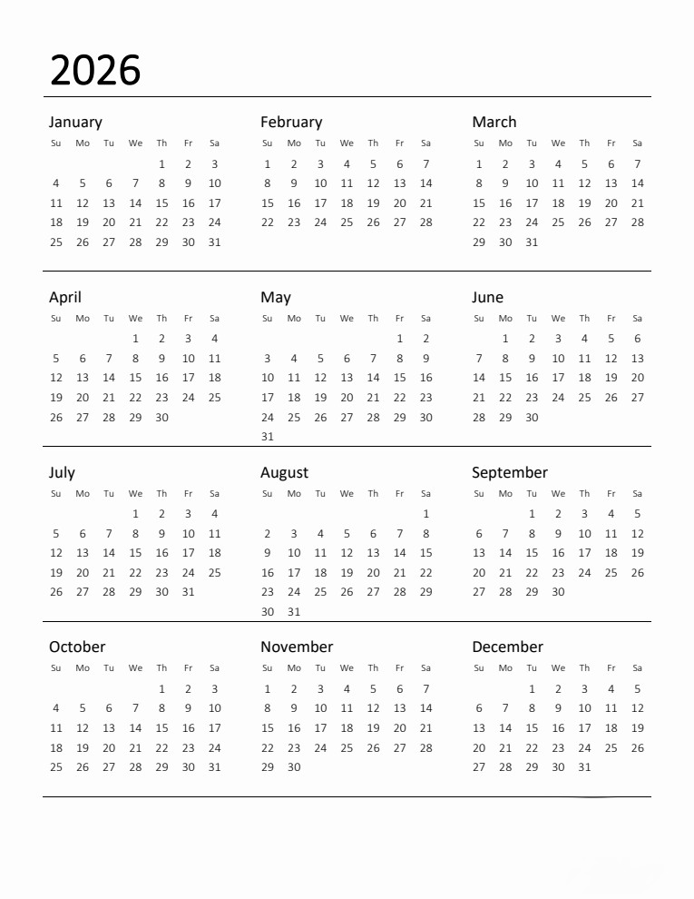
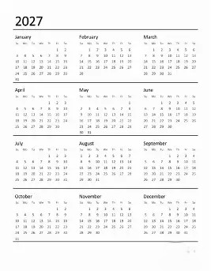

NOTES

NOTES

