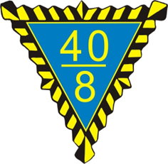 | 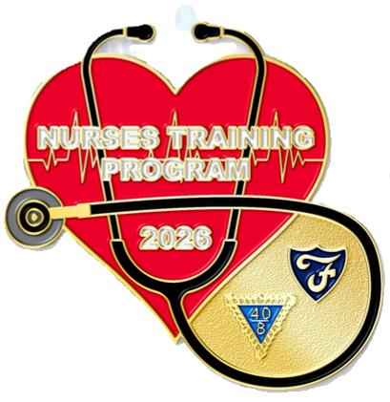

George B. Boland Nurses Training Scholarship Program

Voiture Locale Participation Options

(Quick Reference Guide)

Kevin T. Johnson
National Directeur Nurses Training

Program Overview

Established in 1976 by the 40&8

Supports nursing students (RN or NP track)

Four participation options for Voiture Locale

Grants: Up to $1,500 per academic year (all options)

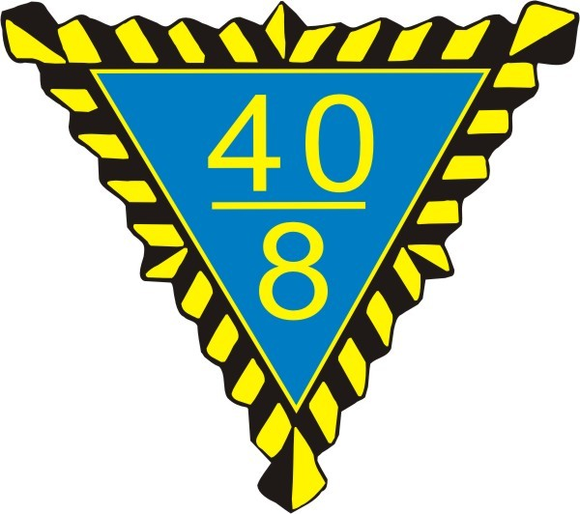

Traditional Scholarship Option

Most popular option
Grant: Up to $1,500

Requirements:
• U.S. Citizen
• Full-time student above high school
• Pursuing RN or NP
• Locale must have already supported at least one student
Limitation: Only one approved application per year

Limited Scholarship Option

Designed for Voitures with limited funds
Grant: Up to $1,500

Requirements:
• U.S. Citizen, full-time nursing student
• Locale participated last year but awarded no scholarships
• Must have donated at least $300 to Boland Trust Fund
Limitation: Only one approved application per year

Advanced Degree Scholarship Option

Administered by Voiture Nationale
Grant: Up to $1,500
For students pursuing advanced nursing degrees
Applications go directly to Voiture Nationale
Locales may forward applications but are not required

At-Large Scholarship Option

Available through Grande Voiture
Grant: Up to $1,500

Requirements:
• Originates from a Voiture Locale
• Locale may have no regular program or prior sponsorship
• Student must be U.S. Citizen, full-time nursing student
Each Grande can submit one application per year

Application Rules

Use correct forms:
• White form → Traditional, Limited, At-Large
• Blue form → Advanced Degree
Must include:
• Transcrits
• Acceptance Letter
• Photo (COLOR)
• Signatures (Chef de Gare/Correspondant)
Incomplete applications → Rejected

Submission Details

Mail applications to:
Voiture Nationale
Attn: Boland Trust Fund
1635 Hawthorne Dr
Plainfield, IN 46168
Applications may also be emailed to:
ttaylor@fortyandeight.org
Email submission requirements:
- The application must be scanned in color (photo must appear in color).
- The application must include all required signatures (Chef de Gare, Correspondant, and applicant where applicable).
- All other rules remain the same as mailed submissions.
Deadlines:
- Traditional, Limited, and Advanced Degree: No deadlines
- At-Large: Deadlines set by each Grande Voiture

Key Takeaways

Four scholarship options: Traditional, Limited, Advanced Degree, At-Large
Grants: Up to $1,500 each
Strict eligibility rules
Only one approved application per Locale per year
Final decisions by Boland Scholarship Committee are non-appealable

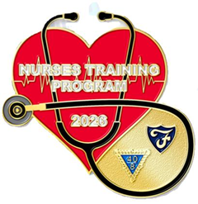

Resubmission of Scholarship Applications
Students who have previously received a George B. Boland Nurses Training Scholarship (e.g., during their freshman or sophomore year) may reapply in a later academic year. When reapplying, the student is only required to submit:
- An official transcript, and
- Proof of current full-time enrollment in an approved nursing program.
The application must still be routed through the Voiture Locale and must include the required signatures of the Chef de Gare and Correspondant before being forwarded to Voiture Nationale.
A resubmission may be made no sooner than one year from the date the previous scholarship grant was awarded.

