 |  | AMERICANISM
 |  | Consolidated Report—2019
Report for (check one) |  | Voiture Locale # ______ du_______________ or Total Membership ____________
Date Prepared ___/___/___ |  | Grande Voiture du ________________________ Total Membership ____________

Directeur’s Name __________________________________________________ Telephone ( ) _____ ‐ ________

Address _________________________________________________City/St/Zip _____________________________

 | GRANDE ONLY: Outstanding Locale "Flags For First Graders" is ______ Outstanding Locale is ______ |  |  |  |  |  |  |  |  |  |  |  |  |  |  | Attach Locale Reports
 | Locale Mail to: Grand Voiture Directeur |  |  |  |  |  | Grand Directeur Mail to: |  |  |  |  |  | (REPORT DUE JULY 15, 2019)
 |  |  |  |  |  |  | Dan Evers, 1850 Walker Rd NE, Salem, OR 97305
 | ACTUAL | ACTUAL |  | ACTUAL |  |  |  |  | CATEGORY
 |  |  |  |  |  |  |  |  | AMERICANISM AWARDS
 |  |  |  |  | School, High School, College, Jr. ROTC, Sr. ROTC,Community Organiza ons, Ci zens
 |  |  |  |  | (Private), Fire Preven |  |  |  |  | on, Law Enforcement, Others
 |  |  |  |  | AMERICANISM SPEECHES AND FLAG ACTIVITIES
 |  |  |  |  | Flag presenta | ons, Flag raising ceremonies, Flag re |  |  |  |  |  |  |  |  |  | rement ceremonies
 |  |  |  |  |  |  |  |  | YOUTH ACTIVITIES
 |  |  |  |  | Band support, Baseball, Boys and Girls State, Oratorical Contests, Scou ng (Boy,
 |  |  |  |  | Girl, Cub), Valley Forge Freedom Founda on, Child ID Programs,
 |  |  |  |  |  |  |  |  | Driver Training, FFA, 4H, PTA, etc.
 |  |  |  |  |  |  |  |  | COMMUNITY ACTIVITIES
 |  |  |  |  | Blood donor, Community Services, Get out the Vote, Na onal Security, Poli cal
 |  |  |  |  | Ac on, Senior Ci | zens, Hunter Safety Programs, Poppy Sales, Special Olympics
 |  |  |  |  | Mee ngs/Promenades/Wrecks, Ac vi es in other Fraternal Organiza ons
 |  |  |  |  |  |  |  |  | HOLIDAYS AND MEMORIALS
 |  |  |  |  | Calvin Kain Memorial Service, Grave Decora |  |  |  |  |  |  | on, Memorial Day, Memorial Ser-
 |  |  |  |  | vices: funerals, memorial dedica |  |  |  |  | ons, Parade par cipa on, patrio c events,
 |  |  |  |  |  |  |  |  | installa | ons, Veterans Day
 |  |  |  |  |  |  |  |  | VETERANS
 |  |  |  |  | Veterans Home Ac vi es, Transporta |  |  |  |  |  |  |  | on to Hospitals/Doctors,
 |  |  |  |  |  |  |  |  | Veterans Employment
 |  |  |  |  |  |  |  | FLAGS FOR FIRST GRADERS PROGRAM
 |  |  |  |  | Number of Schools where Flags were distributed: |  |  |  |  |  |  |  |  |  | Total Number of Flags:
 | _______hrs. |  |  |  | A. $ ______________ |  |  |  | Total Hours x $5.00
 |  | _______mi. |  |  | B. $ ______________ |  |  |  | Total Miles x $.50 ($1.00 for locomo ve)
 |  |  |  | $__________ | C. $ ______________ |  |  |  | Total Cash Spent
$ |  |  |  | TOTAL CASH AND SERVICES (A + B + C)
$ |  |  |  | PER CAPITA (Total Cash divided by membership)

Americanism Award Guidelines

The Americanism Award is a very prestigious award given to an individual who meets the following guidelines. The person who is selected is expected to attend Promenade Nationale and be a keynote speaker at the official functions.

- Involved in an “Americanism” type program on a National or very broad regional scale

- Involved in improving the general conditions of and for Veterans should be considered, but not necessary (there are many community programs that are larger scale and touch all walks of life)

- Need not be a veteran to be eligible, but should be an American citizen either born or Naturalized

- Non-Pay status strictly volunteer work

- No political reflections, influence or ramifications

- Able to attend Promenade Nationale

- Members of La Societe should not be considered for the Americanism Award based on personal actions or office performance involving the 40&8

- If the person is a member of the 40&8 the fact should be downplayed or mentioned only in a passing manner

Recommendations for award should be submitted to Nationale Americanism Directeur no later than

June 1. Nationale Directeur Americanism submits the recommended recipient’s file to the

Correspondant National by June 10. Recommendations should be accompanied by:

- Letters of Recommendation

  - Grande Directeur Americanism

  - Voiture Locale

  - Person making recommendation

- Biography of candidate

- Subjects Program with complete description of the way and degree the person is involved. This should include:

  - Photographs

  - Newspaper articles

  - Letters of recommendations from locale organizations and individuals

  - Demographics of numbers of people involved and monies spent, etc

- Press ready photo for publication in the 40&8er if selected

Note! The package should be assembled in the above stated order in a binder of your choice. It is recommended that you use this document as a check list to insure you do not omit any items

Dan Evers, Nationale Directeur Americanism

1850 Walker Rd NE

Salem, OR 97305

(503) 981-1470 Home

legionpost46@q.com


CARVILLE STAR

Annual Report

Grande Voiture du ______________________________ |  |  | Date __________________
Voiture Locale ____________________ |  | Membership Total: ___________
1. | Total number of pins sold____________@ $3.00 each |  | $ __________________
2. | Total dollar amount for Star subscriptions purchased |  | $ __________________
3. | Total number of Buy‐A‐County purchased___x $50.00 |  | $ __________________
4. | Total number of Buy‐A‐Clinic purchased___x $50.00 |  | $ __________________
5. | Total dollars donated to the Carville Star Museum |  | $ __________________
6. | Total dollar amount donated to the Carville Star General Fund |  | $ ___________________
 | (Please note what program fund, i.e., monument, special project, etc.)
7. | Total amount donated to Carville Star Equipment Fund |  | $____________________
 | (Equipment Fund is used to update computers and copiers)
8. | Money spent in the performance of you Carville Star duties |  | $ ___________________
9. | Total number of hours spent on the program _________x $5.00 |  | $ ___________________
10. Total number of miles traveled (POV) ______________x $.50 |  |  | $ ___________________

TOTAL DOLLAR AMOUNT (add items 1‐10)

$ ___________________

Submitted by:

Name ____________________________________________________

Address ___________________________________________________

City/State/ZIP ______________________________________________

Phone ____________________________________________________

E‐mail ____________________________________________________

Signature _________________________________________________

CHILD WELFARE
John T. Digilio, Jr. Award

Report Form Instructions— 2020


WHO REPORTS: Nega ve reports are required. Each Voiture Locale in La Societe des 40 Hommes et 8 Chevaux must submit a report, even if just to indicate number of members and the $ .25 per member from each Voyageur’s dues which is earmarked for the C. W. Ardery Trust Fund.

FORM TO BE USED: Voiture Locale and Grande Voiture Directeurs will use the same form; Voiture Locale Directeurs should check the block in front of Voiture Locale and show your Voiture #, Grande Voiture and membership, and then forward com‐ pleted report to YOUR GRAND DIRECTEUR, CHILD WELFARE by the deadline established by your Grande Voiture. Please try to be as accurate as possible (es mate value, if necessary, within reason).

The Grand Directeur of Child Welfare will collect all reports, consolidate on this same form, check the block in front of the Grande Voiture du (place name of Grande Voiture here), and indicate Grande Voiture membership as of July 31st, and then forward to the Na onal Directeur by August 1th.

Item “A”: For any money that was spent on Child Welfare. Please do not list cash spent that was reimbursed to your Voiture from the Charles W. Ardery Trust Fund. You may, however, tabulate and take credit for me and mileage involved in such cas‐ es.

Item “B” : “Other than cash” For any assistance and services rendered where other than cash was spent for such items as used clothing, toys, etc., please place a reasonable dollar value on such items and be sure to take credit for any mileage and me spent for this category.

Supplemental Reports: Please give any addi onal facts and figures on separate sheet and a ach to this report form for ac vi‐ es not listed on other side of this report form. Examples could be: Youth to Washington, D. C., an overseas school project where funds were given, providing Pledge of Allegiance banners for school classrooms, Easter Egg Hunts, etc. Record totals of

all supplemental ac vi es in Items 8 & 11, Other.

Special Note: Please also remember, as a member of the American Legion, Masonic Lodge, Knights of Columbus, Lions, Elks, Fire Department, School Boards, etc. Voyageurs may and are encouraged to take credit for all ac vi es within these various organiza ons where you have dealt with Children & Youth Programs, and include monies, mileage, and me spent on your re‐ ports.

It is the submi ng individual’s responsibility to add all items and complete the form.

Awards

At Promenade Na onale each year, the Na onal Child Welfare Commi ee meets to judge entries for awards. It is recommend‐ ed (but not required) that those Voiture Locales and/or Grande Voiture Directeurs who wish to enter their report for compe ‐

on, prepare a binder or note book (similar to the typical Voiture or Grande History Book) containing photos of events, newspaper clippings or ar cles, copies of cancelled checks, copies of Voiture or Grande Newsle ers, etc. to substan ate the work accomplished throughout the year, and submit along with this form (Locales to Grand Directeurs and Grand Directeurs to Na onal Directeur).

Awarded to the Grande Voiture with membership of 1 to 299 that performed the greatest service to La Societe in the Child Wel‐ fare program. A plaque is given to 1st place with honorable mention to 2nd place.

N. Carl Neilson Award

Awarded to the Grande Voiture with membership of 300 - + that performed the greatest service to La Societe in the Child Welfare Progam. A plaque is given to 1st place with honorable men on to 2nd place.

Charles W. Ardery, Jr. Award

Honorary Chef de Chemin de Fer Award to the Best Locale that performed the greatest service to La Societe in the Child Wel‐ fare Program. A plaque is given to 1st place with honorable men on to 2nd place.

Date Prepared ____________
CHILD WELFARE

Consolidated Report 2020

Report for (check one) ____ Voiture Locale # ________ du ______ Total Membership ________

____ Grande Voiture du _______________________________ Total Membership ________

Directeur’s Name _______________________________________________________ Telephone ______________

Address _______________________________________________________________________________________________

Mail Voiture Locale Report to: |  | Mail Grande Voiture Report to: |  | Grande | Voiture Only |  | ________
Grand Directeur Child Welfare |  | National Directeur , Child Welfare |  | Program | # of Locales Reporting |  | ________
 |  | Joseph R Donovan
 |  | 4660 N River Rd Spc 12 |  |  | Outstanding Locale # |  | ________
 |  | Oceanside CA 92057-5879 |  |  | (Please attach report & supporting
 |  | Jdonovan4660@hotmail.com |  |  | documentation)
 |  | FAX 760-721-0339
DEADLINE: ____________ |  | DEADLINE: July 15, 2020
___________________________________________________________________________________________________________

A. Activities for which Cash was donated # of Children Cash Spent

- Direct money assistance to children and families._________________________________________________________________

- Food, Clothing, Rent, and/or Fuel._____________________________________________________________________________

- Health care (medical, dental, surgical, hospital, etc._______________________________________________________________

- Parties, toys, gifts, etc.______________________________________________________________________________________

- Participation in Boys State, Girls State, other Programs involving children._____________________________________________

- Donations – Salvation Army, health care & other charities with services for children.______________________________________

- Flags for first Graders.______________________________________________________________________________________

- Sports organizations (AAU, Little League,

etc).____________________________________________________________________

- Activities in state training schools._____________________________________________________________________________

10. Other.___________________________________________________________________________________________________

SUB-T OTAL A ___ ________ ___________

___________________________________________________________________________________________________________
B. Assistance and Services Rendered in Other than Cash # of Children Cash Spent

- For Medical, Surgical, Dental, or Hospital Services etc.____________________________________________________________

- For Food, Clothing, Rent or Fuel._____________________________________________________________________________

- For School Lunches or other Feeding Services._________________________________________________________________

- For Parties and Entertainment._______________________________________________________________________________

- For Toys, Gifts, etc. (Christmas and other Holidays).______________________________________________________________

- For Services for Children in Facilities including Hospitals, State Training Schools, Nursing

Homes, Probation Placement, etc._________________________________________________________________________

- For Transportation (Children to and from Clinics, Immunization Centers, Hospitals, etc.)__________________________________

- Other.__________________________________________________________________________________________________

SUB-T OTAL B ___ ________ ___________

___________________________________________________________________________________________________________
C. Other Items |  |  |  | TOTALS
 |  |  |  | # Children | $ Spent
Mileage in support of Programs = | __________ @ $ | .50/mile ____________ SUB-TOTAL A |  | ________ ____________
Rolling Stock Mileage in support of Program=__________ @ $ |  | 1.00/mile ___________
Man-Hours in Support of Programs = | __________ @ $ | 5.00/hr | ____________ SUB-TOTAL B | ________ ____________
# Child Welfare Pins Sold = | __________ @ $ | 3.00/each ___________
Direct Donations to CW Program = |  |  | ___________ SUB-TOTAL C |  | ____________
# of Current Voyageurs = | __________ @ $ | .25/Voy ____________
T |  |  | OTAL ___ | ______ ___________
Total $ ____________ of LaFemmes Child Welfare |  | NOTE: Deadline for Grande Voiture Reports to National Directeur Child
Program Activities (Cabane Locale or Grande Cabane) |  | Welfare | is July 15, 2020 >>>>ONLY Grande Voiture Reports are
to |  | be sent to National Dir
CW Rpt 2020 Rev 12/17


HISTORIEN

Grande Voiture & Voiture Locale

History Book & Scrapbook Contest Rules

1, Voitures Locale are to submit their History Book or Scrapbook to their Grande Historien for judging by the Grande. Only the First Place Winners for Locale, one History Book and one Scrapbook from each Grande will be accepted for competition by Nationale. They should be delivered to Nationale prior to the Historiens’ Meeting for Judging. The Locale History Book & Scrapbook must be accompanied by the Certification Form filled out by their Grande. If there is no Certification Form accompanying the Locale’s book, they will be disqualified.

- The Grande History Book and Scrapbook do not need a Certification Form, as the next level for them is Nationale.
- All Locale Books and Grande Books require a Title Page that looks like the following:

**********************************************TITLE PAGE FOR LOCALE*******************************************

Voiture Locale History Format

History Book (or Scrapbook)
of
Voiture Locale No. _______
__________________________County, Grande du/de________________________________

From (Month) of 20___to (Month) of 20___

By: _______________________________

(Person compiling History Book or Scrapbook)

Title: ______________________________

*************************************************TITLE PAGE FOR GRANDE********************************************

Grande History Format

History Book (or Scrapbook)
Of
Grande Voiture du/de____________________________

From (Month) of 20 ___ to (Month) of 20 ___

Grande Chef de Gare _____________________________

Grande Historien ______________________________

- History Books require a Table of Contents, Scrapbooks do not.
- History Books and Scrapbooks require Alphabetical Indexing. Scrapbooks only require a list of activities and on which pages they can be found (to make them easier to find for judging). The alphabetical indexing is located at the end of he History Book or Scrapbook.
- History Books require a Forward that must include a brief statement on the formation of the 40 et 8 as well as a tie-in statement about the formations of the Voiture Locale.
- Reporting period is for the year’s activities and should coincide with their Grande. (Starting and ending with their Grande Promenade.)

- Physical size should be a maximum of 12 by 14 1/2 ins. and have a substantial hard cover. (Books are available from American Legion Headquarters, P.O. Box 1055, Indianapolis, IN 46206

- Identifying captions must be used with all clippings, photographs, and items listing occasion, source, dates, func-tions and names identifying the subject matter.

HISTORIEN

Grande Voiture & Voiture Locale

History Book & Scrapbook Contest Rules

10, Voiture Activity theme is suggested, as the scrapbook history should relate the various activities conducted during the year. Accuracy is most important.

- Arrangement may be either chronological or by the various programs of La Societé. Systematic and logical arrange ment should be sought. The reader must be able to follow the meaning of the illustrations (pictures, etc.) with very little difficulty or confusion.
- Judges will be members of the Forty and Eight Historiens’ Asscoiation selected at Nationale. They will select three
(3) Voiture Locale Histories, three (3) Voiture Scrapbooks and three (3) Grande Voiture Histories as winners.
- Rating Criteria: Cover-5 points; Clearness-5 points; Arrangement-10 points; Table of Contents-10 points; POW/MIA-10 points; Americanism-10 points; Child Welfare-10 points; Nurses Training-10 points; Carville Star-10points; Youth Sports-10 points; Number of Activities-10 points.
- Name and address of Voiture Locale Historien to be on the inside cover, lower left hand corner. This book will be returned to the name and address of the person whose name appears inside the cover of the book or may be picked up by your Voiture or Grande at Nationale after judging.

AWARDS

Locale
1st Place Locale History Book-First Place Plaque 2nd Place Locale History Book-Runner-up Plaque 3rd Place Locale History Book–Plaque
Ist Place Locale Scrapbook-First Place Plaque 2nd Place Locale Scrapbook-Runner-up Plaque 3rd Place Locale Scrapbook-Plaque

Grande
1st Place Grande History Book-First Place Plaque 2nd Place Grande History Book-Runner-up Plaque 3rd Place Grande History Book-Plaque

40 & 8 News Media Awards
40&8 Staff Writer Awards

Final selection is made by the Nationale Forty and Eight Historiens Association, whose decision is final.

NOTE: Cross out either History Book or Scrapbook, whichever applies.

Certification Form

Voiture Locale History Book or Scrapbook Contest

Voiture Locale # ________. Grande Voiture du/de________________________________

Submitted by: Historien _____________________________________Number of Volumes _______

Grande Voiture Certification

Grande Voiture du/de _________________________certifies that this entry participated in and was awarded First Place
in theVoiture Locale History Book or Scrapbook Contest held at the Grande.

Grande Voiture Certification Officer______________________________
Phone____________________________

Street Address———————————————-City/State/ZIP_________________________________________

Date of Grade Certification______________________________
Date Received HQ_______________________

Membership and participation in the Forty and Eight Historiens Association is encouraged, but is not required as a pre-requisite for contest participation.

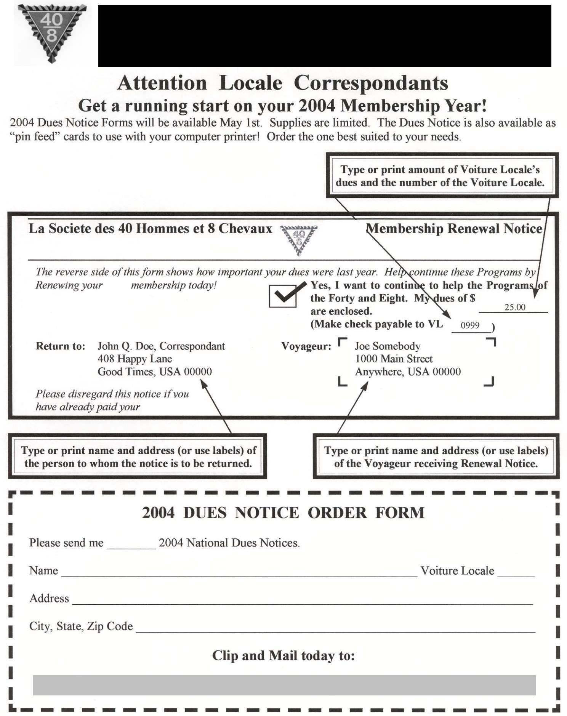
2019 DUES NOTICE FORM

2019

2017

2019

2019

201 dues

2019

2019

Voiture Nationale, 250 E 38th Street, Indianapolis, IN 46205

ss
 |  |  | Nurses Training Consolidation |  |  |  | Report
 |  |  |  | Grande/Locale
 |  |  | Nurses Training |  |  | Consolidation Report
 |  |  | Grande du | ______ |  | Locale | V- __________ | of Grande _______
 |  |  | Reporting Period August 1 2019 to July 31, 2020 |  |  |  |  | >Excel File<
Date Prepared |  |  |  |  |  | Total Membership
N.T. Directeur: |  |  |  |  |  | City:
 | Telephone: |  |  |  | Address:
 | E-Mail:
 | E-Mail/Mail to Nurses Training Directeur |  |  |  | Ernest Lane jr - elanejr3688@gmail.com
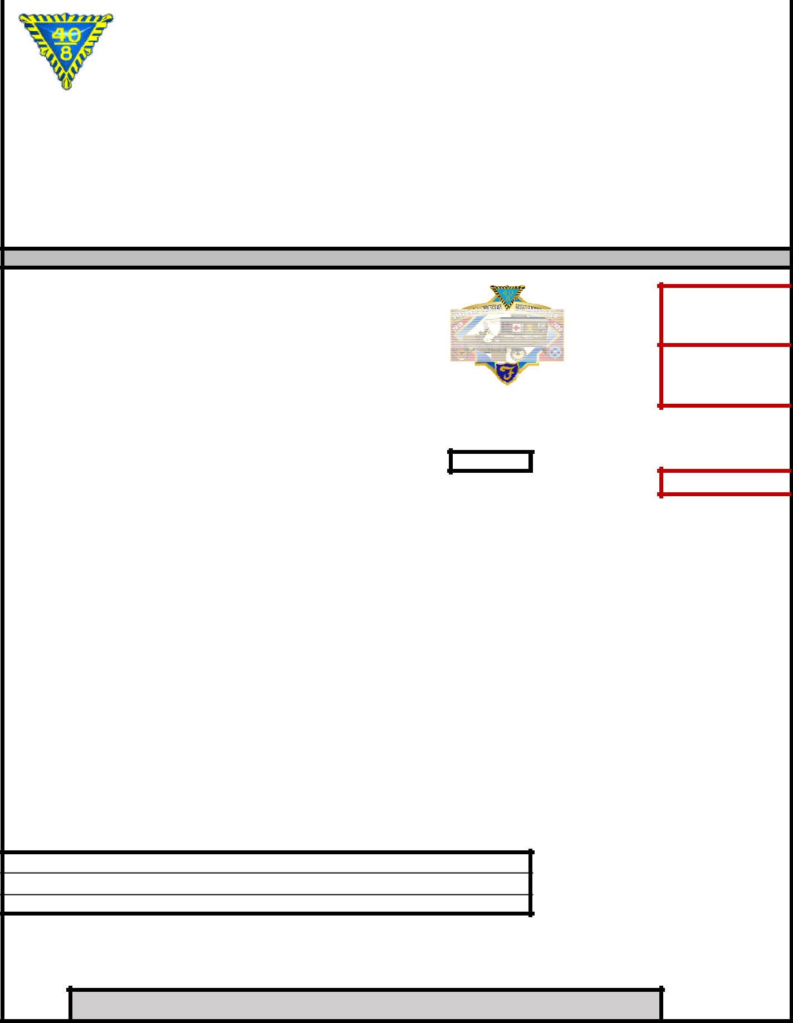

Address: 4286 So. Reindeer Court - Gilbert ,AZ 85297

N.T. Voiture Expenses Reporting

Expenses | (Input)
Annual Car Miles Travel |  | ($.50/mile)
Man-Hours |  | ($5/Hr.)
Loco Miles |  | ($1/Mile)

Calculations

Administrative Expenses (Input)

Ex Phone calls, Pins & Stamps

Total Expenses Reporting

Annual Nurse Training Scholarship Reporting

 | Current Nurse Training Scholarship results | (input) | (input)
Total | Dollar expended in Nursing scholarship this year
Total | Number of scholarships this year
 | Current Program Yearly results
Total | No. of Student in your Nurse Training program
 | (add one Nurse for each $300 Donated to Boland Trust Fund)
Total | This year RN's Graduates in your program
Total | Dollars Donated to the Boland Trust Fund
Total | Dollars expended in Nurse Training this year
List all activities at the Grande, Locale and Communities events |  | Per Capita Investments |  | Accompli Index

Attested By

__________________________________________________________________________________________

Grande/Locale Correspondant Grande/Locale Nurse Training Directeur

Locale Deadline: July 15 Grande Deadline: Aug1 App. Doc. 9/19/2019

 |  | POW/MIA
 | 2020 Consolidated Report
Date Prepared ___/___/___
Report for (check one)Voiture Locale # ______ du________________________ |  |  | Total Membership __________
Grande Voiture du _______________________________ |  | Total Membership __________
Directeur’s Name _____________________________________________________ |  |  | Telephone ( ) _____ ‐ ______

Address _______________________________________________________City/St/Zip __________________________

PLEASE COLLECT THE FOLLOWING DATA:

1. Total Man Hours…………____________.................@ $5.00 per hour……..$_______________
(Include all hours of travel, computer me, phone me, etc.)

- Total Mileage……………..____________.................@$.50 per mile………..$_______________
Include all travel to promenades, post oﬃce, lectures, etc.)

- Actual Expenditures……………………………………………………………$______________
(Postage, prin ng, fuel, room & meals, long distance charges, dona ons, etc.)

- ACCRUED TOTALS…………………………………………………………..$______________
(Although expenses are not reimbursable, they are tax deduc ble. Keep all receipts for your records.)

- Ac vi es
(List all ac vi es a ended at the Grande, Locale and Na onale levels, fund raising events, etc.)
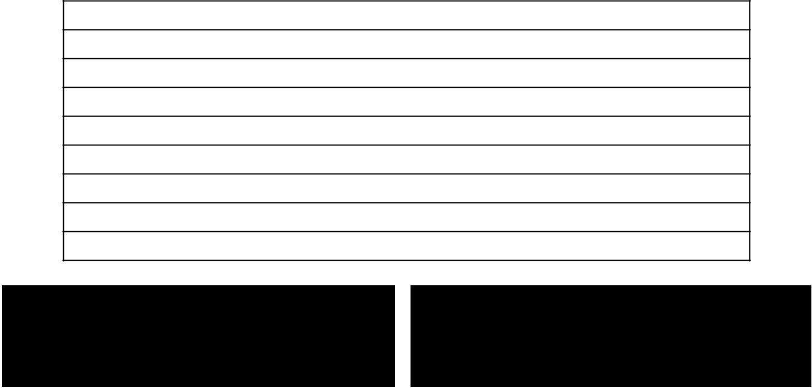

LOCALE DEADLINE: July 1st

GRANDE DEADLINE: July 15st

Mail Consolidated Grande Reports to:

Steven W. Slegers s.t.slegers@q.com 8503 NE 13th St
Vancouver, WA 98664

 |  | PUBLIC RELATIONS
 |  | Annual Report
Date of Report: _______________________ |  | Reporting Period: October 1, 2018 to September 1, 2019

Report type: Check ( ) for Locale Report: Voiture Locale # __________, Grande du _______________________________

Report type: Check ( ) for Grande Report: Grande Voiture du _________________________________________________

Submitting PR Directeur: _______________________________Phone: ( ) ______________________

Address: ______________________________ City: ____________________________State: _______ ZIP: ___________

E-mail: _________________________________________________

Locale Directeur: Mail report to your Grand Public Relations Directeur no later |  |  | IMPORTANT NOTICE
 |  | Reports to National Directeur
than July 1st. |  | must be postmarked not later
 | (Or as assigned by Grand Directeur) |  | than September 1, 2019
Grande Directeur: Mail reports to: Robert Cearlock, Directeur Public Relations
 | P.O. Box 1782
 | Mt. Vernon, IL 47022
 | 1-618-244-5761 E-mail: cearlock@aol.com
Part 1- Grande Voitures |  |  | Yes No

Does your Grande have a Grand PR Directeur?

Is your Grande listed in the National Public Relations submittal report?

Does your Grande have an active* website? {Must be updated within every 30 days to be active}

Does your Grande have a Newsletter or Newspaper?

Has a Grande representative appeared on TV or Radio representing the 40/8 this year?

Part 2- Locale Voitures Yes No

Does your Locale have a PR Directeur?

Is your Locale listed in the National Public Relations submittal report?

Does your Locale have an active* website? {Must be updated within every 30 days to be active}

Does your Locale have a Newsletter or Newspaper?

Has a Locale representative appeared on TV or Radio representing the 40/8 this year?

E-MAIL ADDRESS FOR POINT OF CONTACT FOR YOUR LOCALE/GRANDE:

Please print

RITUAL

Consolidated Annual Report—Locale

____________________________________________________

Voiture Number, County, Grande

_________________

Date

This Form is to be filled out by Voiture Locales only!

Voyageurs in Voiture Locale…………………………………………. Total Number__________

Promenade opened and closed by the Ritual? ………………..

Yes

 No

Do all Voyageurs wear Chapeaus ………………..Yes

No

Calvin Kain Memorial Service conducted by Voiture Locale? ..

Yes

No

Does Voiture Locale have a Wrecking Crew… Yes

No

No. of Voyageurs _______

Number of ac ve and formal wrecks by your Voiture ______

Number of PG’s wrecked ________

# of funerals and memorials a ended by Voiture Locale _______ Number of Voyageurs present________

Does Locale have a color guard? ……..Yes

No

Number of Voyageurs ______

Does your Voiture have an Honor Guard…. Yes

No

Number of Voyageurs ______

Did Voiture Locale par cipate in Na onal Color Guard compe

on? Yes

No

Ritual “3M” Report (Man hours‐Miles‐Money)

Number of Ritual related hours devoted to 40 & 8 work…………

Total ________________

Number of Ritual related miles devoted to 40 & 8 work …………

Total ________________

Amount of Ritual money spent or claimed………………………..

Total _________________

(Out of pocket/Commissaire Intendant expenses only. Do not include hours or miles dollar values)

(List any other comments on the reverse of this form)

If your Voiture Locale wishes to be considered for the Joel A. Bunch Award, awarded by Voiture Na onale

to the Voiture Locale displaying the highest degree of Ritual performance excellence, it must be submi ed on a separate piece of paper. (List your qualifica ons and comments on the Grande Con nua on Report Form)

Prepared by: _________________________________

Forward Report to Grand Directeur | Voiture Locale Directeur or Correspondant
of Ritual and Grand Correspondant | Voiture Locale Directeur or Correspondant
of Ritual and Grand Correspondant | Title: _________________________________
no later than July 10th | Title: _________________________________

15

RITUAL
Joel A. Bunch Award Nominee

(Locale Continuation Sheet)

'ƌĂŶĚ sŽŝƚƵƌĞ ͺͺͺͺͺͺͺͺͺͺͺͺͺͺͺͺͺͺͺͺͺͺͺͺͺͺͺͺͺͺͺͺ

Voiture Locale to be considered for the Joel A. Bunch Award, awarded by Voiture Na onale to the Voiture Locale displaying the highest degree of Ritual performance excellence. (Voiture Locale Report a ached.)

Voiture Locale Name and Number _____________________________ County ______________________

Qualifica ons, comments and recommenda ons for the Joel A. Bunch Award (for legibility, please type).

_____________________________________________________________________________________

______________________________________________________________________________________

______________________________________________________________________________________

______________________________________________________________________________________

______________________________________________________________________________________

______________________________________________________________________________________

______________________________________________________________________________________

______________________________________________________________________________________

______________________________________________________________________________________

______________________________________________________________________________________

______________________________________________________________________________________

______________________________________________________________________________________

______________________________________________________________________________________

______________________________________________________________________________________

(Use addi onal sheets of plain paper, if necessary.).

Prepared by: ______________________________________________

TitůĞ͗ ͺͺͺͺͺͺͺͺͺͺͺͺͺͺͺͺͺͺͺͺͺͺͺ

 |  | Grand Directeurs must forward this report to:
 |  | Steve Bradley, National Ritual Directeur
Recommended by: ______________________ |  | 233 Park Street
Recommended by: ______________________ |  | Antigo, WI 54409 stevepkst@gmail.com
 |  | DEADLINE: July 23, 2019

Grand Chef de Gare


RITUAL

Annual Consolidated Report—Grande


Grande Voiture du __________________________ Date ____________________

Total Number of Voiture Locales in Grande ______ Total Number of Voyageurs in Grande ________

Total Number of Voiture Locales Submi ng Reports ______

How Many Voiture Locales

Opened and Closed Promenades by the Ritual……….______

Conducted Calvin Kain Memorial Service……...……______

Have Wrecking Crews………………………………..______ Number of Voyageurs Par cipa ng _____

Performed Ac ve and Formal Wrecks……….______ Number of PGs Wrecked _____

Wear Chapeaus………………………………………...______

- of Veterans Funerals and Memorials A ended ______ Number of Voyageurs Present _____

Have Color Guards……………………………………______ Number of Voyageurs Par cipa ng ____

Have Honor Guards………………………………...…______ Number of Voyageurs Par cipa ng ____

Ritual “3M” Report (Man Hours — Miles — Money)

Total Number of Ritual Related Hours Devoted to 40 & 8 Work………………………….…..__________

Total Number of Ritual Related Miles Devoted to 40 & 8 Work……………………………...__________

Total Amount of Ritual Moneys Spent or Claimed…………………………………………….__________

(Out‐of‐pocket/Commissaire Intendant expenses only. Do not include hours or miles dollar values)

- Voiture Locale to be considered for the Sam Friedman Award, awarded to the Voiture Locale conduc ng the greatest number of Wrecks during the repor ng year just ending. (Voiture Locale Report aƩached.)

Voiture Locale Name and Number ____________________________

County _____________________

Number of Ac ve and Formal Wrecks Performed………__________

Number of PGs Wrecked ______

Forward this report by July 23rd to: Steve Bradley,

Na onal Ritual Directeur, 233 Park Street, Anitgo, WI

54409, stevepkst@gmail.com

Nationale Color Guard Competition


Please print

Grand Voiture du __________________________________________

Locale Voiture # ___________________________________________

Captain of Color Guard_______________________________________

Sign your name_____________________________________________

Date _____________________________________________________

Please be advised that your unit should be at the designated area for competition at less (1/2) half hour before the competition begins.

Grande Directeurs must forward this report by July 23rd to:

Steve Bradley, National Ritual Directeur, 233 Park Street, Antigo, WI 54409 stevepkst@gmail.com

Proposed Password change

please print

New

Password_____________________________________________________

French Password

_____________________________________________________________

Meaning ________________________________________________________

Submitted by_____________________________________________________

Grand Voiture ____________________________________________________

Locale Voiture ____________________________________________________

Date

____________________________________________________________

Do not write below this line

Forward this report by July 23rd to: Steve Bradley, Nationale Ritual Directeur, 233 Park Street, Antigo, WI 544409, stevepkst@gmail.com

Approved at Nationale Yes____________ No__________________

Nationale Ritual Directeur_____________________________________

SPECIAL AWARDS

Where to Start? - 2020

These Special Awards pages are instructions for submitting nomination packets for competition. The third page is also to be used for end of year reports from both Locale and Grande. Special Awards is one of the “newer” programs. Each Voiture Locale should appoint a Spe-cial Awards Program Chairman. That Chairman should contact his/her Grande Directeur for current and pertinent information.

If no one is appointed to do the job, it falls back on the Chef de Gare and/or Correspondant to get it done or, in so many cases, it doesn’t get done. If it doesn’t get done, it isn’t fair to your Voiture and the voyageurs associated with it. It also isn’t fair to potential candidates for these awards. They deserve better.

There is a lot of satisfaction in giving out these awards. The pride in the eyes of the recipient will make you a believer when you pre-sent them an award. The presentation can be made at your regular Promenade, a special meeting or a dinner meeting is even nicer. Contact the media to get some publicity for the recipient. He or she will enjoy this and believe it or not, it will acquaint the public with La Societe also. You can promote your other programs at this same time. Your Voiture will appreciate this publicity the next time they are raising funds for their pro-grams. If people have heard of you, it is a lot easier to sell tickets and other fund raising items.

HERO OF THE YEAR | VOYAGEUR OF THE YEAR
LAW OFFICER OF THE YEAR | CITY OR TOWN OF THE YEAR

The Nomination Form is designed so it can be used for any of the four awards. A separate nomination form must be submitted for each award; for instance, one form for Hero; one form for Voyageur; etc. The top part of the Nomination Form is to be completed by the Locale. The bottom is used for reporting to Nationale Special Awards. All nominations to Nationale must go through the Grande Voiture and be accompanied by a Par-ticipation Reporting Form (found on page 19 in this booklet) signed by the Grand Correspondant.
The submission process starts with the Voiture Locale submitting their nominations to their Grande Voiture by June 1st or a date set by the Grande. The Voiture Locale’s nominations must be accompanied by the Participation Reporting Form completed with all requested information (top part pf page 19). The Grande Voiture then selects a winner to send to the National Sous Directeur Special Awards judge for that category. The selected winner is usually honored by the Grande Voiture at one of its Grande functions, such as a Grande Promenade or Grande Cheminot meet-ing. These winning Grande Voiture nomination packets must be received by the designated National judges no later than July 1st. The bottom part of page 19 must be completed with all requested information and signed by the Grand Correspondant.

Year 2020

- Your Grand Hero of the Year nomination is to be sent to Sous Directeur National Special Awards Courtland Bradbury, 155 Sunset Dr., Auburn, CA 95603, cdbradbury007@att.net
- Your Grand Law Officer of the Year nomination is to be sent to Sous Directeur National Special Awards, Dale Oatman, 405 E. 10th Ave., Antigo, WI 54409, daleoatman@frontier.com
- Your Grand Voyageur of the year nomination is to be sent to Sous Directeur National Special Awards James Carpenter, 15750 Arroyou Dr. SP#1, Moorpark, CA 93021, carpenterjg@msn.com
- Your Grand City/Town of the Year nomination is to be sent to Sous Directeur National Special Awards Wayne Sorrentino, 85 McNaughton Ave, Cheektowaga, NY 14255, wayne.sorrentino868@gmail.com

General Guidelines for Special Awards

- Each Voiture Locale may enter only one (1) candidate for each of the four awards. Likewise, Grande Voitures may enter one candidate for each of the four awards. All nominations to Nationale must come through the Grande Voiture and must be accompanied by a Participation Reporting Form from the Grande Voiture. A nomination without a Participation Reporting Form is considered incomplete and will not be judged.
- All entries must be made on the form approved by Voiture Nationale. All nominations must be typewritten or legibly printed.
- All documentation is to be attached to, or included with, the Official Nomination Form (page 18). Documentation includes, but is not limited to, a biography newspaper clippings, radio/TV transcripts, magazine articles, letters of commendation, etc. It is suggested, but not required, that two color photos (one 8 x 10 and one 3 x 5) accompany the nomination. In any event, photos will be required within a few days of the individual’s selection as a Nationale winner. These are for the article in the Forty and Eighter magazine.
- All candidates must live or be involved in the jurisdiction of the Grande Voiture.
- All Grande Voiture nomination “packets” must be received by the appropriate National Sous Directeur of Special Awards judge by July 1st. “Packets” received late cannot be judged as there is no time to spare to get everything done for the Forty and Eighter Magazine deadline and Promenade Nationale.
 |  | SPECIAL AWARDS
 |  | Official Nomination Form—2020
For: | Hero of the Year

Law Officer of the Year City/Voyageur of the Year

Make a separate Official Nomination Form for each Award you are submitting and “X” one of the above.

Date ____________

Candidate’s Name: _________________________________________________________________________________

Complete Mailing Address: __________________________________________________________________________

_________________________________________________________________________________________________

Telephone ___________________

If Candidate is for Law Officer give Position: ________________________________________

and Employer: _________________________________________________________________

Brief description of why this nominee deserves this Award: (Attach a second sheet if necessary)

Please attach (or include) all documentation to this form.

__________________________________________________________________________________________________________

__________________________________________________________________________________________________________

__________________________________________________________________________________________________________

__________________________________________________________________________________________________________

_____________________________________________________________

Can candidate attend Grande and Nationale Promenades if selected and requested? ____Yes ___No

Submitted by: ______________________________Title: _______________________________

Voiture Locale # ___________ Grande Voiture de ______________________

Voiture Locale is to complete all of the above and by June 1 send to Grand Directeur Special Awards or Grand Correspondant if Grande does not have a Special Awards Directeur. Application must include Locale’s Participation Report (Page 19).

++++++++++++++++++++++++++++++++++++++++++++++

Grande Voiture is to complete all below and send to the designated Sous Directeur National Special Awards judge. Nomination packets must be received by July 1st. Late packets will not be considered. Current names and addresses may be found in the Octo-ber issue of the Forty & Eighter Magazine.

This certifies that the above has been selected as the ___________________of the Year

for the Grande Voiture du ___________________.

_______________________________ Grand Directeur Special Awards

_______________________________ Grand Correspondant

THE GENERAL’S CLUB

The funding for the Nationale Special Awards Programs is the General’s Club. Contact any of the members of the Special Awards Committee, current General’s Club members (recognized by the five star pin they wear) or Nationale Headquarters, for how to join. The General’s Club is a worthwhile club to which you will be proud to belong and wear the five star pin. An added bonus is the General’s Brunch which is held on Friday morning at Promenade Nationale. Watch for information in the Forty and Eighter!

SPECIAL AWARDS

Participation Reporting Form-2020


 |  |  | LOCALE REPORT
 |  |  | LOCALE REPORT
Date of report:_____________ | Voiture _________ |  |  | Membership __________ | Grande_________
Date of report:_____________ | Voiture _________ |  |  | Membership __________ | Grande_________
Submitted Candidates to Grande: |  |  |  | ___Yes ___No
Submitted Candidate for Hero of the Year to Grande |  |  |  | ___Yes ___No
* Hero of the Year | ___ Yes ___No
Submitted Candidate for Law Officer of the Year to Grande ___Yes ___No
* Law Officer of the Year | ___Yes ___ No |  |  | ___Yes ___No
Submitted Candidate for Voyageur of the Year to Grande |  |  |  | ___Yes ___No
* Voyageur of the Year | ___Yes ___No |  |  | ___Yes ___No
Submitted City of Town of the Year to Grande |  |  |  | ___Yes ___No
* City or Town of the Year ___Yes ___No
Homme Hours______ x $5.00 equals $_______ |  |  | Miles Traveled $0.50 equals $______
Homme Hours______ x $5.00 equals $_______ |  |  | Miles Traveled ______ x $0.50 equals $_________
Actual Cash Expended $___________ |  | Total $_________ ($ Hours + $Miles + Actual Cash)
Actual Cash Expended $___________ |  | ($ hours + $ miles + $ actual cash) = Total $____________
Person responsible for submitting report ______________________________.
Person responsible for submitting report ______________________________.

Signature of Locale Correspondant ______________________________.

Voiture Locale: X “ box”, complete all above and send to Grand Directeur Special Awards or Grand Correspondant by June 1st each year. If sending in a Candidate attach to Nomination Report.

++++++++++++++++++++++++++++++++++++++++++++++++++++++

Grande Voiture: X “box” below and complete all below. A copy of the below report must accompany all nominations for Special Awards ,. as shown on the Official Nomination Form, as well as year end report to Special Awards Directeur!

 |  |  | GRANDE REPORT
 |  |  | GRANDE REPORT
Date of Report___________(Deadline is July 1st) |  | Grande Submitting Report ______________
Date of Report___________(Deadline is July 1st) |  | Grande Submitting Report ______________
Submitted Candidate for Hero of the Year to Nationale ___Yes ___No
Submitted Candidate for Hero of the Year to |  |  | Nationale ___Yes ___No
Candidate’s Name, Address, and Phone______________________________________________________________
Candidate’s Name, Address, and Phone__________________
Submitted Candidate for Law Officer of the Year to Nationale___Yes ___No
Submitted Candidate for Law Officer of the Year to |  |  | Nationale___Yes ___No
Candidate’s Name, Address and phone ________________________________________________________________________
Candidate’s Name, Address and Phone_________________________________________________________________
Submitted Candidate for Voyageur of the Year to Nationale___Yes ___No
______________________________________________________________________________
Candidate”s Name, and Address and Phone_______________________________________________________________________
Submitted Candidate for Voyageur of the Year to |  |  | Nationale___ Yes ___No
Submitted Candidate for City/Town of the Year to Nationale ___Yes ___No
Candidate”s Name, and Address and Phone_______________________________________________________________________
City or Town Name______________________________________________________________
Membership of Grande_______________
__________________________________________________________________________________________________________
Number of Locales in Grande__________(A) |  |  |  | Nationale___Yes ___No
Submitted Candidate for City or Town of Year to |  |  |  | Nationale___Yes ___No
Number of Locales Reporting __________(B) | Percentage of Participation(B divided by A)___
City or Town Name______________________________________________________________
Number of Locales submitting a Candidate______
Membership of Grande_______________
Homme Hours_____X $5.00 = $_______ Miles _____X $0.50 = $_______
Number of Locales in Grande__________(A)
Actual Cash Expended $_______ Total $______ ($Hours +$Miles + $Actual Cash)= Total $ ____________
Number of Locales Reporting __________(B) | Percentage of Participation(B divided by A)___
Name, address and phone # and title of Grande Officer Submitting Report______________________________________________
Number of Locales submitting a Candidate______

Homme Hours_____X $5.00 = $_______ Miles _____X $0.50 = $_______
__________________________________________________________________________________________________________

Actual Cash Expended $_______ Total $______ (Hours +$Miles + Actual Cash)
Name, address and Phone and title of Grande Officer Submitting Report_________________________________________________
Signature of Grand Correspondant ______________________________

IMPORTANT: Each nomination packet must include this form completely filled out and signed. If this form is omitted or incom-plete, the nomination packet will automatically be disqualified from Nationale Competition.

______________________________

SPECIAL AWARDS

Nominations Guidelines—2020

Guidelines for Hero of the Year

The Hero of the Year award was adopted by La Societe during 1991. The purpose of the award is to recognize and pay tribute to a person whom, without hesitation or regard for their own safety, did demonstrate an unselfish desire to aid others. By recognizing and respecting those who perform a heroic deed, we familiarize our community, state and nation with the programs of the 40 et 8.

In every Voiture’s community or state there are individuals w orthy of becoming a candidate for the Hero of the Year Award.
Don’t wait for another Voyageur to sponsor a candidate, for it may be too late and never happen.
- A Grande Voiture may submit a candidate only once for a specific heroic deed.
- The candidate need not be a veteran to be eligible. The candidate, however, must be living and over the age of 18.

- The candidate’s “packet” must be received on or before July 1st by Sous Directeur National Special Awards judge Courtland Bradbury, 155 Sunset Dr., Auburn, CA 95603.

Guidelines for Voyageur of the Year

The Voyageur of the Year was adopted by La Societe during 2001. The purpose of this award is to recognize and honor Voya-geurs who have performed outstanding service to La Societe. Each Voiture Locale should honor a Voyageur each year at one of their main Promenades. Our Voyageurs doing service for La Societe deserve to be recognized. This service can be for something done for a particular program (Nurses Training, Child Welfare, Americanism or any of our named programs or for La Societe in general (attending functions, setting examples and/or creating an atmosphere of camaraderie that will create a desire for one to be or become a Voyageur Militaire). There are many Voyageurs among us worthy of this honor and should be recognized at all levels-Locale, Grande and N a-tionale.

- A Grande Voiture may submit the same candidate only once in three years.
- A previous winner of the Nationale award cannot renominated.
- A candidate may live anywhere. His membership must be within the Grande Voiture submitting the candidate.

- It is not a requirement to hold or have held an office in La Societe, but must be living Voyageur in good standing.

- The candidate’s “packet” must be received on or before July 1st by Sous Directeur National Special Awards judge James Carpenter, 15750 Arroyo Dr., SP#1, Moorpark, CA 93021

Guidelines for Law Officer of the Year

The Law officer of the Year a ward has been in existence for some time and has been well received by the Membership. The purpose of this award is to recognize and pay tribute to a Law Enforcement Officer who has done an outstanding job of performing his or her duties at the level of his employment, both past and present.

Candidates for this award may be obtained by seeking recommendations from the agency chief executive (Superintendent,
Sheriff, Chief, etc.) or directly by the Voiture Locale. The rules for selection are as follows:
- A Grande Voiture may submit the same candidate only once.
- At the time of entry, the candidate shall be a living, full-time Law Enforcement Officer (Local, County, State, Federal, Military, etc.). The candidate must reside within and/or perform his duties within y our Grande Voiture, but not neces sarily within the jurisdiction of the submitting Voiture Locale.
- The candidate need not be a veteran to be eligible for this award.
- It is not a prerequisite, although a favorable attribute, for any candidate to have accomplished an extraordinary feat to
be eligible. It is the intent of the Program to recognize the Law Enforcement Officer who has performed their duties in an outstanding manner for a number of years, as well as their off-duty contributions to the community,

state and nation.
- The candidate’s “packet” must be received on or before July 1st by Sous Directeur National Special Awards judge, Dale Oatman, 405 E. 10th Ave., Antigo, WI 54409.

Guidelines for City or Town of the Year

The City or Town of the Year was adopted by La Societe during 2001. The purpose of this award is to recognize and honor a City or Town which has and/or is doing something significant for veterans in that City or Town. There are many cities and towns that meet this requirement. These cities and towns should be recognized and given publicity at all levels-Locale, Grande and Nationale. This recognition, hopefully, will encourage other cities and towns to do more for Veterans. The rules for selection are as follows: 1. A Grande Voiture may submit the same candidate only once in three years.

- A previous winner of the Nationale Award cannot be renominated.
- The City or Town should be within the jurisdiction of the Grande Voiture.

- The candidate’s “packet” must be received on or before July 1st by Sous Directeur National Special Awards judge Wayne Sorrentino, 85 McNaughton Ave, Cheektowaga, NY 14255
VOITURE ACTIVITIES


Consolidated Report 2019

INSTRUCTIONS FOR COMPLETING YOUR 2019 VOITURE ACTIVITES REPORT Forms are available at the Nationale Website: www.fortyandeight.org

LOCALE INSTRUCTIONS

List all events held throughout the year. Most of the activities are Listed on the Locale Report. List the number of Voyageurs attending each activity. Fill in the boxes under the different activities and add the columns for their totals. Dames should be listed under number of Voyageur. Use as many continuation sheets as necessary, remembering to carry all your totals to the front page. If the activity included rolling stock be sure to enter "yes", number of miles and dollars spent. Do not forget to include quests. Submit your completed report to your Grande Directeur by whatever deadline he established.

GRANDE INSTRUCTIONS

Once you have received all of your Locale Reports, do the formula, left of center (# of Voyagers

participating divided by # of events, divided by total member’s equals and come up with a Grande Percentage participation. The column's right of center, (guest, $ spent, mileage, without rolling stock and with rolling stock) are for reporting at Nationale Promenade. Please be sure to send in the highest scoring Local report and also the highest scoring Locale with rolling stock reports with your Grande report.

There are three Nationale Awards for Voiture Activities, including:

- Best Grande Program

- Best Local

- Best Locale with Rolling Stock
VOITURE ACTIVITIES 2019 Locale


Report

VOITURE LOCALE |  | GRANDE DU

TOTAL MEMBERSHIP

- Attend any Meetings, Proms, Wrecks, Picnics?

# OF VOYAGEURS | # OF
& LA FEMMES | EVENTS | GUESTS | $ SPENT | MILES | HOURS

ROLLING STOCK?

YES NO

- Attend any activities concerning the Flag? (Presentations, Raising, Retirement or distribute to First Graders?

# OF VOYAGEURS | # OF
& LA FEMMES | EVENTS | GUESTS | $ SPENT | MILES | HOURS

ROLLING STOCK?

YES NO

- Participate in any Memorial Services? (Funerals, Dedications, Color Guard, Rifle Squad, Grave Decorations)?

# OF VOYAGEURS | # OF
& LA FEMMES | EVENTS | GUESTS | $ SPENT | MILES | HOURS

ROLLING STOCK?

YES NO

- Activities in any/or attended any school functions; be it Elementary, High School, College, ROTC Programs, Community Organizations (Elks, Eagles, Lions, Moose, Legion, Fire Prevention, Law Enforcement)

# OF VOYAGEURS | # OF
& LA FEMMES | EVENTS | GUESTS | $ SPENT | MILES | HOURS

- Participate in parades (Color Guard, Marching Units, Riding)?

ROLLING STOCK?

YES NO

# OF VOYAGEURS | # OF
& LA FEMMES | EVENTS | GUESTS | $ SPENT | MILES | HOURS

ROLLING STOCK?

YES NO

- Any sport activities concerning the Youth? (Baseball, softball, Bowling, Basketball, T-Ball, Soccer) How many Youths participated?

# OF VOYAGEURS | # OF
& LA FEMMES | EVENTS | GUESTS | $ SPENT | MILES | HOURS

ROLLING STOCK?

YES NO

- Other

# OF VOYAGEURS | # OF
& LA FEMMES | EVENTS | GUESTS | $ SPENT | MILES | HOURS

ROLLING STOCK?

YES NO

TOTALS
 |  | TOTAL # OF
 |  | VOYAGEURS & LA |  | TOTAL # OF | TOTAL | TOTAL |  | TOTAL
 |  | FEMMES |  | EVENTS | GUESTS | $ SPENT | TOTAL MILES | HOURS |  |  | ROLLING STOCK?
 |  |  |  |  |  |  |  |  |  | YES |  |  | NO

 |  |  |  |  |  |  |  |  |  |  |  |  |  |  |  |  |  |  |  | VOITURE ACTIVITIES 2019
 |  |  |  |  |  |  |  |  |  |  |  |  |  |  |  |  |  |  |  |  |  |  |  |  |  |  |  | Grande Report
GRAND DU |  |  |  |  |  |  |  |  |  |  |  |  |  |  |  |  |  |  |  |  |  | LOCALE |  |  |  |  |  |  |  |  |  | MEMBERSHIP
REPORT FILED BY |  |  |  |  |  |  |  |  |  |  |  |  |  |  |  |  |  |  |  |  |  |  |  |  |  |  |  |  |  |  |  | TITLE
ADDRESS
 |  |  |  |  |  |  |  | DESCRIPTION OF EVENT |  |  |  |  |  |  |  |  |  |  |  |  |  |  |  |  |  |  |  |  |  |  |  | INFORMATION FOR NATIONALE REPORTING ONLY
 |  |  |  |  |  |  |  |  |  |  |  |  |  |  |  |  |  |  |  |  |  |  |  |  |  |  |  |  |  |  |  |  |  |  |  |  |  |  |  |  |  |  |  |  |  |  |  | WITHO UT |  |  |  |  |  |  |  |  |  |  | WITH
VOITURE |  |  |  |  |  |  |  |  | # O F |  |  |  |  |  | # O F |  |  |  |  | % |  |  |  |  |  |  |  | GUEST |  |  |  |  | HRS |  |  |  |  | $ SPENT |  |  |  | MILEAGE |  |  |  |  |  | RO LLING |  |  |  |  |  |  |  |  | RO LLING
 |  |  |  |  | VO YAGERS |  |  |  |  |  |  |  | EVENTS |  |  |  |  |  |  |  | PARTICIPATIO N |  |  |  |  |  |  |  |  |  |  |  |  |  |  |  |  |  |  |  |  |  |  |  |  |  |  |  | STOCK |  |  |  |  |  |  |  |  | STOCK

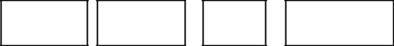

ALL THE ABOVE TOTALS TO BE ENTERED BELOW

GRAND

TO TAL

 |  |  |  |  |  |  | ÷ |  |  |  |  |  |  |  | ÷ |  |  |  |  |  | EQ UALS |  | %
 |  | # O F
 | VO YAGERS |  |  |  |  |  |  |  | NUMBER
PARTICIPATI |  |  |  |  |  |  |  |  |  |  |  | O F |  |  |  |  | TO TAL
 |  |  | NG |  |  |  |  |  |  |  | EVENTS |  |  |  |  |  | MEMBERS

Please submit your completed reports to the National Directeur-Voiture Activities with one copy to the Sous Directeur-Voiture Activities by July 25, 2019. Electronic submissions are fine. Also, submit your highest percentage of participation for a Locale without rolling stock and Locale with rolling stock. Submit by Mail or e-mail to:

Joseph Dolwig 1502 U.S. Hwy 52

New Richmond, OH 45157-9408 Submit by Email Print Form 513-553-6302 jdolwig132@gmail.com
 | V.A.V.S. & S.V.H.
 | Consolidated Report—2019
Report for (check one) | Voiture Locale # ______du_________________ | Total Membership _____________
Date Prepared___/___/___ | Grande du ______________________________ | Total Menbership _______________

Directeur’s Name __________________________________________________ Telephpone ____________________

Name of (Specify) VAVS or SVH Representative__________________________________________________
Name of (Specify) VAVS or SVH Deputy Representative____________________________________________
Names of Other 40/8 Volunteers (includes La Femmes)_____________________________________________
____ ___________________________________________________________
Name of person preparing this report (If not Grande Directeur) _______________________________________
Miles Traveled________________
Money Spent_________________
Number of VAVS or SVH Committee meetings attended_____________Hours________ Miles Traveled _______
Number of Veteran’s Advisory Committee Meetings attended _________ Hours ________ Miles Traveled ______
Number of Junior Volunteers secured for your facility_______________________________________________

SERVICES RENDERED
 |  |  |  |  |  |  |  | Hours
Escort Service………………………………………………………………………………………..
 |  |  |  |  |  |  |  | ______
Pharmacy……………………………………………………………………………………………. |  |  |  |  |  |  | ______
Feeding Pa ents…………………………………………………………………………………….. |  |  |  |  |  |  | ______
Filing………………………………………………………………………………………………… |  |  |  |  |  |  | ______
Clerical Work……………………………………………………………………………………….. |  |  |  |  |  |  | ______
Serving Coﬀee………………………………………………………………………………………. |  |  |  |  |  |  | ______
Using Bookmobile…………………………………………………………………………………… |  |  |  |  |  |  | ______
Informa on Desk……………………………………………………………………………………. |  |  |  |  |  |  | ______
Salute to Veterans…………………………………………………………………………………… |  |  |  |  |  |  | ______
Decora ng for Holidays…………………………………………………………………………….. |  |  |  |  |  |  | ______
Country Store……………………………………………………………………………………….. |  |  |  |  |  |  | ______
Other Services Rendered _________________________________________________________ |  |  |  |  |  |  | ______
Special Occasions________________________________________________________ |  |  |  |  |  |  | ______
 | ________________________________________________________ |  |  |  |  |  | ______
 | ________________________________________________________ |  |  |  |  |  | ______
Other: | ________________________________________________________ |  |  |  |  |  | ______
 | ________________________________________________________ |  |  |  |  |  | ______
 | ________________________________________________________ |  |  |  |  |  | ______
 |  | TOTAL HOURS……………………………………………. |  |  |  |  | ______
Mail Voiture Locale Report to: |  | Mail Grande Voiture Report to: |  |  |  | Grande Voiture Only
Grande Directeur, VAVS |  | Ronald W. Rolfes, Jr. |  |  |  | Number of Locales Reporting:
 |  | National Directeur-VAVS
 |  | 5450 Tropic Dr.
 |  | New Port Richey, FL 34653 |  |  |  | ________________
 |  | E-Mail: rolfesr@hotmail.com
Deadline:__________________
 |  | Deadline: August 15th


V.A.V.S. & S.V.H.

Certification Form for Grande Voitures

Date:

Correspondant Na onale
Voiture Na onale
250 E 38th Street

Indianapolis, IN 46205‐2644

Dear Sir,

The Grande Voiture du _______________________________ takes GREAT PLEASURE in

submi ng the:

NAME OF:

ADDRESS:

CITY, STATE, ZIP CODE:

EMAIL ADDRESS: ________________________________________________________________

For Appointment as:

Representa ve Deputy Recer fica on

In VA Hospital/Clinic:

ADDRESS:

CITY, STATE, ZIP CODE:

Approved By:

Grand Chef de Gare / Grand Correspondant

NATIONAL YOUTH SPORTS

Report for Voiture Locale

For the period covering August 1, 2018 through July 31, 2019

Date of Report ______________ Locale # ________Grande du _________ with Membership of__________

 | Cash Expended for Youth Sports Participation
Youth Sports Booster Cards, Pins, Merchandise Purchased |  |  |  | $ ____________
Direct Donations to the Nationale/Grande Youth Sports Program |  |  |  | ____________
Donations to Teams or Individuals |  |  |  | ____________
Other Cash Expenditures |  |  |  | ____________
TOTAL CASH SPENT AS LISTED ABOVE |  |  |  |  |  |  | $ ____________
 |  | Assistance and Service Other than Cash
Miles driven for the Youth Sports Program . . . . . @ $ |  |  | .50 mile $ ____________
Hours donated for the Youth Sports Program . . . @ $ |  |  | 5.00 hour | ____________
Other Assistance or Services Provided |  |  |  | ____________
TOTAL OF ASSISTANCE OTHER THAN CASH |  |  |  |  |  |  | $ ____________
GRAND TOTAL OF ALL CONTRIBUTIONS FOR YOUTH SPORTS |  |  |  |  |  |  | $ ____________

GRAND TOTAL OF ATHLETES ASSISTED ____________

 |  | Name, Address and Telephone Number of the |  |  |  |  |  |  |  |  |  |  |  |  | Name, Address, Telephone Number of Individual
 | Voyageur that performed the most work in |  |  |  |  |  |  |  | support |  |  |  |  |  | who prepared this Report:
 | of the Youth Sports Program:
 | Name ______________________________________ |  |  |  |  |  |  |  |  |  |  |  |  |  | Name ______________________________________
 | Address ____________________________________ |  |  |  |  |  |  |  |  |  |  |  |  |  | Address ____________________________________
 | City, State, Zip Code __________________________ |  |  |  |  |  |  |  |  |  |  |  |  |  | City, State, Zip Code __________________________
 | Telephone Number ___________________________ |  |  |  |  |  |  |  |  |  |  |  |  |  | Telephone Number ___________________________
 | E-Mail: ___________________________________ |  |  |  |  |  |  |  |  |  |  |  |  |  | E-mail: ____________________________________
 |  |  |  |  |  |  |  |  |  |  |  |  |  |  | Locale # ____________________________________
 |  |  |  |  |  |  |  | Forward Report to Grand Directeur of
 |  |  |  |  |  |  | Youth Sports and Grand Correspondant
 |  |  |  |  | no later than date established by your Grande Voiture

27


NATIONAL YOUTH SPORTS

Consolidated Report for Grande Voiture

For the year of August 1, 2018 through July 31, 2019

Date of Report _______________ Grande Voiture du _____________with a Membership of ____________

 | Cash Expended for Youth Sports Participation
Youth Sports Booster Cards, Pins, Merchandise Purchased |  |  |  | $ ____________
Direct Donations to the Nationale/Grande Youth Sports Program |  |  |  | ____________
Donations to Teams or Individuals |  |  |  | ____________
Other Cash Expenditures |  |  |  | ____________
Pocket change for Kids |  |  |  | ____________
TOTAL CASH SPENT/DONATED AS LISTED ABOVE |  |  |  |  |  |  | $ ____________
 |  | Assistance and Service Other than Cash
Miles driven for the Youth Sports Program . . . . . @ $ |  |  | .50 mile $ ____________
Hours donated for the Youth Sports Program . . . @ $ |  |  | 5.00 hour | ____________
Other Assistance or Services Provided |  |  |  | ____________
TOTAL OF ASSISTANCE OTHER THAN CASH |  |  |  |  |  |  | $ ____________
GRAND TOTAL OF ALL CONTRIBUTIONS FOR YOUTH SPORTS |  |  |  |  |  |  | $ ____________

GRAND TOTAL OF ATHLETES ASSISTED ________

*************************************************

Note: Please attach a copy of the best Voiture Locale Report to this report when you forward it to the National Directeur at the address below.

Individual who prepared this report:


Grand Directeurs must forward report to | Name _________________________________
National Youth Sports Directeur Robert Kadow | Name _________________________________
6214 NW McKinley Dr, Vancouver, WA 98665 | E-mail: ________________________________
no later than August 15, 2019 | E-mail: ________________________________

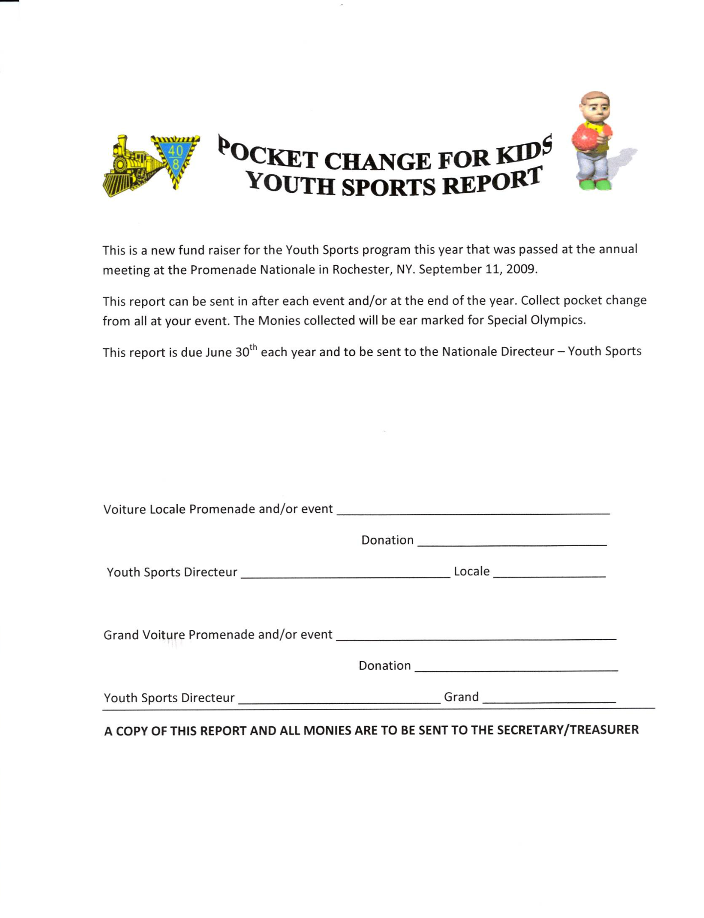

Robert Kadow

6214 NW McKinley Dr
Vancouver, WA 98665

William "Bill" Simpson
204 Horseshoe Drive
Goose Creek, SC 29445
wsimpson204@comcast.net

